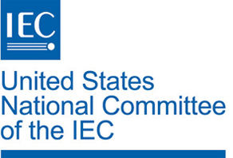

Invitation to all to attend an IEC Training Workshop at Sony Electronics Inc., San Diego, California, on 11 January 2016
In its continuing series of round table discussions and workshops, the IEC Central Office will again be administering its successful IEC Training Workshop on tools, processes and procedures for standardization and conformity assessment.
This third North American IEC training workshop will be held on Monday, 11 January 2016 at:

Sony Electronics Inc.
16535 Via Esprillo
San Diego, CA 92127
This course will be administered by Mr. Peter Lanctot of the IEC Regional Centre for North America.
A sample program of the event and information about the location including recommended hotels can be found below.
All interested parties should register by emailing Tony Zertuche, USNC Deputy General Secretary, at tzertuche@ansi.org indicating:
a) Your Name and Organization
b) Your Role in your Committee, TAG or Working Group

All registrations should be received no later than 18 December 2015.

Sample Agenda of the IEC Training Workshop

- Opening Remarks
- Introductions
- IEC and the Masterplan
- Roles and Responsibilities / Code of Conduct
- Conformity Assessment
- IEC Systems Work
- *Lunch Break –

- IT Tools and Services
- IT Tools and Services in Development
- Break-out Sessions (20min)

- Group 1 Improving IEC Standardization Processes
- Group 2 Improving IEC Tools and Services
- Group 3 Improving Participation in Standardization in the US

- Break-out Session Reports
- Wrap-up and Closing

*Lunch will be provided.
Please call SEGTravel directly at 201.930.0550 to book a room at the Sony discounted rate at any of the following preferred hotels:

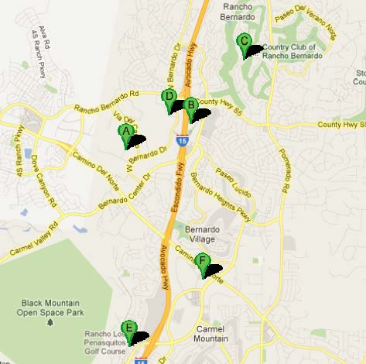
A – Sony Electronics Inc.: 16535 Via Esprillo, San Diego, CA

B - Courtyard Marriott: 11611 Bernardo Plaza Court, San Diego, CA (858) 613-2000 - $120/night

C – Rancho Bernardo Inn: 17550 Bernardo Oaks Drive, San Diego, CA (858) 675-8500 - $152/night

D – Radisson Suite Hotel: 11520 West Bernardo Court, San Diego, CA (858) 451-6600 - $122/night
‎
E - Doubletree Golf Resort: 14455 Penasquitos Drive, San Diego, CA 92129 (858)672-9100 - $125/night

F - Staybridge Suites by Holiday Inn (Extended Stay): 11855 Avenue of Industry, San Diego CA (858) 487-0900 - $119/night

- All rates subject to change and based on availability
- All hotels offer shuttle service to the Sony Electronics location

