**Workshop on Standards to Support U.S.-Ghana Trade and Investment**

**Volta Hall**

**Holiday Inn, Accra Airport**

**Accra, Ghana**

**March 31, 2017**

|  |  |
| --- | --- |
| 9:00 – 9:30am | **Opening remarks**   * Richard Chen, USAID * Madeleine McDougall, ANSI * GSA |
| 9:30 – 10:30am | **Overview of the U.S. and Ghanaian standards systems, and the link between globally relevant standards and economic growth**   * GSA * Madeleine McDougall, ANSI * Q & A |
| 10:30 – 10:45am | **TEA/COFFEE BREAK** |
| 10:45 – 12:30pm | **Transportation infrastructure: State-of-Play in Ghana**   * Ghanaian Speaker * Q&A   **“Transportation Infrastructure: Pathway to Vitality and Growth”**   * Eli Cuelho, Western Transportation Institute * Q&A   **“ASTM International: Overview and Collaboration with West Africa”**   * Kim Simms, ASTM International * Q&A |
| 12:30pm – 2:00pm | **LUNCH** |
| 2:00 – 3:30pm | **Water: State-of-Play in Ghana**   * Ghanaian Speaker * Q&A   **“Standards in the U.S. Water System”**   * Frank Kurtz, American Water Works Association (AWWA) * Q&A |
| 3:30 – 3:45pm | **TEA/COFFEE BREAK** |
| 3:45 – 4:30pm | **Energy: State-of-Play in Ghanaian**   * Ghanaian Speaker * Q&A |
| 4:30 – 5:00 pm | **Closing Remarks** |

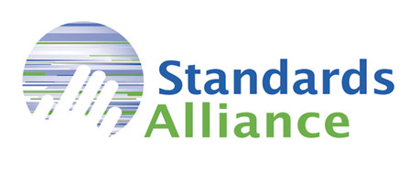

**ABOUT STANDARDS ALLIANCE: A PUBLIC-PRIVATE PARTNERSHIP BETWEEN ANSI AND USAID**

The Standards Alliance was announced by USAID in November 2012 as a new funding facility designed to provide capacity-building assistance to developing countries, specifically related to implementation of the World Trade Organization (WTO) Technical Barriers to Trade (TBT) Agreement. The main objectives of the program, which will inform the activities to be conducted, include:

* Increased understanding of WTO TBT principles
* Implementation of the Code of Good Practice for the Preparation, Adoption and Application of Standards
* Improved transparency in the development and/or modification of technical regulations
* More robust and transparent engagement with the private sector in standards development and use.

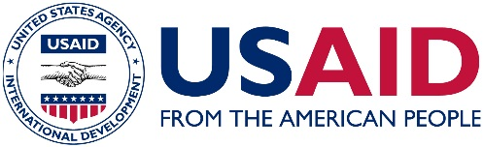

**ABOUT USAID**

The U.S. Agency for International Development (USAID) assists U.S. foreign policy by administering the U.S. foreign assistance program in more than 80 countries worldwide. USAID provides humanitarian assistance and economic support with the goal of promoting international good will, global development, and the expansion of stable, democratic societies and open financial markets.

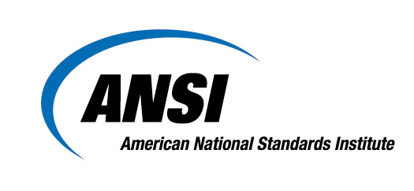

**ABOUT ANSI**

The American National Standards Institute (ANSI) is a private non-profit organization whose mission is to enhance U.S. global competitiveness and the American quality of life by promoting, facilitating, and safeguarding the integrity of the voluntary standardization and conformity assessment system. Its membership is made up of businesses, professional societies and trade associations, standards developers, government agencies, and consumer and labor organizations.

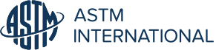

**About ASTM International**

Over 12,000 ASTM standards operate globally. Defined and set by ASTM, they improve the lives of millions every day. Combined with innovative business services, ASTM standards enhance performance and help everyone have confidence in the things they buy and use – from the toy in a child’s hand to the aircraft overhead. Working across borders, disciplines and industries ASTM harnesses the expertise of over 30,000 members to create consensus and improve performance in manufacturing and materials, products and processes, systems and services.

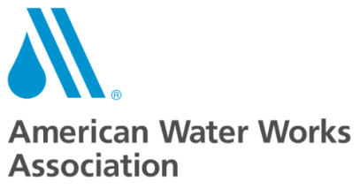

**ABOUT AWWA**

Established in 1881, the American Water Works Association is the largest nonprofit, scientific and educational association dedicated to managing and treating water, the world’s most important resource. With approximately 50,000 members, AWWA provides solutions to improve public health, protect the environment, strengthen the economy and enhance our quality of life.



**ABOUT DELOITTE**

In the US, Deloitte LLP and Deloitte USA LLP are member firms of DTTL, which provide industry-leading audit, consulting, tax, and advisory services to many of the world’s most admired brands, including 80 percent of the Fortune 500 and more than 6,000 private and middle market companies. Deloitte works across more than 20 industry sectors with one purpose: to deliver measurable, lasting results. We help reinforce public trust in our capital markets, inspire clients to make their most challenging business decisions with confidence, and help lead the way toward a stronger economy and a healthy society.

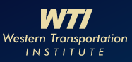

**ABOUT WESTERN TRANSPORTATION INSTITUTE**

The Infrastructure Maintenance and Materials program area at Western Transportation Institute (WTI) aims to use progressive research to improve the design and maintenance of rural highway infrastructure. WTI conducts basic and applied research to address the immediate and long-term construction and maintenance needs of rural highway departments in the following areas:

* Materials – Conduct research using new materials, such as geosynthetics or high performance concrete, to evaluate their benefit in new and rehabilitated highway structures.
* Maintenance – Develop best management practices using cost-benefit analyses to help state highway departments select the most appropriate and cost-effective maintenance methods to extend the life of their facilities.
* Monitoring – Test and evaluate instrumentation and remote sensing technologies to better monitor the condition of transportation infrastructure.