Standards Writing Workshop in Malawi

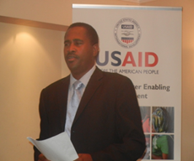

The Trade Hub held a two-day training session on “Writing of Standards for Standards Technical Committee Chairpersons and Secretaries” in Blantyre, Malawi March 4-5. The workshop was held in partnership with the Malawi Bureau of Standards and facilitated by standards expert Dr. Mukayi Musarurwa.

The workshop trained twenty participants on proper clarification of roles and responsibilities to manage technical committees effectively during standards writing, among other things. USAID/Malawi attended the opening program of the workshop as represented by Douglas Arbuckle (Mission Director), John Edgar (Director, Sustainable Economic Growth Office) and Chris Chibwana (Private Sector Specialist). The US Ambassador to Malawi, Virginia Palmer, also stopped by briefly to visit the workshop.

A similar workshop will be held in Maseru, Lesotho March 9-10 in partnership with the Lesotho Department of Standards & Quality Assurance.

Training to Improve Standards for Lesotho

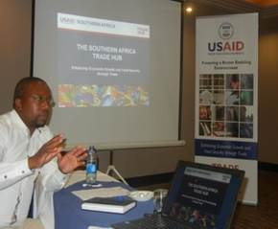

The Trade Hub held two days of training on “Writing of Standards” in Maseru, Lesotho March 9-10. The workshop was held in partnership with the Lesotho Department of Standards & Quality Assurance (DSQA) and was facilitated by standards expert Dr. Mukayi Musarurwa. The 17 participants (of which 10 were women) were Standards Technical Committee Chairpersons and Secretaries drawn from the government, private sector, academia, and regulators.

The training is coming at an opportune time for Lesotho since the country is in the process of setting up technical committees to develop their own national standards. The training also follows the passage of legislation in July 2014 that established a National Standards Body (NSB) for the country. The Trade Hub helped Lesotho to develop a strategy and implementation plan for the NSB and assisted in the drafting of Lesotho’s National Quality and Food Safety Policies, all of which are critical to the successful establishment of the NSB.

The training provided an overview on WTO standards, the roles and responsibilities of technical committee chairs and secretaries, and stakeholder involvement necessary for successful standards development.

