**Awareness workshop on Ethanol as a Home Cooking and Appliance Fuel**

**Technical Standard**

**HOST:** Uganda National Bureau of Standards

**SPONSOR:** The Standards Alliance in collaboration with ASTM International

**DATE: November15, 2016**

**Location: Kampala Serena Hotel**

8:45 a.m. Registration

9:00 a.m. **Welcoming Remarks**

* Speaker, Madeleine McDougall, American National Standards Institute
* Speaker, David Rogers, USAID
* Speaker TBD: Dr. Ben Manyindo (Executive Director , Uganda National Bureau of Standards)
* Logistical Announcements

9:45 – 10:15 a.m. **Session 1: Process of standards development and the need for standards**

* Speaker: Mr. David Eboku ( UNBS)
* Question & Answer Session

10:15 – 10:45 a.m. *Coffee/Tea Break*

10:45 – 12:15 p.m. **Session 2: Reviewing the ASTM standard and related work**

* Presentation on ASTM standard; Brady Luceno, POET
* Speaker: Dan Seals, POET
* Question & Answer Session

12:15 – 1:30 p.m. *Luncheon*

1:30 – 3:00 p.m. **Session 3: Application and Implementation**

* Speaker: Nicole Kearney, CLASP
* Speaker: Farhan Nakhooda and Kenneth Barungi, Kakira Sugar Ltd.
* Question & Answer Session

3:00- 3:30 p.m. *Coffee/Tea Break*

3:30 – 4:30 p.m. **Session 4:Institute arrangement in Uganda to support standardization of ethanol for cooking and other applications**

* Speaker : Mr. Michael Ahimbisibwe; MEMD
* Question & Answer Session

4:30 p.m. **Way forward**

Final Comments and Questions

4:40 p.m. **Photo Opportunity**: All Workshop Participants

4:45 p.m. Adjourn Workshop

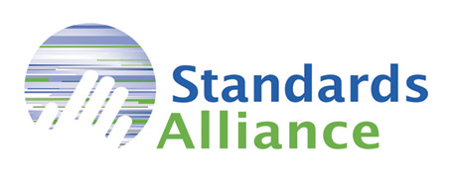

**ABOUT STANDARDS ALLIANCE: A PUBLIC-PRIVATE PARTNERSHIP BETWEEN ANSI AND USAID**

The Standards Alliance was announced by USAID in November 2012 as a new funding facility designed to provide capacity-building assistance to developing countries, specifically related to implementation of the World Trade Organization (WTO) Technical Barriers to Trade (TBT) Agreement. The main objectives of the program, which will inform the activities to be conducted, include:

* Increased understanding of WTO TBT principles
* Implementation of the Code of Good Practice for the Preparation, Adoption and Application of Standards
* Improved transparency in the development and/or modification of technical regulations
* More robust and transparent engagement with the private sector in standards development and use.



**ABOUT USAID**

The U.S. Agency for International Development (USAID) assists U.S. foreign policy by administering the U.S. foreign assistance program in more than 80 countries worldwide. USAID provides humanitarian assistance and economic support with the goal of promoting international good will, global development, and the expansion of stable, democratic societies and open financial markets.

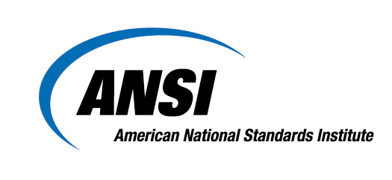

**ABOUT ANSI**

The American National Standards Institute (ANSI) is a private non-profit organization whose mission is to enhance U.S. global competitiveness and the American quality of life by promoting, facilitating, and safeguarding the integrity of the voluntary standardization and conformity assessment system. Its membership is made up of businesses, professional societies and trade associations, standards developers, government agencies, and consumer and labor organizations.



**About ASTM International**

Over 12,000 ASTM standards operate globally. Defined and set by ASTM, they improve the lives of millions every day. Combined with innovative business services, ASTM standards enhance performance and help everyone have confidence in the things they buy and use – from the toy in a child’s hand to the aircraft overhead. Working across borders, disciplines and industries ASTM harnesses the expertise of over 30,000 members to create consensus and improve performance in manufacturing and materials, products and processes, systems and services.



**ABOUT POET**

POET, one of the world’s largest ethanol producers, is a leader in biorefining through its efficient, vertically integrated approach to production. The 28-year-old company has a production capacity in excess of 1.7 billion gallons of ethanol and 9 billion pounds of high-protein animal feed annually from its network of 27 production facilities. POET, through its joint venture with DSM, also operates a commercial-scale cellulosic ethanol plant in Emmetsburg, Iowa. For more information, visit http://www.poet.com.



CLASP is an impartial and independent nonprofit organization, first established in 1999 to mitigate the growing energy demand resulting from the use of appliances, lighting, and equipment. CLASP develops and shares practical and transformative policy and market solutions in collaboration with global experts and local stakeholders. CLASP is the leading international resource and voice for energy efficiency standards and labels (S&L) for appliances, lighting, and equipment.