Weekly Project Progress Report
September 29-October 3, 2014

Launch of National Enquiry Point for Malawi

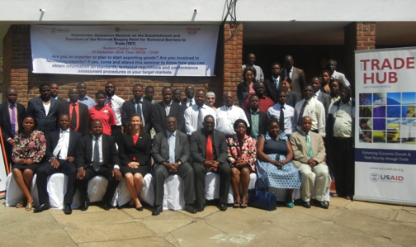
In conjunction with the Malawi Bureau of Standards, the Southern Africa Trade Hub launched the Malawi National Enquiry Point (NEP) in Lilongwe on September 24 and held NEP awareness seminars in Blantyre (September 22), and Mzuzu (September 26). Feed the Future Coordinator Lynn Schneider gave USAID’s keynote address, while Economic Officer Heather Dressler represented the US Embassy in Malawi and Evans Chinembiri attended on behalf of USAID/Southern Africa. A total of 150 stakeholders attended the event, which was designed to increase understanding of NEP functions and their importance in international trade.

The WTO’s Agreement on Technical Barriers to Trade requires each WTO member state to set up a National Enquiry Point and notification authority to help encourage fair and effective trade standards. Without a National Enquiry Point, the private sector has no simple and accessible means of gathering required information for trade, which hampers economic growth and food security in the region.

A National Enquiry Point reduces the time and cost of trade by offering a single contact point to which requests for information can be made. In addition to responding to all enquiries concerning regulations, standards and conformity assessment procedures, an effective enquiry point maintains a reference collection of standards, specifications, test methods, codes and recommended practices. With the launch of the NEP as well as the purchase of needed office equipment for the enquiry point, USAID is helping Malawi utilize twenty-first century tools to make the trading process more simple and effective.

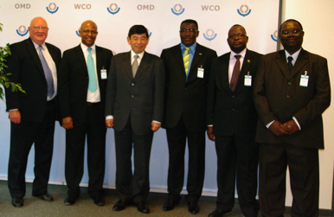
Second WTO Trade Facilitation Agreement Working Group
The Trade Hub accompanied four representatives of the Customs Administrations of Malawi, Botswana, Namibia and SADC to Brussels, Belgium to attend the Second WTO Trade Facilitation Agreement (TFA) Working Group. The working group was held to update WCO members on the status of TFA negotiations, to discuss the WCO Mercator Program for TFA technical assistance, and to plot the way forward on WCO members adopting modernization programs required to comply with the TFA.
Approximately 170 participants attended, including WCO members, donors (World Bank, UNECE, UNCTAD, European Commission). All participants were eager to move forward on TFA compliance measures despite the stall in progress of the TFA by WTO members. Bevan Simataa, Commissioner of Customs, Namibia, was a panelist on the WCO Mercator Program panel. Willie Shumba, Senior Customs Advisor, SADC, engaged the Working Group on a number of discussion issues related to the “regional” implications for the TFA. Overall the Working Group was a huge success that paves the way for strategic planning efforts by WCO members to address the TFA and its requirements proactively.
Brian Glancy (Trade Hub), Philiso Valashia (Commissioner BURS), Shadric Namalomba (Commissioner Malawi Revenue Authority) and Willie Shumba (SADC) meet with Kunio Mikuriya, the Secretary General of the WCO.
During the Working Group, the Trade Hub arranged for its beneficiary partners to attend a meet and photo opportunity with the Secretary General of the WCO, Kunio Mukirya, and other Executive Branch members. The Secretary General expressed delight at the level of assistance currently being provided by USAID to assist SADC members in moving forward with Customs Modernization efforts. Mr. Mukiya mentioned that he would be traveling to Washington DC in October and was eager to meet with USAID there to discuss ongoing technical assistance for TFA efforts in WCO member states.
The Trade Hub also arranged meetings with key representatives of the WCO Risk Management, Cargo Targeting System and WCO Publications units to familiarize the visiting customs officials with technical assistance available through the WCO itself. Meetings were also arranged with the Director of the WCO Capacity Building section managed by Erich Kieck, former senior manager for the South Africa Revenue Service (SARS), who is well-known to SADC and its members.
USAID Grant to Establish First-of-its-Kind Testing Laboratory in Zambia

USAID has approved a USD$90,000 Strategic Partnership Grant to Deltamune, a South Africa-based biotechnology company, to establish ISO 17025 accredited test laboratory services in Zambia, the first of their kind to be available in the country. Currently, SADC businesses in the region are forced to send their samples to South Africa for testing, which is expensive and time-consuming. The new lab services will speed trade for Zambian exporters, improve food safety and support the agricultural community at large, especially the groundnut industry as aflatoxin testing is being developed as a priority for the lab. The USAID grant will enable Deltamune to make appropriate investments in the lab, attain accreditation, conduct training, finance a senior management person, and hire a Zambian apprentice who will take over management once all qualifications are met. In addition, Deltamune South Africa will serve as the reference and calibration laboratory for the Zambian lab.
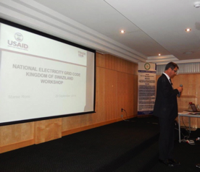
Electricity Grid Code Training and Validation Workshop for Swaziland
The Trade Hub hosted an Electricity Grid Code Training and Validation Workshop in Manzini, Swaziland on September 29 for 63 participants (including 12 women) as part of its technical assistance to the Swaziland Energy Regulatory Authority (SERA) to develop a Grid Code for the Electricity Supply Industry in Swaziland and to build SERA’s capacity to do this work in the future. The Grid Code is one of the fundamental regulatory documents setting the rules for the electric grid operator and users: defining technical standards, connection, operation and maintenance rules, information exchange protocols, market relations, etc. Most importantly, it also includes rules for renewable energy producers to connect to the grid. The Grid Code is one of the priority recommendations by the Renewable Energy and Independent Power Producers’ policy currently being developed in Swaziland with the assistance of the Trade Hub.

According to SERA’s CEO Mr. Mkhumane, the Grid Code “will shorten Power Purchase Agreement registration and simplify the Independent Power Producers’ application process, as well as level the playing field in the energy sector of the country…[an] exercise that is long overdue in Swaziland.” The Trade Hub has drafted the Grid Code in collaboration with SERA, who has undertaken public review of the code in a transparent and open process.

The Trade Hub will collect participants’ comments on the Draft Grid Code within the next two weeks, at which point the Draft Grid Code will be finalized and submitted to USAID and SERA.

Upcoming Events:
Start Date | End Date | Location | Activity
October 14 | October 17 | Botswana | Gender Integration Training for Trade Hub staff
October 16 | October 16 | Zambia | Renewable Energy Feed-In Tariff Policy Validation Workshop
October 29 | October 29 | Swaziland | Renewable Energy & Independent Power Producers (RE&IPP) Policy Validation Workshop
October 29 | October 29 | Namibia | National Single Window Private Sector Engagement Workshop
November 3 | November 14 | Namibia | Project Management Training on National Single Window
November 10 | November 10 | Zambia | Renewable Energy Feed-In Tariff Policy Validation Workshop
November 10 | November 12 | Kenya | Origin Africa: ACTIF-sponsored trade show
November 19 | November 21 | South Africa | International Apparel, Textile Footwear Trade Exhibition

