**Weekly Project Progress Report**

**November 17-21, 2014**

**NSW Project Management Training for Namibia**

From November 3-14, the SA Trade Hub provided Project Management training to the Namibian National Single Window (NSW) project team and delegates from Customs and Excise, and the Ministry of Trade and Industry in Windhoek, Namibia.

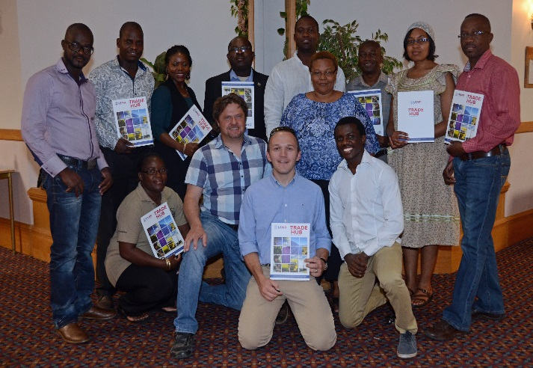

*Project management trainees in Windhoek, Namibia*

Training was led by Dr. Andre Malan using a Namibian tailored syllabus derived from the Project Management Institute (PMI), a leading global organization providing standards for project management. Dr. Malan is one of only nine PMI Project Management Professionals registered in Namibia and, in addition to training and consultancy, is striving to build national awareness and recognition of project management.

**SADC Comprehensive Trade Facilitation Program (CTFP) Taking Form**

The Southern Africa Development Community (SADC) is working closely with the SA Trade Hub to develop a Comprehensive Trade Facilitation Program (CTFP). The CTFP will act as a roadmap for SADC and member states on how best to address impediments to the cross-border flow of international goods in compliance with the WTO Agreement on Trade Facilitation (TFA), the WTO’s Revised Kyoto Convention (RKC) and other international and regional trade facilitation initiatives.

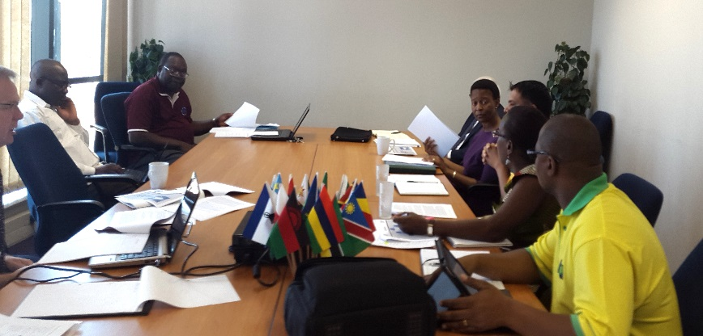

*Trade Hub and SADC Trade Facilitation discussion*

The SA Trade Hub met with the SADC TIFI Director and her team on November 14, 2014 to receive SADC’s views and concurrence on its Inception Report. The draft CTFP will be submitted before the end of the year, and following a Member States’ Consultative Workshop in late January, the final CTFP will be completed by February 2014.

**Capacity Needs Assessment for RERA**

On November 12-14, SA Trade Hub Clean Energy Director participated in a workshop for representatives from the Human Resource Departments (HR) for members of the Southern Africa Regional Electricity Regulators Association (RERA) held in Swakopmund, Namibia. He delivered the intermediate results of Capacity Needs Assessment conducted for RERA by the SA Trade Hub.

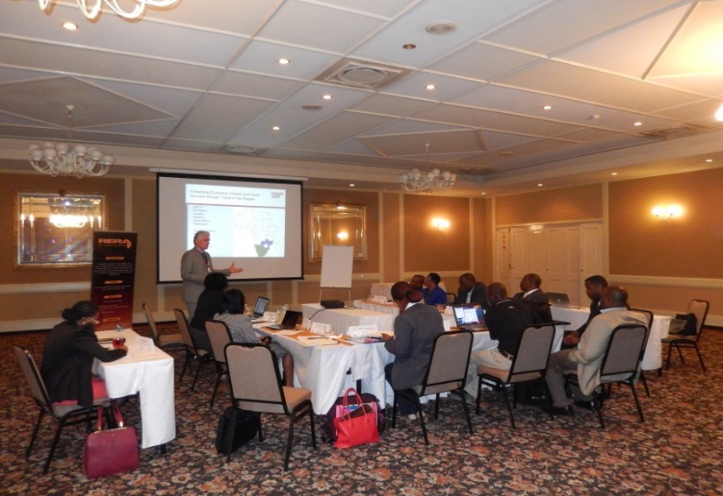

*The Trade Hub presents the interim survey results to RERA’s HR representatives*

The SA Trade Hub is assisting RERA in institutionalizing its training program by helping RERA to design a “train the trainers” program.

The goal of this activity is to establish a regional platform for sustainable long-term capacity building for RERA’s regulatory agencies board members, commissioners, and other technical and support staff.

The HR meeting was gathered under the umbrella of RERA’s Capacity Building and Information Sharing Committee. According to RERA’s Executive Secretary Mr. Elijah Sichone, this was the first time a Capacity Needs Assessment was undertaken in-depth for RERA by professionals.

**Lesotho Launches WTO TBT Enquiry Point**

On 18 November, distinguished representatives from the US Embassy/Lesotho and the United States Agency for International Development (USAID) and their partners from the Lesotho Ministry of Trade and Industry, Cooperatives and Marketing and the Department of Standards and Quality Assurance (DSQA) celebrated the launch of the country’s first National Enquiry Point (NEP).

Under the World Trade Organization (WTO) Technical Barriers to Trade (TBT) Agreement, member nations develop enquiry points and strengthen their legal and regulatory framework for standards to increase trade. The USAID PTF Standards Alliance facility was designed specifically to assist countries to help implement their commitments under the WTO TBT Agreement.

*The Honorable Mats’epo Ramakoae, Lesotho Deputy Minister of Finance at the NEP Launch*

“What we are witnessing here is a very important milestone in positioning our country Lesotho as a destination of choice to prospective investors,” stated Acting Permanent Secretary of the Lesotho Ministry of Trade and Industry, Molebatsi Rabolinyane.

Local exporters and importers will now have a ‘one-stop shop’ where they can receive crucial information on laws, regulations, and quality standards for doing business.

Lesotho was the only SADC country without a standards body. The Deputy Finance Minister Ramakoae announced during the NEP launch the Lesotho Standards Institution Bill 2014 was enacted, and the Government has set aside US$2.0 million to establish a National Standards Body (NSB).

**Lesotho Prioritizes the Investor Roadmap**

The SA Trade Hub team recently met with representatives of the Lesotho National Development Corporation (LNDC) and the Department of Policy and Strategic Planning under the Ministry of Development Planning (DPSP) in Maseru, Lesotho to discuss next steps regarding the Investor Roadmap process the SA Trade Hub is supporting.

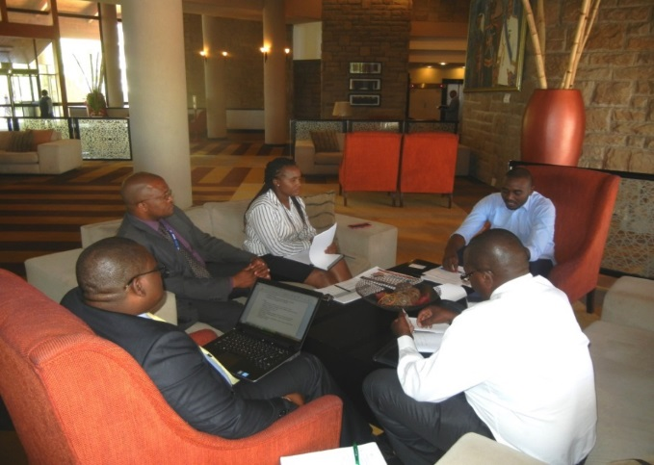

*Trade Hub meets the LNDC and Ministry of Development and Planning in Maseru, Lesotho*

Lesotho's Investor Road Map implementation is making progress with a number of recent positive developments including the investor climate reform program now to be overseen by a Cabinet Committee, the DPSP assigned as the overall champion for coordination of the Investor Roadmap and the establishment of nine technical groups based on the 11 *World Bank Ease of Doing Business* indicators. Going forward the SA Trade Hub will conduct another Investor Roadmap audit to identify gaps to be addressed, culminating in a two-day capacity building workshop on investor roadmap best practices for the Lesotho Investor Roadmap Implementation Committee.

**Matchmaking Potential for Botswana Textiles**

The President of the newly formed Botswana Textiles and Clothing Association (BTCA), the Department of Industrial Affairs, Ministry of Trade and Industry and lead textiles/apparel industrialists in Botswana, and representatives from the SA Trade Hub met to discuss how to collaborate on the implementation of a medium to long-term Botswana textile and clothing strategy.  Botswana faces numerous export challenges including limited market access, underutilized capacity, SME development, export incentives, and capacity deficiencies.  The Trade Hub reviewed a proposed strategic partnership between South African retailers and Botswana manufacturers to capitalize on underutilized capacities.

Two companies expressed interest in the initiative and their profiles were sent to South African retailers for business matchmaking.  To increase the number of local companies exporting to the US market, the SA Trade Hub shared with the BTCA information on exhibiting as part of the Africa Pavilion in the upcoming Magic trade show in Las Vegas, February 15-17, 2015. The SA Trade Hub will support export ready regional companies to participate in this marquis international event. The participation of suitable Botswana textile/apparel industry companies would raise their visibility and increase market access.

**Upcoming Events:**

| **Start Date** | **End Date** | **Location** | **Activity** |
| --- | --- | --- | --- |
| November 24 | November 27 | Zambia | Regional Variety Release and Launch workshop |
| November 24 | November 25 | Zambia | Bags2Bulk Training |
| December8 | December 10 | Zambia | Training Technical Chairpersons and Secretaries on Code of Good Practice on Standards |
| December 8 | December 12 | Zambia | Regional Electricity Regulation Association (RERA) Annual Conference |
| December 7 | December 13 | Zambia | Referencing Standards in Technical Regulations Workshop |
| January 21 | January 22 | South Africa | Validation Workshop for SADC regional SPS Strategy at the Seventh SADC SPS Coordinating Meeting |
| January 2015 | January 2015 | Malawi | Training on in-shelling Groundnuts Trading |
| February 2015 | February 2015 | Namibia | Change Management Training for National Single Window Technical Committee Members |
| February 2015 | NA | Namibia | Launch of the Trade Information Portal |