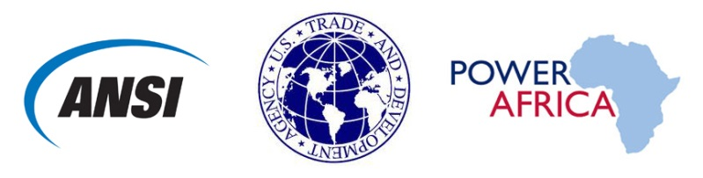

U.S.-Africa Clean Energy
Standards Program

Activity Proposal Template and
Commercial Benefit Questionnaire

www.StandardsPortal.org/us-africacesp
Please include as much detail on this form as possible.

1 | CONTACT INFORMATION  Who Is the best point of contact at your company for follow-up on potential participation with this activity? | Name  Title  Organization  Telephone  Email

2 INDUSTRY SECTOR/TOPIC OF INTEREST
Please indicate in the space provided a detailed description of the industry sector and specific topic of your proposed activity.

3 OBJECTIVES OF WORKSHOP/ACTIVITY
What are your objectives for the workshop? How would participating help further these objectives? The typical format for the U.S.-Africa CESP is a two-day workshop. If you recommend the activity utilize another format, please provide details.

4 OPPORTUNITIES IN THE TARGET MARKET
Please name the proposed location of your activity and list near or long term opportunities for your company/organization in the market.
5 POTENTIAL EXPORT BENEFIT
What products or services would you hope to gain sales leads for by participating in this activity? What is the U.S. content of these products/services?

What is the size (USD value) of the addressable market for your products/services or identified opportunity?

Who are your primary customers in the market (company name/country of origin)?

6 STANDARDS-RELATED PRIORITY
How do the objectives of the activity relate to standards, conformity assessment, and/or technical regulations? Is there a particular opportunity or challenge that would be addressed?

7 TIMETABLE
Please indicate possible dates for the proposed activity. If the dates are flexible, please indicate your preferred timetable.

8 PRIVATE SECTOR CONTRIBUTION
USTDA seeks to demonstrate that its investment in each activity is matched by contributions from the U.S. private sector. Please indicate the sources and approximate amount, if known, of expected contributions for the activity. These may be in the form of sponsorship or in-kind through donation of a venue or materials, expert time, and/or travel expenses. Please also list U.S. companies that may support the activity either through content development, participation, or both.

9 ADDITIONAL INFORMATION
Please include any additional information about your proposed activity, including:
- Suggested participants from the U.S. and partner country/countries:
  - Are they established contacts?
  - Are they aware of the proposed workshop?
- Topics for discussion
- Any other relevant details

