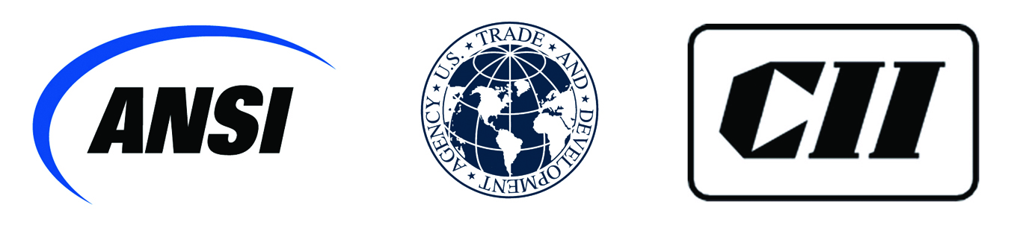

U.S.–India Standards and Conformance Cooperation Program (SCCP)
Workshop – Safe Storage of LNG

February 15, 2010
Venue:
Taj Palace Hotel, Mumtaz Hall
New Delhi

www.StandardsPortal.org/us-indiasccp

AGENDA | Inaugural Session
08:45 – 09:30  09:30 – 09:45  09:45 – 09:50  09:50 – 10:05  10:05 – 10:35  10:35 – 10:45  10:45 – 10:55  10:55 – 11:15 | Registration and Networking  Welcome / Opening Remarks  - Dr. Sarita Nagpal, Deputy Director General, CII  Address  - Mr. S Joe Bhatia, President and CEO, ANSI  Address  - Mr. P K Gambhir, Scientist ‘G’ Technical, BIS  Special Remarks  - Mr. Ambrish Mishra, Director, OISD  Discussion  Concluding Remarks  - Mr. Ramani Iyer, Chairman, CII Standards Council  Tea/Coffee Break

 | Technical Session: U.S.-India Cooperation in LNG, LPG, and CNG Standards and Conformance
11:15 – 11:50  11:50 – 12:20  12:20 – 12:45  12:45 – 12:55  12:55 – 13:10  13:10 – 13:35  13:35 – 13:45  13:45 – 14:15  14:15 – 14:40  14:40 – 15:05  15:05 – 15:30  15:30 – 15:45  15:45 – 16:00  16:00 – 16:05 | Lead Presentation (LNG, CNG, LPG)  - Mr. C K Veda, Head-MED, BIS  Review of U.S. Early Experiences with LNG  - Mr. Ted Lemoff, Staff Liaison, NFPA  Safety Overview of Indian Experiences with LNG Terminal Operations  - Mr. M M Ahuja, Senior Vice President (Technical), Petronet LNG Ltd  Overview of LNG Shipping Concerns  - Capt B B Sinha, Senior Vice President, Shipping Corporation of India Ltd  Safety Overview of Indian Experiences with LNG Road Transportation, Distribution and Operation of Small LNG storages  - Mr. V P Sinha, Deputy General Manager (LNG), Indian Oil Corporation Ltd  Regulatory Framework on CNG-City Gas in India  - Mr. Vijay Duggal, Deputy General Manager (CGD), Bharat Petroleum Corporation Ltd  Discussion  Luncheon  Applicability of NFPA Codes and Standards in India  - Mr. S K Hazra, Technical Committee Member LNG (NFPA 59A) & LPG (NFPA 58) & Chairman, Safety, Health & Environment Expert Committee, Indian Chemical Council  LNG Spill Testing  - Mr. Ted Lemoff, Staff Liaison, NFPA  Regulatory Framework for LPG in India  - Mr. Subasis Ray, Explosives Petroleum and Explosives Safety Organization of India  Lead Presentation  - Mr. Anil Jauhri, Adviser, Quality Council of India  Discussion  Concluding Remarks  - Mr. Ramani Iyer, Chairman, CII Standards Council  Adjourn

