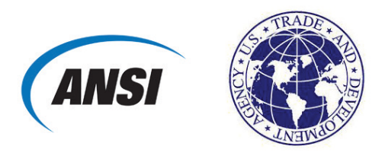
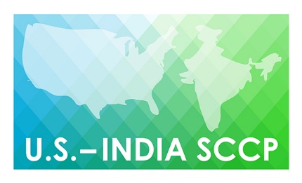 |  | U.S.-India Standards and Conformance Cooperation Project (SCCP), Phase II  Proposal and Commercial Benefit Questionnaire  www.standardsportal.org/us-indiasccp2
Please include as much detail on this form as possible.

1 | CONTACT INFORMATION  Who Is the best point of contact  at your company for follow-up  on potential participation in  this activity? | Name  Title  Organization  Telephone  Email

2 INDUSTRY SECTOR/TOPIC OF INTEREST
The three proposed areas for the SSCP Phase II project are clean energy, water and sanitation, and smart and sustainable cities. Please indicate in the space provided a detailed description of the industry sector and specific topic of your proposed workshop/activity.

3 OBJECTIVES OF WORKSHOP/ACTIVITY
What are your objectives for the workshop? How would participating help further these objectives? The typical format for the U.S.-India SCCP is a 2-day workshop: day one for sector-related speakers and day two for a site visit or follow-up meeting. What are some site visits or activities you are interested in for day two of any of the workshops?

4 OPPORTUNITIES IN THE INDIAN MARKET
Please name the proposed location of your activity and list near- or long-term opportunities for your company/organization in the Indian market.
5 POTENTIAL EXPORT BENEFIT
What products or services would you hope to gain sales leads for by participating in this workshop/activity? What is the U.S. content of these products/services?

What is the size (USD value) of the addressable market for your products/services or identified opportunity?

Who are your primary customers in the market (company name)?

6 STANDARDS-RELATED PRIORITY
How do the objectives of the workshop/activity relate to standards, conformity assessment, and/or technical regulations? Is there a particular opportunity or challenge that would be addressed?

7 TIMETABLE
Please indicate possible dates for the proposed workshop/activity. If the dates are flexible, please indicate your preferred timetable.

8 PRIVATE-SECTOR CONTRIBUTION
USTDA seeks to demonstrate that its investment in each activity is matched by contributions from the U.S. private sector. Please indicate the sources and approximate amount, if known, of expected contributions for the activity. These may be in the form of sponsorship or in-kind through donation of a venue or materials, expert time, and/or travel expenses. Please also list U.S. companies that may support the activity either through content development, participation, or both.

9 ADDITIONAL INFORMATION
Please include any additional information about your proposed activity, including:
- Suggested participants from the U.S. and Indian partners:
  - Are they established contacts?
  - Are they aware of the proposed workshop?
- Topics for discussion
- Other known events or workshops that are taking place on these topics that may be relevant to the proposed topics, locations, and/or timing.
- Any other relevant details

