**U. S. - CHINA**



**STANDARDS AND CONFORMANCE COOPERATION PROGRAM**

U.S.-China Environmental Technology and

Pollution Control Forum (Dalian)

Friday, November 4, 2016

**Venue:** Dalian Inn Fine Hotel, Dalian City, Liaoning Province, China

**Sponsored by:** U.S. Trade and Development Agency (USTDA)

**Supported by:** Dalian Jinpu New Area

Dalian Development and Reform Commission

Dalian Environmental Protection Bureau

Dalian University of Technology

**Organized by:** U.S.-China Energy Cooperation Program (ECP)

U.S. Commercial Service Shenyang

Administrative Committee of Dalian Puwan Economic Zone

American National Standards Institute (ANSI)

**RSVP:** ANSI: Mr. Xu Fang, Chief Representative in China

Email: [us-chinasccp@ansi.org](mailto:us-chinasccp@ansi.org)

“Reducing emissions and improving environmental quality in Liaoning Province” is highlighted as a strategic focus area in the 13th Five-Year Environmental Plan (2016-2020). Based on the plan Dalian has set emission targets and objectives to enhance environmental standards.  
  
This workshop aims to introduce U.S. environmental technology, best practices, and standards in support of the Environmental Plan’s goals. The workshop will address topics such as innovative wastewater treatment technology and applications, urban waste gasification solutions, and VOC abatement technology among other things.

To learn more about the U.S.-China SCCP or sponsor or participate in a workshop, please visit our website.

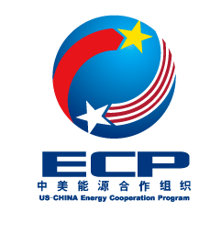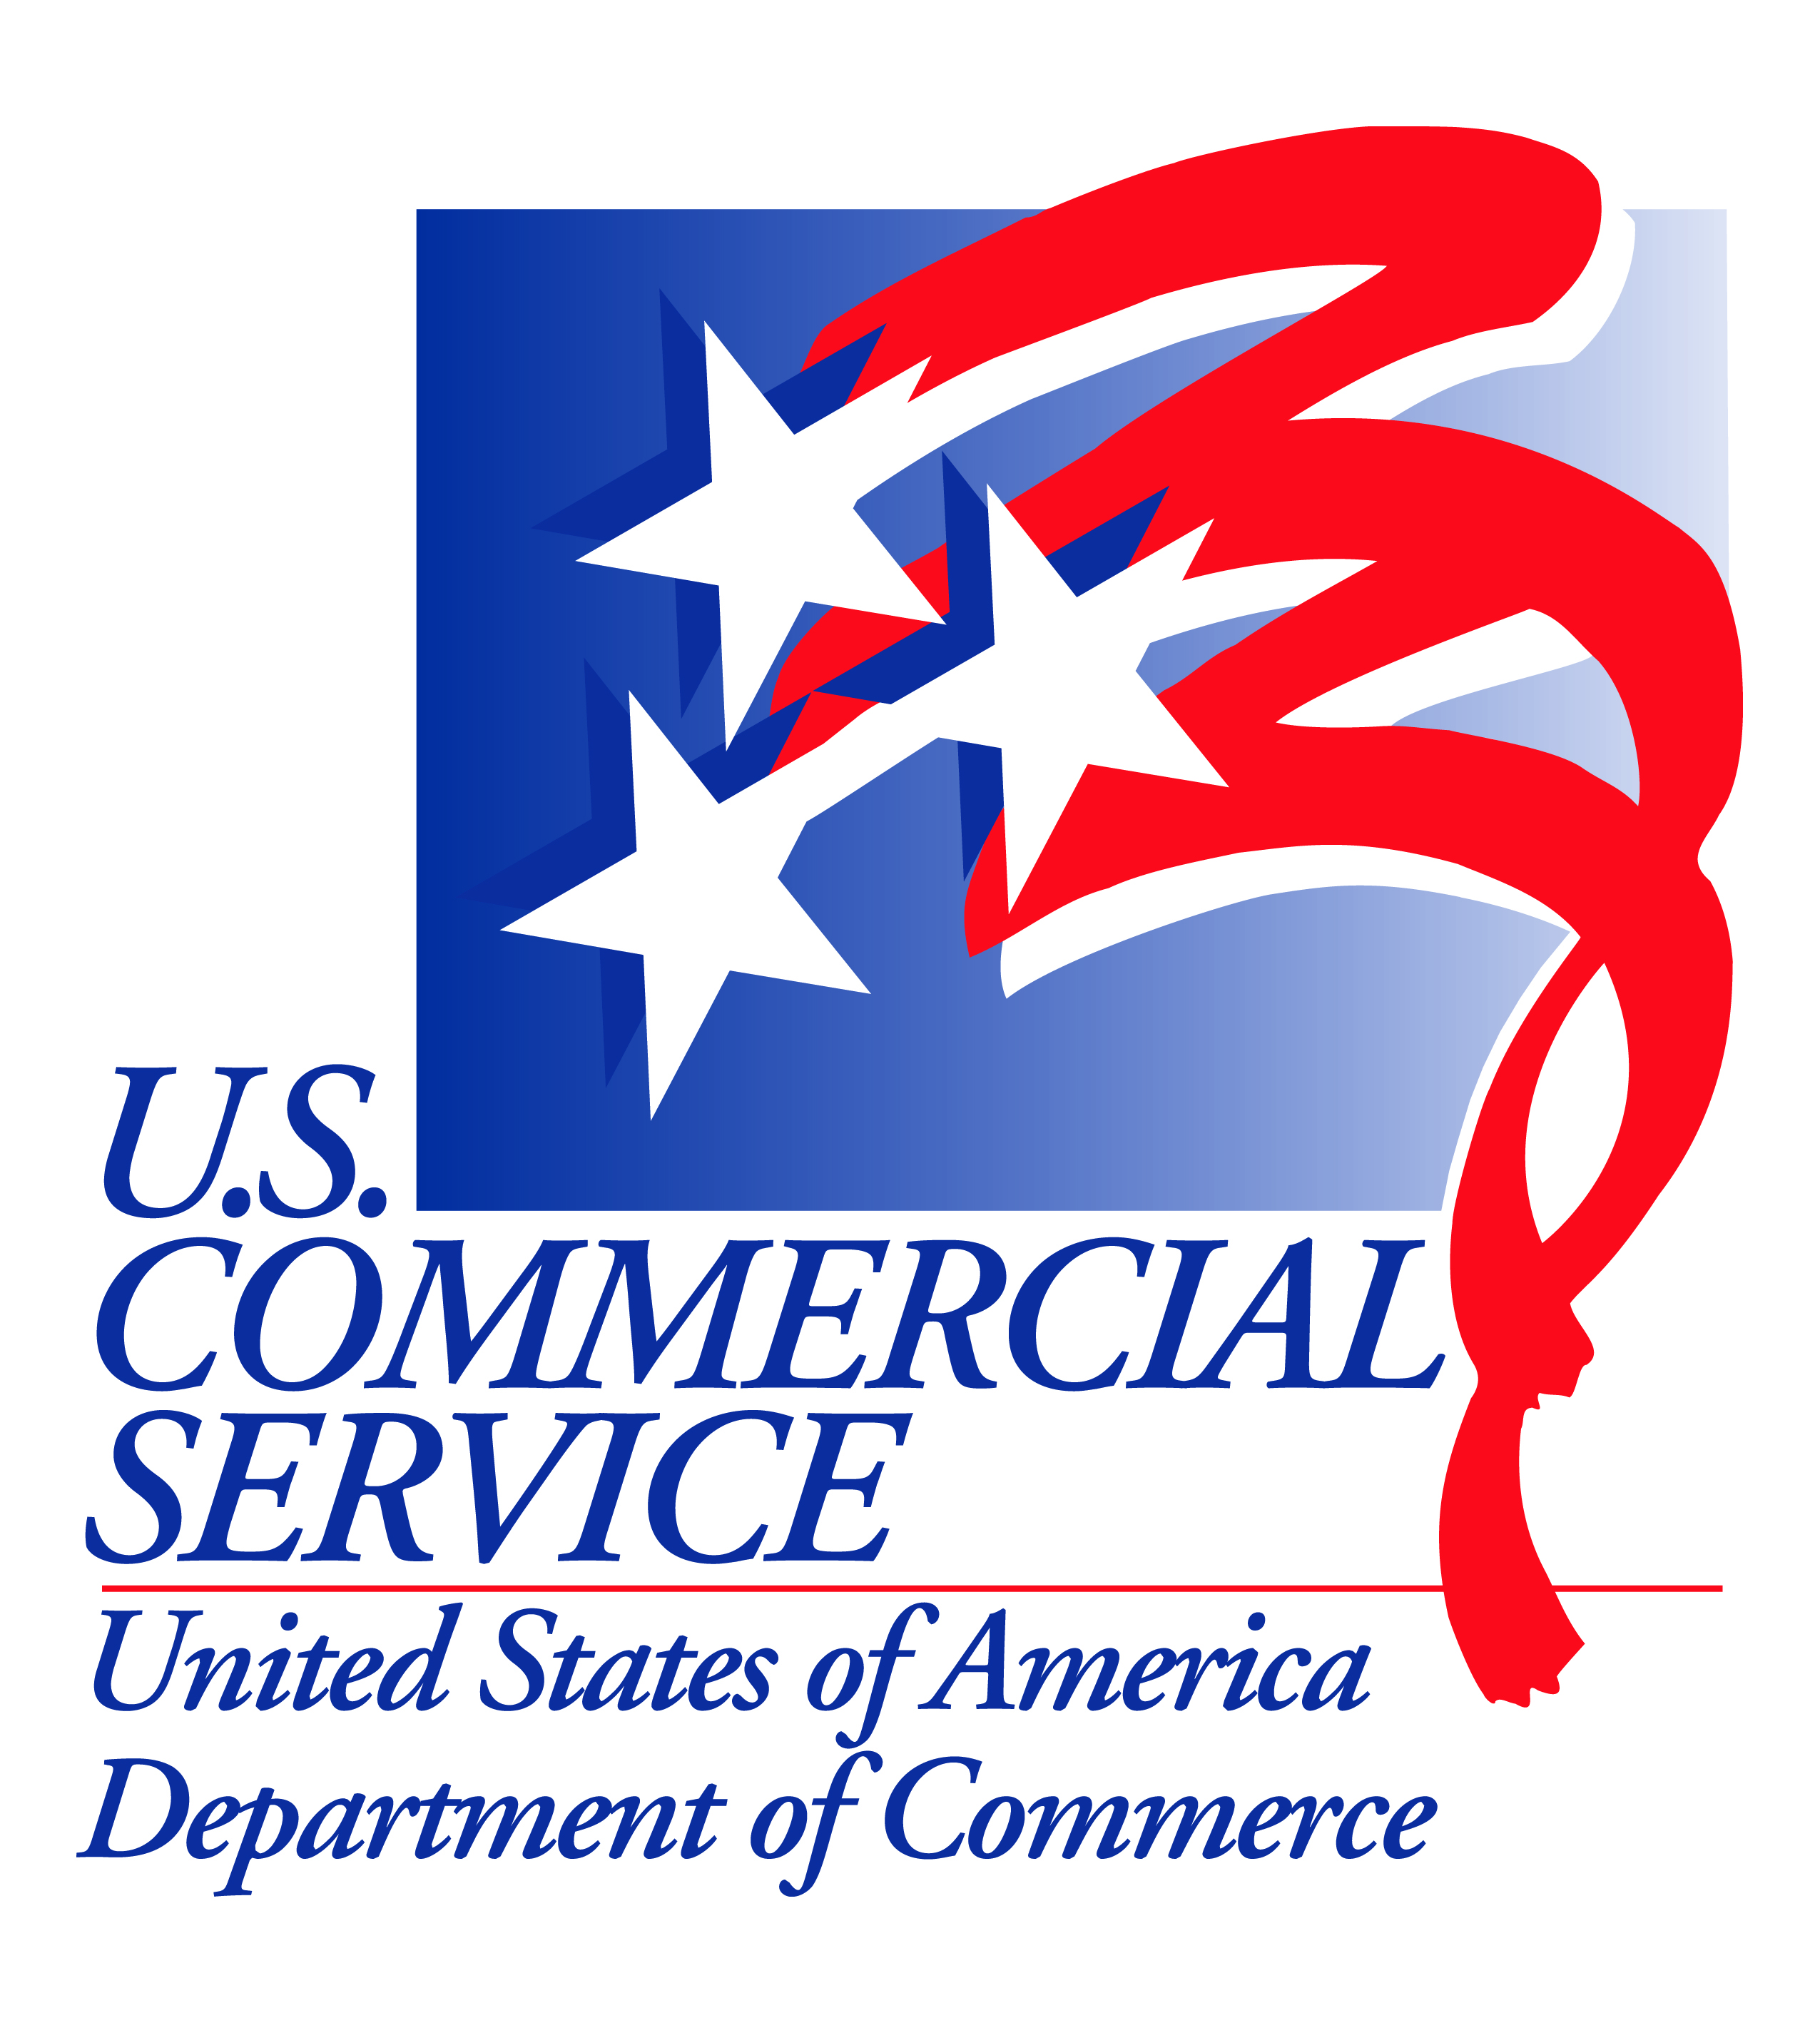

*w w w . s t a n d a r d s p o r t a l . o r g / u s - c h i n a s c c p*