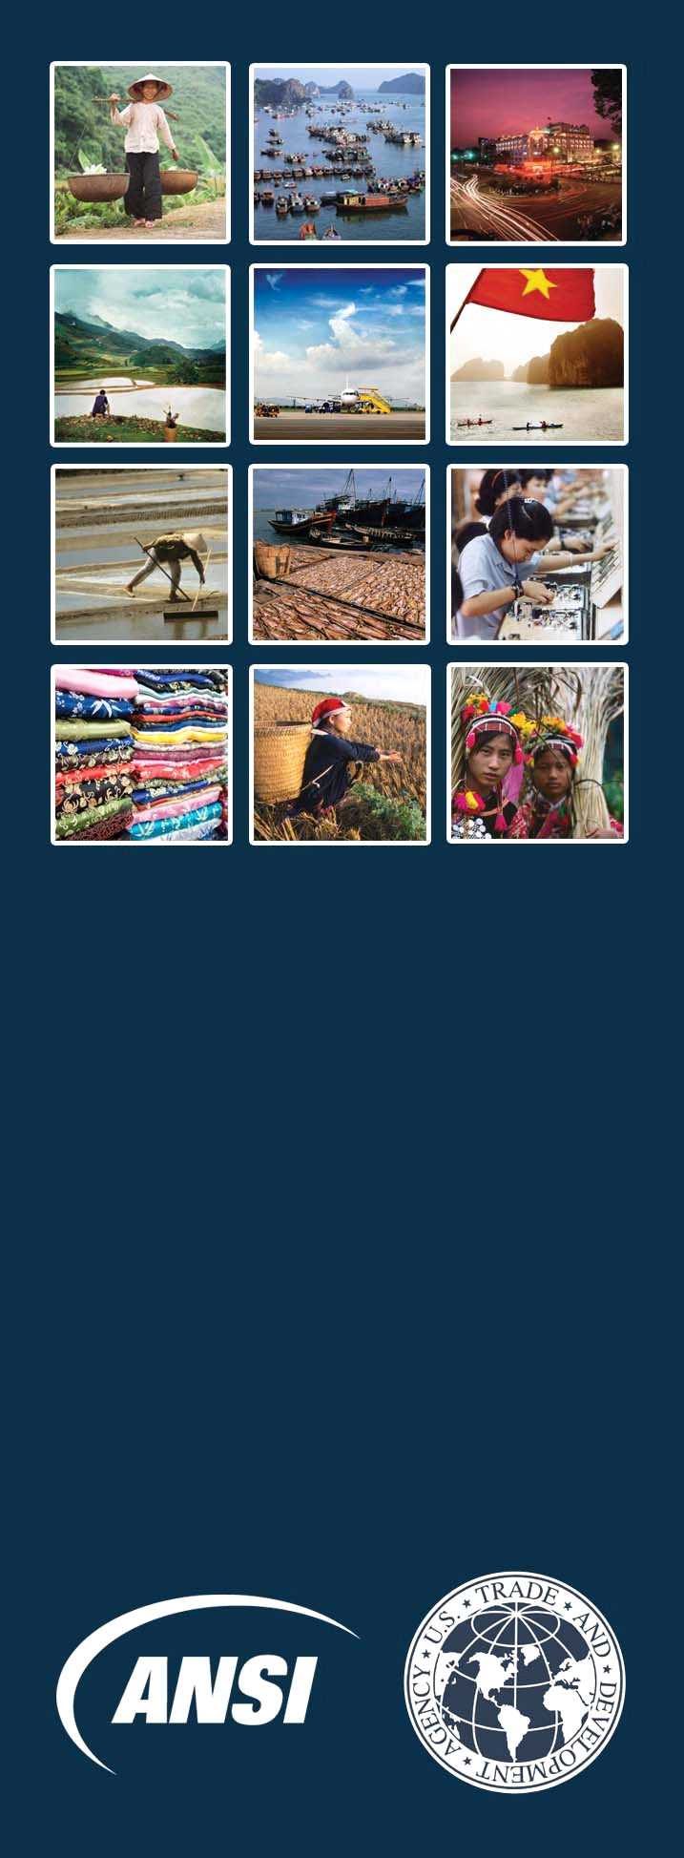

U.S. - Vietnam
Standards Training Program
(VSTP)

FINAL REPORT
Produced through cooperation between
The American National Standards Institute (ANSI)
and
The Vietnam Directorate for Standards and Quality (STAMEQ)
Under Sponsorship
of the United States Trade and Development Agency (USTDA).
July 15, 2009
All rights reserved.

FINAL REPORT
For the
U.S. Vietnam Standards Training Program (VSTP)
(24 September 2007 – 30 April 2009)
Project No. USTDA-2007-31005B

Submitted to:
U.S. Trade and Development Agency (USTDA)
1000 Wilson Boulevard, Suite 1600
Arlington, VA 22209-3901

Prepared by:
The American National Standards Institute (ANSI)
1819 L Street, NW, Suite 600
Washington, DC 20036-3807

This report was funded by the U.S. Trade and Development Agency (USTDA), an export promotion agency of the United States Government. The opinions, findings, conclusions, or recommendations expressed in this document are those of the author(s) and do not necessarily represent the official position or policies of USTDA. USTDA makes no representation about, nor does it accept responsibility for, the accuracy or completeness of the information contained in this report.

1000 Wilson Boulevard • Suite 1600, Arlington VA 22209-3901
Phone: 703-875-4357 • Fax 703-875-4009 • Web site: www.ustda.gov • email: info@ustda.gov

The U.S. Trade and Development Agency
The U.S. Trade and Development Agency (USTDA) advances economic development and U.S. commercial interests in developing and middle income countries. The agency funds various forms of technical assistance, feasibility studies, training, orientation visits and business workshops that support the development of a modern infrastructure and a fair and open trading environment.
USTDA’s strategic use of foreign assistance funds to support sound investment policy and decision-making in host countries creates an enabling environment for trade, investment and sustainable economic development. Operating at the nexus of foreign policy and commerce, USTDA is uniquely positioned to work with U.S. firms and host countries in achieving the agency’s trade and development goals. In carrying out its mission, USTDA gives emphasis to economic sectors that may benefit from U.S. exports of goods and services.

1000 Wilson Boulevard • Suite 1600, Arlington VA 22209-3901
Phone: 703-875-4357 • Fax 703-875-4009 • Web site: www.ustda.gov • email: info@ustda.gov
Table of Contents

- Executive Summary……………………………………………………………………….7

- Summary of VSTP Approach……………………………………………………………11

- Objectives of the Program……………………….………………………………………13

  - VSTP Teaching Points……………………….………………………………………13

  - VSTP Measures of Success……………….…………………………………………19
    - Standards development (IS1)…………………………………………………….19
    - Conformity assessment (IS2)…………………………………………………….19
    - Regulatory principles (IS3)………………………………………………………20
    - WTO/TBT (IS4)………………………….………………………………………21
    - APEC (IS5)………………………………………………………………………21
    - Environmental policies (IS6)…………………………………………………….21
    - Industry perspectives (IS7)………………………………………………………22

- Program Evaluation……………………………...………………………………………23

  - Immediate-Term Indicators of Success……...………………………………………23
    - Highlights from VSTP Intermediate Report…….……………………………….23
    - Broad dissemination of VSTP information………………………………………24
    - Sustained interest in VSTP teaching points……...………………………………24
    - Vietnamese interest in follow-on training………..………………………………24
    - Continued U.S. – Vietnam engagement………….………………………………25
    - Vietnamese support for U.S. engagement in ASEAN……...……………………26

  - Longer-Term Indicators of Success…………………………….……………………27
    - Standards development……………………………………..……………………27
    - Conformity assessment……………………………………..……………………27
    - Regulatory principles……………………………………….……………………28
    - WTO/TBT…………………………………………………..……………………30
    - APEC……………………………………………………….……………………31
    - Environmental policies and industry perspectives……………………………….31

- Recommendations for Follow-Up Actions………………………………………………33

- List of Appendices……………………………………………………….........................35

Appendix 1: Immediate-Term Accomplishments.…………………………………………37
Appendix 2: Longer-Term Indicators of Success….………………………………………41
Appendix 3: List of VSTP Participants ………………………….………………………..43
Appendix 4: VSTP Instructors’ Biographies………………………………………………45
Appendix 5: Agendas for Virtual Sessions………………………………………………..55
Appendix 6: Agenda for Intensive Sessions ………………………………………………59
Appendix 7: Intensive Session Course Overviews and Teaching Points……………….…61
Appendix 8: List of Intensive Session Training Materials..………………………………69
Appendix 9: Student Questions and Comments from Intensive Session...…………..…….79
Appendix 10: Overview of Private Sector Panel……..……………………………………89
Appendix 11: Data from Intensive Session Questionnaires……………………………….95
Appendix 12: Summary of VSTP Follow-up Interviews…………………………………101
Appendix 13: Data from Final VSTP Participant Survey………………………………….109
Appendix 14: U.S. Company Testimonials………………………………………………125
Appendix 15: Summary of Vietnamese Requests for Follow-up Training……………...127
Appendix 16: Reference Glossary of Standards and Conformance Terms………………131
Appendix 17: Standards and Conformance Acronyms……...……………………………..135

Executive Summary

“Our experience doing business around the world has shown that knowing the right leader to talk to, and having a positive relationship with key leaders is a key factor in enabling companies to address potential issues or concerns before they become trade barriers…Over the period during which the VSTP has been implemented, Caterpillar’s export business continues to benefit from its [Vietnam’s] progressive policy changes for a more open economy.”
-Dan Roley, Director of Standards and Regulations, Caterpillar

“Technology and business model neutrality and effectiveness of national standardization policies around the world directly impact our ability to do business internationally, and proactive engagement with governments and other stakeholders in standardization is critical to ensuring our ongoing ability to do business. We appreciated that the Vietnam Standards Training Program (VSTP) addressed ways for Vietnam to further open its trade to American companies.”
-Kent Baker, Vice President, Standards and IPR, Government Affairs, QUALCOMM Inc.

The U.S. Vietnam Standards Training Program (VSTP) was designed and implemented by the American National Standards Institute (ANSI) with the goal of improving and strengthening the operation of Vietnam’s existing regulatory and standards regime, while considering U.S. private sector interests. Given Vietnam’s considerable market-driven economic reforms and recent accession to the World Trade Organization, the program was implemented at a significant point in the development of the U.S.-Vietnam trade relationship. The U.S. Trade and Development Agency (USTDA) awarded a contract to implement VSTP to the American National Standards Institute (ANSI) on September 13, 2007 as project number USTDA-2007-31005B.

ANSI and USTDA were committed to achieving measurable successes from the training and realizing a tangible impact on Vietnam’s standards and regulatory policy-making process. Toward that end, specific goals for the desired outcomes of the VSTP were identified at the start of the program, the topics and teaching points of each training session were carefully developed, measures of success for both the immediate and longer terms were identified, and evaluation mechanisms such as participant quizzes, surveys, and interviews were employed to gauge the success of the training. Based on these evaluations, ANSI has observed a high degree of success for immediate term indicators, and has already observed significant progress toward longer term goals of the program. The VSTP should be considered a successful program, both in its efforts to achieve USTDA’s goals, and the technical assistance provided to Vietnam.

The training was conducted in several phases: Virtual Sessions (VS), conducted via digital video conference between Hanoi, Vietnam and Washington, DC in January 2008; Intensive Sessions (IS), conducted in classroom format in Hanoi in March 2008; Train-the-Trainer (T3) Sessions conducted in Hanoi in April 2008; and the follow-up sessions. Following the training, ANSI evaluated the effectiveness of the sessions at multiple stages. Follow-up interviews were conducted in Vietnam in September 2008, and surveys were distributed and completed by participants approximately twelve months after the conclusion of training. All of these mechanisms, as well as ANSI’s interaction with government and private sector stakeholders in both the U.S. and Vietnam have helped ANSI identify specific immediate and longer-term indicators of the success of the VSTP. Additional information on the VSTP approach is outlined in Section B of this report.

At the outset of the program, ANSI and USTDA identified two mechanisms to evaluate the success of the VSTP: a set of teaching points for each topic covered in VSTP Intensive Sessions (IS), against which VSTP student comprehension would be measured; and a set of “Measures of Success” for the VSTP program that outline policy changes and developments in Vietnam that could be facilitated by comprehension of the teaching points and that would increase U.S. access to the Vietnamese market. These mechanisms are outlined in greater detail in Section C of this report.

Questionnaires administered at the conclusion of the IS showed that students obtained had high degree of comprehension of VSTP teaching points (students had an average of over 90% correct answers on the final examination). ANSI credits VSTP students’ strong performance to a high degree of commitment to the VSTP on the part of the Vietnamese Grantee, strong participation and interaction from VSTP students, and a high degree of U.S. expert participation in VSTP instruction (over 25 experts from the U.S. government and private sectors participated in IS training).

Following the conclusion of the IS, ANSI observed short-term indicators of success that demonstrated that comprehension of the teaching points would be translated into positive action. For example, Vietnamese participation in VSTP follow-up sessions was even stronger than in IS courses. A significant number of VSTP students volunteered to become T3 students and committed to passing along VSTP teaching points to other Vietnamese government and industry stakeholders. Finally, the VSTP maintained high visibility and continued to be an important priority area for STAMEQ and other agencies, and there were several requests for follow-on training that would build off of the VSTP.

Since the completion of VSTP instruction, ANSI has also observed significant progress toward the Measures of Success (including longer-term indicators of success that were outlined in the VSTP Intermediate Report), which include developments such as harmonization of Vietnamese standards to globally relevant international standards, acceptance of testing and certification completed by competent private-sector conformity assessment bodies, and notification of proposed technical regulations to the World Trade Organization (WTO) Secretariat as required by the WTO Technical Barriers to Trade (TBT) Agreement.

In the area of standards development, Vietnam has continued to adopt international standards (including standards from ISO and IEC, as well as from ASTM International and possibly others), and databases of Vietnamese standards are now accessible online through STAMEQ’s website. In addition, feedback from STAMEQ and other agencies have indicated a strong interest in moving toward a more market-driven standards system in Vietnam, and in encouraging more industry participation, which will encourage the development of standards that meet industry needs and support global trade.

In the area of conformity assessment, a major success was observed in July 2009 when Vietnam notified the WTO of a proposed technical regulation for the safety of electrical and electronic equipment. The notification is the first of its kind in Vietnam, and indicates that certificates of conformity issued by accredited private sector conformity assessment bodies will be accepted to demonstrate compliance with the regulation. This approach will eliminate duplicative testing requirements for U.S. companies exporting products to Vietnam.

Regulatory principles such as encouraging transparency and reducing negative impact on trade were an important focus of VSTP training. Successes witnessed thus far have included indication that STAMEQ will finalize a new law containing a consistent definition for “technical regulation” based on WTO criteria. In addition, Vietnam has begun notifying new and amended technical regulations to the WTO Secretariat, and has expressed willingness to address comments. All of the proposed regulations notified to the WTO by Vietnam have referenced voluntary consensus standards.

Related to good regulatory practice is compliance with WTO/Technical Barriers to Trade (TBT) requirements. As mentioned above, Vietnam has begun notifying the WTO of proposed technical regulations. In addition, representatives of Vietnam’s WTO/TBT Enquiry Point have started carrying out training for other government agencies and industry to increase understanding of WTO/TBT requirements.

In the area of effective participation in the Asia Pacific Economic Cooperation (APEC) and the APEC Sub-Committee on Standards and Conformance (SCSC), Vietnam has consistently attended and participated in meetings of the APEC/SCSC. In August 2009, Vietnam and the U.S. will co-sponsor and carry out a workshop to discuss APEC interaction with the business community, which was originally proposed by Vietnam.

Finally, with respect to industry perspectives, STAMEQ has proactively sought input from U.S. industry on some of its recent proposed technical regulations. ANSI has also received feedback from the International Trade Administration (ITA) of the U.S. Department of Commerce (DOC) that U.S. company concerns related to standards, conformity assessment and technical regulations in Vietnam have been stable.

Based on all of the immediate and longer-term indicators identified and described in this Final Report, ANSI is confident that positive developments will continue to be observed in Vietnam. ANSI has provided recommendations for follow-up activities that will build upon the foundation of knowledge provided during VSTP and that will continue to strengthen Vietnam’s capacity to implement a transparent, open and consensus-based standards and regulatory system. These are outlined in greater detail in Section E of this report, and include future training programs in Vietnam that build upon the VSTP and the application of the VSTP approach to other emerging markets.

“VSTP training materials are like a dictionary and reference for us; we use them all the time.”
– Ba Tran Thien Thuy, QUACERT

B. Summary of VSTP Approach

The Vietnam Standards Training Program (VSTP) was designed to help the Government of Vietnam meet its WTO obligations and to implement a transparent, open and consensus-based standards and regulatory system that incorporates international practices and facilitates trade. The Program focused on key topics such as the development and application of standards, conformity assessment (e.g. testing, certification, inspection, etc.), good regulatory practice, WTO compliance, and effective engagement in the Asia Pacific Economic Cooperation (APEC), and consideration of industry perspectives.

In order to help the participants internalize the teaching material, and apply it in their ensuing job responsibilities, ANSI designed the VSTP as a facilitated opportunity for participants to learn interactively, rather than a classroom methodology in which teachers simply deliver their materials. The training program included highly interactive discussions and lectures, sector-specific case studies and practical exercises which combine policy-making, regulatory and business practices for each of the topics presented. In developing the curriculum, ANSI carefully considered the ultimate objectives of the program, namely to develop human capacity within the public and private structures of the Vietnamese economy so that people who receive this training will not only have a strong comprehension of the VSTP teaching points, but also be prepared to translate this knowledge into action.

In total, more than 2200 person-hours of virtual sessions, classroom time and networking/ discussion time was delivered. Training was conducted by U.S. experts in collaboration with the Vietnam Directorate for Standards and Quality (STAMEQ). Representatives from U.S. companies and organizations with an interest in the Vietnamese market also participated in the training as volunteer subject matter experts to share their experiences and perspectives with Vietnamese leaders.

Training was conducted in several phases: Virtual Sessions (VS), Intensive Sessions (IS), Train-the-Trainer (T3) Sessions and the follow-up sessions. Both the IS and T3 sessions relied heavily on instructor/ participant interactive discussion, Q&A, practical exercises and case studies.

Virtual Sessions (VS) were conducted on January 15-18, 2008 as a series of three “virtual” sessions delivered via digital video conference between Hanoi, Vietnam and Washington, D.C. These two-hour courses provided a foundation of information on the current U.S. and Vietnamese approaches to standardization and highlighted the voluntary approach used in the United States.

Intensive Sessions (IS) were conducted in Hanoi in classroom format during March 10-18, 2008 at facilities provided by STAMEQ. The subjects presented in the IS sessions included Standards Development, Conformity Assessment, Regulatory Principles, World Trade Organization/ Technical Barriers to Trade, Asia Pacific Economic Cooperation (APEC), Product-focused Environmental Policies, and Industry Perspectives. At the beginning and end of each day, quizzes were administered to evaluate participants’ baseline knowledge and progress after training. A final exam was also administered at the end of the IS, and the participants with the strongest scores were invited to join the Train-the-Trainer (T3) Sessions.

Train-the-Trainer Sessions (T3) were conducted in Hanoi during April 8-10, 2008 and provided reinforcement of these subjects and pedagogical techniques for clearly presenting the subject material in local classroom settings. Participants in the T3 sessions were advised to conduct at least one training session on their own before joining the T3 follow-up.

Follow-up Sessions reinforced key teaching points from the IS, provided additional opportunities for the participants to ask questions after a period of reflection and application of the course material, and presented lectures with additional practical examples of topics covered in the IS. These lectures included detail on the ANSI Essential Requirements and the American National Standards process, a case study of public-private partnership based on the U.S. toy industry’s Toy Safety Certification Program (TSCP), and an overview of available online information resources to help stakeholders find standards and regulations for the U.S., as well as related policies.

ANSI evaluated the effectiveness of VSTP at multiple stages throughout the program. Questionnaires were administered at on each day of IS training to establish a baseline of students’ knowledge. A final questionnaire was conducted at the conclusion of IS training to evaluate students’ comprehension of all VSTP teaching points and to receive students’ feedback on the overall training approach. ANSI returned to Vietnam in September 2008 to conduct follow-up interviews with VSTP students and a survey was administered to VSTP participants approximately twelve months after the IS training.

Objectives of the Program

Establishing clear and meaningful key objectives for the program was important to USTDA and ANSI, and was first raised at the Kick-off meeting on September 24, 2007. Subsequent conference calls which included ANSI, the USTDA Commercial Officer’s Technical Representative (COTR) and USTDA’s Evaluations Department were held to discuss key objectives and explore how the outcome of VSTP might best be evaluated. Ultimately, two sets of objectives were determined: a set of teaching points for each topic covered in VSTP Intensive Sessions (IS) against which VSTP student comprehension would be measured; and a set of “Measures of Success” for the VSTP program that outline policy changes and developments in Vietnam that could be facilitated by comprehension of the teaching points and that would increase U.S. access to the Vietnamese market.

1. VSTP Teaching Points
These teaching points formed the baseline for the development of instructional material. Each Teaching Point is summarized below with reference to the principle session in which it was featured. (Please refer to Appendix 7 for additional detail on VSTP curricula)

- Standards vs. Technical Regulations: Standards are “voluntary” (i.e. not enforced by government) guidelines or characteristics for products, related processes and production methods. Technical regulations, on the other hand, are “mandatory” (i.e. enforced by government). (IS1)

- Importance of Standards: Although standards are not enforced by governments, compliance with standards is often called for by global markets: retailers generally will not purchase products that do not meet minimum standards; compliance with standards is often required to acquire insurance; non-compliance with standards can leave companies vulnerable to lawsuits and other legal recourse; etc. (IS1)

- Market-Driven Standardization: Societal and economic benefits can be gained from a market-driven standards system based on voluntary consensus in which the government and private sector work in an equal partnership to achieve shared objectives. (IS1)

- International Standards: Use of international standards facilitates international trade and is encouraged by the WTO, APEC and many other international and regional organizations. International standards can be developed by national participation organizations that function by “one country, one vote” model (e.g. ISO, IEC, etc.) or by direct participation organizations in which technical experts participate at the company or organizational level (e.g., ASTM International, ASME, SAE, IEEE etc.). (IS1)

- Vietnamese Involvement in International Standards Development: Vietnam is encouraged to increase its involvement in international standards development activities. ANSI can help Vietnamese technical experts wishing to learn more about standards development organizations and their activities in order to facilitate increased participation from Vietnam and other Southeast Asian economies. (IS1)

- Market Access vs. Market Acceptance: The rules and regulations that govern access to the marketplace do not guarantee market acceptance. Additional steps may be necessary to establish confidence in the marketplace. (IS2)

- Conformity Assessment Mechanisms: Conformity Assessment provides confidence to stakeholders (consumers, retailers, “Authorities Having Jurisdiction”, and regulators) that a product or system meets specific safety, quality, or technical requirements. The selected conformity assessment mechanism should reflect the product-specific characteristics, the level of risk reduction sought, and the resources available for conformity assessment. (IS2)

- U.S. Product Safety System: The U.S. product safety system is highly decentralized, reflecting a mix of private sector (market-based) policies and government regulations, and includes elements of market access and market acceptance needs which vary by sector. (IS2)

- Product Certification Schemes: Certain functions and elements need to be considered regardless of by what party conformity assessment is carried out. These include testing, evaluation, documentation, and certification - authorization to use and apply product marking; factory inspection; and market surveillance and corrective action to validate compliance of products in the marketplace. (IS2)

- Suppliers’ Declaration of Conformity (SDoC): A supplier’s declaration of conformity may be appropriate when the risks associated with non-conformity are low-to-moderate and market and/or regulatory mechanisms are capable of adequately addressing non-conformities. (IS2)

- Third-Party Product Certification Programs: Product Certification programs involve evaluation and testing of the product construction, initial assessment of the production process or quality system, evaluation of the test and assessment reports, a certification decision, license to use product marking, ongoing surveillance of the production process or quality system, and product surveillance by testing or inspection of samples from the factory or the open market. (IS2)

- Assessing Testing and Certification Bodies: In the U.S., ISO/IEC standards and guides define the internationally accepted criteria used to assess the capabilities of Testing and Certification Bodies. Accreditation Bodies are relied upon to assess and ensure that conformity assessment agencies meet the technical and management competency requirements in testing and certification. (IS2)

- Market Surveillance: There are two broad categories of market surveillance: pre-market and post-market. Pre-market surveillance places responsibility on the private sector to find problems with a product before it reaches the consumer; however, regulators may require some form of pre-market surveillance for particular product sectors. Post-market surveillance involves the evaluation of conformity of products once they are placed on the market. Post-market surveillance is increasingly conducted by private sector conformity assessment bodies for both private sector and regulatory needs. Regardless of the type of conformity assessment system adopted, governments often have some level of responsibility in dealing with non-compliant products in the marketplace. (IS2)

- Data-Acceptance Methods: The IECEE CB Scheme is a method of mutual recognition of test reports that simplifies certification at the national level by eliminating duplication of testing to IEC based standards. The Scheme facilitates access to the private and/or national marks of participating organizations, promotes harmonization and use of IEC standards, and places reliance on accreditation procedures for building confidence and assuring acceptance by legal and regulatory authorities as well as by private sector conformity assessment bodies. (IS2)

- Use of Standards in Regulations: The U.S. National Technology Transfer and Advancement Act (NTTAA, U.S. Public Law 104-113) and related policies such as OMB Circular A-119 are examples of policies that encourage regulators to incorporate existing standards into regulations, in lieu of developing government-unique technical requirements. This practice facilitates trade and advances regulatory objectives. (IS3)

- Private-Sector Delivery of Conformity Assessment Procedures: Increasingly, U.S. regulators administer their accreditation and/or certification and testing responsibilities by using qualified and approved private-sector conformity assessment organizations. This allows regulators to accommodate the growing volume of products and services on the market while also encouraging compliance and efficiency for manufacturers. (IS3)

- Public-Private Communication: U.S. regulators maintain regular communication with the private sector and have processes in place to encourage continuous reporting and information exchange. As a result of this practice, compliance problems can be detected and addressed early, reducing threats to public safety and the need for excessive punishment for manufacturers that proactively work with regulators to address issues. (IS3)

- Transparency: U.S. regulators are required to follow an open and transparent process; The Code of Federal Regulations (CFR) and the Federal Register (FR) are used to ensure that relevant information is consistently available to all stakeholders in a central data source. (IS3)

- Stakeholder Input: The U.S. system provides regulators with a clear process to gather, review and address comments submitted by U.S. industry and other stakeholders. Once a regulation is adopted, companies are given reasonable notice and ample time to incorporate any new requirements into their manufacturing and business processes and to address any concerns or obstacles associated with compliance, before regulations go into effect. (IS3)

- Cost/Benefit Analysis: The use of cost/benefit analysis ensures that proposed regulations are introduced only when voluntary mechanisms alone will not address environment, health and safety (EHS) concerns and when it has been demonstrated that the proposed regulations will effectively meet their purpose. This practice encourages the use of regulations that can be enforced evenly on domestic and foreign industry. (IS3)

- Interagency Coordination: Regular communication and coordination efforts between regulatory bodies (i.e., government agencies) help to avoid overlap or duplication in regulations, and ensure that critical areas related to EHS are not overlooked. (IS3)

- Core Objectives: The WTO Technical Barriers to Trade Agreement (TBT) ensures that technical regulations and conformity assessment procedures are not prepared, adopted, or applied with the effect of creating unnecessary obstacles to trade. (IS4)

- Legitimate Regulatory Objectives: Legitimate objectives for technical regulations are recognized, including national security requirements, prevention of deceptive practices (such as misleading labeling), and the protection of human health/safety, animal or plant life/health, and the environment. (IS4)

- Non-Discrimination: Discriminatory regulatory practices designed to protect domestic industry, or to treat the industry of one nation differently than the industry of another nation are discouraged. (IS4)

- International Standards: Harmonization of technical regulations is encouraged by calling on WTO members to use international standards “as a basis” of technical regulations unless they are “ineffective or inappropriate.” (IS4)

- Performance vs. Design: Wherever possible, performance-based approaches are encouraged. Design-based approaches are discouraged. (IS4)

- Conformity Assessment Procedures: Conformity assessment procedures should be nondiscriminatory and should not create unnecessary obstacles to trade. (IS4)

- Transparency: WTO members establish and maintain national enquiry points, notify and provide copies of draft regulations and conformity assessment procedures, allow for a comment period and take written comments into account in their final regulations. (IS4)

- Bottom-up Approach: APEC has adopted a bottom-up approach to standards, conformity assessment and technical regulations, aiming for the development of a single (and open) global market, rather than a single regional internal market. The APEC approach facilitates trade within (and to and from) the region, supports innovation, and allows each economy to converge toward common standards (e.g. the “one standard, one test, accepted everywhere” or 1:1:1 model) at a pace appropriate for their level of economic development as well as for their industries, consumers, governments and other stakeholders. (IS5)

- APEC SCSC: The APEC Sub-Committee on Standards and Conformance (SCSC) supports APEC's trade and investment liberalization and facilitation agenda by reducing the negative effects that differing standards and conformity assessment requirements in the region can have on trade and investment flows. (IS5)

- Cooperation in SCSC: The SCSC supports several areas of cooperation including trade facilitation work, good regulatory practice (GRP) initiatives and a standardization education project. (IS5)

- Proposed Interaction with Business Initiative: Vietnam has proposed (and the U.S. has co-sponsored) a workshop on improved interaction between the business, standards, and conformity assessment communities to be held in 2009. (IS5)

- Future Opportunities: The U.S. and Vietnam should continue to consider how the APEC structure can be further leveraged to increase bilateral cooperation and to support international trade. For example, can any of the APEC work also be tied into work Vietnam undertakes as part of its membership in the Association for Southeast Asian Nations (ASEAN), particularly given the U.S.-ASEAN Enhanced Partnership? (IS5)

- Environmental Regulation Impact on Product Lifecycle: There are many different types of product-targeted environmental regulation. Each regulation type impacts a product differently and must be reviewed as to both how and when during the lifecycle compliance can be achieved as part of a holistic approach to improved environmental performance. (IS6)

- Supply Chain Impact: Most products, and therefore their supply chains, were not designed using environmental performance as a key set of metrics. Companies which try to overlay inappropriate metrics for environmental performance on current supply chains often find that the results are not satisfactory while being very costly. (IS6)

- Compliance Process: Companies must take a coherent, budgeted approach to compliance, and this can take time. Regulators must understand that in many cases, environmental regulation is in fact trying to change fundamental characteristics of how companies operate. Therefore, the actual regulation must allow for the necessary timeframes to change how businesses and industries operate in order to achieve the results desired. If they do not, and if they do not work closely with industry during the development of regulations, the costs of compliance can be very high and the results achieved can be suboptimal. (IS6)

- Harmonized Regulations, Harmonized Standards: Many industries, including electronics, tend to make products that are easily configurable for sale throughout the world. This requires internationally harmonized standards and regulations that maximize commonality and minimize costs, facilitating trade and market access for the U.S. and other countries. (IS6)

- Successful Environmental Standards: Characteristics of successful environmental standards include bottom-up development, strong and credible management, inclusion of a broad constituency, evidence of need, the prospect of a real and meaningful impact, and a real market. (IS6)

- Closer Partnership Between Industry, Standards Organizations, NGOs, and Government: With big opportunities come big challenges. Having all stakeholders working together on setting the goals and working on what can be achieved through regulation and voluntary standards will help produce the desired change. (IS6)

2. Measures of Success
In November 2007, ANSI outlined desired policy changes and developments in Vietnam that would show that Vietnam has translated comprehension of the teaching points into action. These policy changes were discussed with USTDA and ultimately became the VSTP “Measures of Success”. Progress toward the Measures of Success would reduce barriers for U.S. exports to Vietnam, and would be expected in the five-year period following the VSTP. The Measures of Success are organized according to the principle session in which they were covered, and are outlined below. ANSI’s evaluation of progress toward the Measures of Success is outlined later in this report (please refer to Section D: Program Evaluation).

a. Standards Development (IS1)
Demonstrate the benefits of a bottom-up, market-driven standards system that embraces the core principles of international standards, openness, transparency, consensus and due process. This will help U.S. industry by ensuring that Vietnam considers and accepts all of the international standards used by U.S. industry (not just those developed by ISO and IEC), ensuring that the U.S. has a voice in the development of Vietnamese standards and standards policies, facilitating the end goal of harmonization.

Measures of success in the area of standards development include:
- Harmonization of Vietnamese standards to globally relevant international standards wherever practicable. Develop Vietnamese-unique, “home-grown” standards only as a last resort.
- Official and/or legal recognition of “international standards” to include standards that meet the principles for international standards development outlined in a document called “The Decisions and Recommendations adopted by the TBT Committee since 1 January 1995 (G/TBT/1/Rev.8, 23 May 2002 Section IX” (G/TBT/1/Rev.8.)
- In some cases, Vietnamese industry may not be able to meet international standards, and may need to temporarily maintain Vietnamese-unique standards. In such cases, Vietnam should have a plan to “phase in” international standards within a set time frame, and should accept international standards as equivalent to the corresponding national standards in the mean time.
- In cases where Vietnam-unique standards are developed, Vietnam should follow the ANSI essential requirements for standards development (openness, transparency, due process, balance, etc.).

b. Conformity Assessment (IS2)
Encourage a flexible, risk-based approach to conformity assessment in Vietnam (i.e. more rigid requirements for high-risk products and less rigid requirements for low-risk products) that relies on mutual acceptance of conformity assessment results through international agreements and on conformity assessment activities carried out by competent private sector bodies. This will help U.S. industry by eliminating duplicative testing and unnecessarily complex testing and certification requirements.

Measures of success in the area of conformity assessment include:
- Adapt conformity assessment requirements and procedures to the characteristics of individual industry sectors and the associated risks of specific products.
- Provide equal access to the Vietnamese market for all conformity assessment bodies, both foreign and domestic. Ensure that criteria for conformity assessment bodies are open, transparent and based on applicable international standards.
- Accept testing and certification completed by competent private-sector conformity assessment bodies both for regulatory functions and private sector conformity assessment needs.
- Consider accepting Suppliers’ Declaration of Conformity (SDoC) for appropriate product sectors.
- Join the IECEE/CB Scheme and other IEC conformity assessment schemes (accept IECEE test results in the mean time).

c. Regulatory Principles (IS3)
Adopt and implement a U.S.-style Administrative Procedures Act in Vietnam that requires interagency coordination and transparency for regulatory activities. This will help U.S. industry by ensuring that industry understands and is able to influence Vietnamese technical regulations, and encouraging Vietnamese regulators to adhere to international practices for regulations.

Measures of success related to regulatory principles include:
- Adopt a consistent and accepted definition, based on the definition outlined by the WTO/ TBT Agreement, for what constitutes a “technical regulation”.
- Develop and implement a comprehensive Vietnamese Code of Federal Regulations (CFR) and Federal Register (FR) mechanism.
- Develop and implement procedures to consider and address stakeholder input on proposed regulations.
- Implement cost/benefit analysis for all proposed technical regulations.
- Ensure effective enforcement for all technical regulations. Enforcement should be consistent for domestic and foreign companies.
- Develop and implement polices allowing Vietnamese regulators to use voluntary consensus standards as a foundation for their regulations, e.g. the National Technology Transfer and Advancement Act (NTTAA, U.S. Public Law 104-113).

d. World Trade Organization / Technical Barriers to Trade (IS4)
Facilitate Vietnamese policy makers’ understanding of and adherence to Vietnam’s WTO obligations. This will help U.S. industry by eliminating Vietnamese technical regulations that are more trade restrictive than necessary and by creating a key partner for the U.S. in the WTO.

Measures of success related to the WTO/TBT Agreement include:
- Consistently notify the WTO Secretariat for proposed Vietnamese technical regulations that would significantly affect trade.
- Develop and implement procedures to disseminate WTO notifications and other TBT-related information to Vietnamese stakeholders.
- Develop and implement procedures to collect broad Vietnamese stakeholder input to support the development of Vietnamese positions in the WTO/TBT Committee.
- Provide a clear understanding of WTO/TBT requirements among Vietnamese trade agencies, standards officials, regulators and industry.

e. Asia Pacific Economic Cooperation (IS5)
Maximize U.S. – Vietnam cooperation in APEC. This will help U.S. industry by solidifying a key partner in ensuring that policies in APEC related to standards, conformity assessment, and technical regulations facilitate trade and advance industry’s interests in the region.

Measures of success related to APEC include:
- Develop and implement procedures to coordinate broad Vietnamese industry input, support and participation in the APEC Sub-Committee on Standards and Conformance (SCSC), as well as the in the Pacific Area Standards Congress (PASC), the APEC Specialist Regional Body (SRB) for standardization.
- Reinforce the bottom-up, decentralized cooperative model approach embraced by APEC.
- Encourage Vietnam-U.S. cooperation on project proposals in the APEC-SCSC and other relevant APEC fora.

f. Product-Focused Environmental Policies (IS6)
Demonstrate the broad implications of environmental policies and encourage Government of Vietnam (GVN) officials to rely on private sector mechanisms to protect the environment (e.g. voluntary standards, non-regulatory programs, private sector conformity assessment) wherever possible. This will help U.S. industry by encouraging Vietnamese policies that protect the environment without unnecessarily hindering U.S. access to the Vietnamese market.

Measures of success related to product-focused environmental policies include:
- Understanding and consideration of potential supply-chain-wide impact of environmental regulations targeted at end-user (consumer/business) products on the part of Vietnamese policy makers.
- Understanding of how voluntary programs can support product-focused environmental policies; Vietnamese reliance on such programs in lieu of mandatory regulations wherever possible.
- Use of applicable international standards (e.g. IEC, ASTM International, IPC, etc.) as a foundation for voluntary and mandatory chemical management programs and the potential impact of regulating without the support of standards.
- Use and acceptance of private sector conformity assessment for voluntary and mandatory product-focused environmental management programs.

g. Industry Perspectives (IS7)
Amplify the voice and impact of U.S. industry in the GVN standards, conformity assessment, and technical regulations policy development. This will help U.S. companies by ensuring that U.S. access to the Vietnamese market is not unnecessarily impacted through policies that do not take into consideration industry perspectives.

Measures of success related to industry perspectives include:
- Help GVN officials understand the impact (positive or negative) of SCATR policies on trade and on U.S. industry.
- Help GVN officials to see U.S. industry as a cooperative partner that can help advance common objectives of facilitating trade and protecting the environment, health and safety (EHS).
- Highlight current or potential U.S. industry concerns in a neutral, cooperative forum.
- Establish linkages between U.S. industry panelists and GVN officials.
- Encourage GVN willingness to seek out and/or consider input from U.S. industry on current and proposed SCATR policies.

D. Program Evaluation

The VSTP may be considered highly successful in that the program objectives were met, and significant positive impact is measurable with regard to both short and long term indicators. The program has shown and will continue to show tangible benefits for the U.S.–Vietnam trading relationship. The training covered foundational concepts that will continue to influence the policy development process in Vietnam in the future. Through the virtual and intensive training sessions described below, Vietnamese participants developed and improved their familiarity with various aspects of the U.S. approach to standards and technical regulations. This will allow companies in both countries to have consistent understanding of key concepts related to standards and conformance and therefore be better equipped to engage cooperatively to avoid trade issues, and to effectively address challenges if they do they arise.

The relationship-building effects of the VSTP are equally important to the capacity building accomplished through the training. By utilizing the strengthened relationship with the U.S. standards and conformance community, Vietnam has already started to engage more effectively in international fora such as the International Organization for Standardization (ISO), the World Trade Organization (WTO) and the Asia Pacific Economic Cooperation (APEC). In addition, the goodwill the Vietnamese have shown U.S. standards and conformance stakeholders as a result of the training has already been manifested via support for U.S. goals and positions in strategic areas such as ISO and the Association of South East Asian Nations (ASEAN). The following section lays out immediate- and longer-term indicators of success for the VSTP.

1. Immediate-Term Indicators of Success
The following section highlights indicators of success from the VSTP Intermediate Report, and outlines additional immediate-term indicators of success that have been observed through follow-up VSTP interviews, the final VSTP survey, and other interaction.

Highlights from VSTP Intermediate Report
The VSTP Intermediate Report, submitted to USTDA on June 16, 2008, outlined indicators of successes that were observed between December 2007 and May 2008. These indicators are summarized below and outlined in full detail in Appendix 1:

- Excellent comprehension of VSTP teaching points. Questionnaires on key teaching points were administered at the beginning of each day of VSTP Intensive Sessions (IS). The rate of questions answered correctly at the beginning of the training sessions had significantly increased at the end of the IS. VSTP students averaged 90% correct answers in a final exam that was administered at the conclusion of the IS, and covered the key teaching points. (please see Appendix 11 for more information)
- Strong Participation: One reason for the high comprehension level among VSTP participants can be explained by strong participation and interaction in VSTP training sessions. Over 120 Vietnamese and 28 U.S. representatives participated in the VSTP, with an average of 35 Vietnamese students attending each day of the Intensive Sessions and an increase in attendance at the Intensive Follow-up sessions. Over 10% of IS participants volunteered to become Train-the-Trainer (T3) instructors, and 85% (12 of 14) of those actually attended each of the T3 training sessions. Vietnamese students demonstrated curiosity in the key teaching points and were very engaged in all classroom activities and discussions (please refer to Appendix 9 for a summary of questions from VSTP students). U.S. instructors and volunteers were also very engaged in training sessions, participating in discussions and activities along side Vietnamese students.
- High visibility for VSTP: VSTP attracted positive press coverage in Vietnam and in the South Asia region. This included an interview of Mr. Steven Bipes, ANSI’s Director for International Policy – Regional and Bilateral Programs by the national newspaper Voice of Vietnam.

Broad dissemination of VSTP information
Over the past year, VSTP participants involved in the “Train the Trainer” sessions of the program have demonstrated their commitment to passing along knowledge acquired during the VSTP to other Vietnamese stakeholder groups. When ANSI conducted follow-up interviews in August 2008, six of the twelve T3 instructors (50%) had already performed training on VSTP subjects, using VSTP training materials. Of these, four indicated that they had conducted more than one training session. Based on these interviews, it is estimated that T3 instructors have delivered training to over 120 Vietnamese government and private sector stakeholders. (Please refer to Appendix 12 for additional information)

Sustained interest in VSTP teaching points
Follow-up interviews and the final participant survey indicate that VSTP participants continue to have a high level of interest in the subject matter presented throughout the VSTP, and that they continue to consider the training useful. Participants reported that the following subjects were particularly helpful to their work: Standards Development, Conformity Assessment, Regulatory Principles, WTO/TBT, and Product-Focused Environmental Policies. The most often cited intended training subjects were WTO/TBT, Regulatory, Standards development and Conformity Assessment. (Please refer to Appendix 12 for additional information)

Vietnamese interest in Follow-on Training
Vietnamese and U.S. stakeholders have indicated that there is significant interest in future workshops that build off the key teaching points covered in the VSTP. STAMEQ has expressed a particularly strong interest in continued programs, asking ANSI to consider a “VSTP 2” and offering to work with ANSI to find future sources of funding for such a project. Follow-up interviews show that Vietnamese participants considered the VSTP to be an important basis for understanding key principles in international best practices, but that additional practical training is needed in specific areas as they continue to apply these basic principles. Such practical training has been requested for a wide range of areas, including: risk analysis and impact assessment for technical regulations, development of cohesive standards and regulations, effective preparation for WTO/TBT meetings (including interagency coordination), implementation of the WTO/TBT and SPS commitments at the line ministry level, developing technical regulations that conform to the U.S. approach, promoting industry participation in standards development (national and international), and mechanisms for referencing voluntary consensus standards in regulations

Vietnamese participants in VSTP have also proactively sought out sector- and technology-specific training and cooperation opportunities with other U.S. organizations. For example, following a September 2008 “Standards in Trade” (SIT) workshop (outlined below), Vietnam put forward a detailed proposal for a follow-on event that advanced cooperation in specific technical areas of interest within the field of fire protection. This proposal led to a second SIT workshop that will take place in September 2009. (Please refer to Appendix 16 for additional information on Vietnam’s requests for follow-up training)

Continued U.S. – Vietnam engagement
The VSTP has supported the development and strengthening of connections between U.S. and Vietnamese stakeholders. These connections have supported continued U.S.–Vietnam engagement, as shown by the following three examples of events organized by U.S. organizations that participated in the VSTP:

- NIST Standards in Trade Workshop: In September 2008, the National Institute for Standards and Technology (NIST) organized a week-long “Standards in Trade (SIT)” workshop on fire protection and fire safety for buildings with Vietnam. The training was held at NIST’s headquarters in Gaithersburg, Maryland and covered a range of topics from relevant fire safety codes and standards to how conformity assessment is used and implemented in both the U.S. and Vietnam. Representatives from Vietnam’s Ministry of Public Security, Ministry of Construction, STAMEQ and other organizations attended the workshop. A follow-on workshop will be organized in September 2009 in Hanoi, Vietnam.
- CPSC/STAMEQ MOU and Training: In January 2008 the U.S. Consumer Product Safety Commission (CPSC) established a memorandum of understanding (MOU) with STAMEQ aimed at improving the safety of products. The MOU calls for information and technical exchanges to implement consumer safety programs, including training on the use of standards. Under the MOU, CPSC organized training sessions for over 500 Vietnamese government and industry stakeholders in March 2008 and November 2008.
- UL/QUACERT MOU and Training: In October 2008 UL opened a representative office in Vietnam and signed a significant MOU with Quality Assurance and Testing Center 3 (Quatest 3). Under the MOU, certain products tested to UL standards at UL laboratories worldwide will be considered fully compliant with local Vietnamese compulsory certification requirements. This relationship also paves the way for a larger partnership with STAMEQ, with indications that Vietnam would be open to using UL standards for areas such as fire and security products, where standards are still under development in Vietnam. UL is currently carrying out training on UL testing procedures for Quatest 3 staff.

Vietnamese support for U.S. engagement in ASEAN
As mentioned above, the training provided through VSTP has advanced the U.S.-Vietnam relationship and encouraged Vietnam’s support of the U.S. international agenda for standards and conformance. As a tangible example, a U.S. goal for some time has been to increase its engagement in ASEAN in the area of standards and conformance. The politics and policies of ASEAN play a key role in standards and conformity assessment in Vietnam and countries in Southeast Asia due to high-level commitment of governments in the region to regional integration. Challenges to increased U.S. engagement in ASEAN have included issues such as closed meetings, unclear or complex processes that are often not transparent, and other challenges.

Immediately following the VSTP IS, in April 2008, ANSI attempted to participate in a meeting of the ASEAN Consultative Committee on Standards and Quality (ACCSQ), but was unable to gain admittance. However, in August 2008, STAMEQ offered its support for ANSI’s participation and ANSI was invited to attend the meeting and give a presentation outlining possible mechanisms for coordination. Throughout the course of the preparation for and participation in the meeting, STAMEQ provided ANSI with invaluable insights into the ACCSQ process and politics, and also provided feedback on group discussions which took place after ANSI’s presentation.

ANSI’s participation in the August ACCSQ meeting and the visibility gained would likely not have been possible without the support of STAMEQ, and certainly was not possible before the VSTP.

Longer-Term Indicators of Success
This section will discuss measurements of progress over the past twelve months against the VSTP Measures of Success outlined at the beginning of the VSTP (please refer to Section C.2), and the longer-term indicators of success that were proposed in the VSTP Intermediate Report (please see Appendix 2).

Standards development
The VSTP Measures of Success and Intermediate Report outline developments such as harmonization of Vietnamese standards to international standards, establishing plans to “phase in” international standards in cases where Vietnamese industry can not meet international standards, transparency for Vietnamese national standards and related policies, and use of the “ANSI Essential Requirements” for standards development. The following section outlines progress toward these developments.

Since the conclusion of VSTP instruction, Vietnam has continued to adopt international standards (including standards from ISO, IEC, ASTM International and possibly others). U.S. participants in VSTP have indicated that they have observed Vietnam move toward plans to “phase in” international standards within a set time frame. Databases of Vietnamese standards, as well as standards from other developers of international are accessible online through the STAMEQ Information Center website (http://new.tcvninfo.org.vn/en/), where subscribers can access catalogs of Vietnamese standards, regulations and laws, and receive updates on future developments.

Interviews and interaction with STAMEQ and other agencies have also shown a strong interest in moving toward a more market-driven standards system in Vietnam, and in encouraging more participation from companies. This will encourage standards that meet the needs of industry and that support global trade. STAMEQ has indicated a commitment addressing structural and political challenges which still must be overcome to fully move toward this goal, and has indicated that it is evaluating such long-term steps as privatizing parts of STAMEQ. In the more immediate term, the VSTP training materials and teaching points are regularly used in T3 training programs, and follow-on training has been requested in areas such as engaging industry in standards development, and developing standards and processes that meet the ANSI Essential Requirements and the WTO/TBT criteria for the development of international standards.

Conformity assessment
The VSTP Measures of Success and Intermediate Report outline the importance of developments such as Vietnam joining the IECEE/CB Scheme, allowing competition among foreign qualified conformity assessment bodies, and accepting test results from qualified private sector bodies (e.g. UL, Intertek, SGS, BV, etc.) for regulatory compliance so that duplicative conformity assessment requirements can be reduced. The following section describes progress toward these developments.

Underwriters Laboratories (UL) was an active supporter of the VSTP, and dispatched five staff to participate in intensive sessions in Vietnam. UL reported that the VSTP allowed it to engage stakeholders in Vietnam and to find out more about Vietnam’s particular market needs. On October 20th, 2008 UL established a representative office in Vietnam and signed a Memorandum of Understanding (MOU) with Quality Assurance and Testing Center 3 (Quatest 3), a division of STAMEQ. Under the MOU, Quatest 3 will enter UL’s Data Acceptance Program (DAP) and becoming a CB Test Laboratory under UL. CBTLs are laboratories recognized in the CB Scheme to conduct testing and issue CB test reports in one or more product categories. Under the MOU, products under harmonized categories that have been tested and certified at UL laboratories outside Vietnam will be considered fully compliant with local Vietnamese compulsory certification requirements. This will reduce duplicative testing and certification requirements, which add significant expense and delays to market for U.S. companies exporting to Vietnam. Further, it provides access to the Vietnamese market for UL, a U.S. company with substantial global exports of testing, certification and other services. (Please refer to Appendix 15 for additional information)

In July 2009, Vietnam notified a proposed technical regulation for safety of electrical and electronic equipment (WTO/TBT/VNM/5). The notification indicates that certificates of conformity issued by accredited third-party conformity assessment bodies will be accepted to demonstrate compliance with the regulation. Leveraging international mutual recognition arrangements such as that of the International Laboratory Accreditation Cooperation (ILAC), Vietnam will recognize accreditations from Vietnam’s National Accreditation Body, or from U.S. based accreditation bodies such as ANSI, the American Association for Laboratory Accreditation (A2LA), and the National Voluntary Laboratory Accreditation Program (NVLAP) of the National Institute for Standards and Technology among others. Because this proposed regulation is based on Vietnamese standards, and equivalent to international standards, this approach will allow U.S. companies to apply testing and certification results they have already obtained to meet U.S. requirements, rather than being required to re-test and re-certify their products in Vietnamese facilities.

Regulatory Principles
One of the most important areas or focus for the VSTP was to encourage technical regulations in Vietnam that meet the criteria laid out in the WTO/TBT agreement, including transparency and achieving of legitimate objectives (protection of environment, health, safety and national security) without unnecessarily impacting trade. The following section outlines specific criteria to demonstrate Vietnam’s progress toward this goal, and progress that has been made:

WTO-Consistent Definition for “Technical Regulations”: The Measures of Success and Intermediate Report mentioned having Vietnam adopt a WTO/TBT-consistent definition for what constitutes a technical regulation as an important step toward these goals. In the final VSTP survey, U.S. participants indicated that they have observed Vietnam move toward adopting a WTO-consistent definition for what constitutes a “technical regulation. STAMEQ is prepared to finalize a new law on technical regulations in the near future and ANSI anticipates that the new law will provide a consistent definition for “technical regulation” based on the WTO/TBT criteria. STAMEQ has requested training and consultation that could assist in aligning the law more closely with the U.S. approach.

Transparency for Technical Regulations: The Measures of Success and Intermediate report identified increased transparency for technical regulations as an important goal of the VSTP, as evidenced by developments such as: notification of new and amended technical regulations to the WTO Secretariat, encouraging stakeholder involvement and comment and proposed drafts, putting procedures in place to consider and address stakeholder input, and addressing stakeholder comments and questions in writing. Following the VSTP instructional sessions, STAMEQ strengthened the “Vietnam TBT Network” which is coordinated by Vietnam’s WTO/TBT Enquiry Point at STAMEQ and includes “Ministerial-level TBT Notification Authorities and Enquiry Points” at Vietnamese line ministries of Industry and Trade, Construction, Labor, War Invalids and Social Affairs, Natural Resources and Environment, Transport, Agriculture and Rural Development, Information and Communications, Health; and “Provincial TBT Notification Authorities and Enquiry Points” at 64 provincial Services of Science and Technology. Each of these “Enquiry Points” has designated representatives who are responsible for answering questions or concerns related to technical regulations promulgated by that agency. With these systems in place, Vietnam has started to notify new and amended technical regulations to the WTO (see “WTO/TBT section below). While ANSI is unaware of any U.S. stakeholder comments on Vietnam’s notifications, STAMEQ has expressed a willingness to answer any comments it receives, and to engage in dialogue with U.S. stakeholder organizations. For example, Vietnam notified a proposed technical regulation for toy safety in June 2008. Aware of U.S. private sector efforts to develop a Toy Safety Certification Program (TSCP), STAMEQ provided a preliminary draft of their regulation to ANSI even before it was notified. STAMEQ asked ANSI to share the draft with U.S. industry, and to encourage U.S. industry to contact STAMEQ if they had any questions or comments. STAMEQ indicated that it was considering adopting the ISO and European toy safety standards primarily because these standards were better understood by Vietnamese stakeholders, but that it would be open to dialogue with U.S. industry to consider “ASTM F963: Standard Consumer Safety Specification for Toy Safety”, the standard referenced in U.S. legislation and used by U.S. industry.

Technical Regulations that Meet Legitimate Objectives: The Intermediate Report and Measures of Success also identified cost/benefit analysis for proposed technical regulations, consideration of potential trade impact of proposed regulations, and consistent enforcement of technical regulations for both domestic and foreign companies. Stated another way, technical regulations should produce outcomes, not just requirements on paper. Increasing transparency and stakeholder consultation for proposed technical regulations as outlined above plays a significant role in advancing these goals. These processes create opportunities for companies and other stakeholders to highlight the business impact of proposed requirements, to provide perspectives on potential challenges to enforcement, and to present alternative mechanisms that could achieve the legitimate objectives in a less trade restrictive way. In addition to increasing transparency and stakeholder consultation, Vietnam has indicated that strengthening and institutionalizing cost/benefit analysis in the development of technical regulations is a priority. STAMEQ has requested follow-on practical training in this area, including practical guidance on conduct effective impact analysis and risk assessment for technical regulations.

Use of Standards in Technical Regualtions: The Measures of Success and Intermediate Report stated the importance of implementation of policies allowing Vietnamese regulators to use existing voluntary consensus standards as a foundation for their regulations (as opposed to creating unique “home grown” requirements), using the U.S. National Technology Transfer and Advancement Act (NTTAA, U.S. Public Law 104-113) as an example. Since the conclusion of the VSTP instruction, Vietnam has notified five proposed technical regulations to the WTO Secretariat (see “WTO/TBT” section below), all of which reference voluntary consensus standards from developers such as the International Organization for Standardization (ISO) the International Electrotechnical Commission (IEC), ASTM International, the European Committee for Standardization (CEN), and the United Nations Economic Commission for Europe (UNECE)

- WTO/TBT
The VSTP Measures of Success and Intermediate Report outlined developments such as consistent notification of proposed technical regulations, consistent participation in the WTO/TBT Committee, development and implementation of procedures to disseminate WTO notifications to Vietnamese stakeholders, development and implementation of procedures to collect Vietnamese stakeholder input to support the development of Vietnamese positions in the WTO/TBT Committee, and increased understanding of WTO/TBT requirements among Vietnamese government agencies and industry. The following section outlines progress toward these developments.

Vietnam notified the WTO Secretariat of its proposed technical regulations for the first time in June 2008. To date, Vietnam has submitted a total of WTO/TBT Notifications. The TBT Agreement calls WTO members to make the draft regulations available to other WTO member countries on request, but does not require that drafts be made available in English. Since VSTP initiation, Vietnam has consistently made their draft regulations available for comment and review, and has even provided English language reference versions for three of the five notified draft regulations.

Representatives of Vietnam’s WTO/TBT Enquiry Point have indicated that they have already started carrying out training for industry and for other GVN agencies to increase understanding of WTO/TBT requirements, and that VSTP materials have been used in support of these efforts. Vietnam has also explored mechanisms to disseminate WTO/TBT notifications from WTO members to Vietnamese stakeholders, including discussions with NIST (which houses the U.S. TBT Enquiry Point) on possible use of its “Notify U.S.” system.

Since the conclusion of VSTP instruction, Vietnam has consistently participated in meetings of the WTO/TBT Committee, but Committee minutes to not show that Vietnam has actively participated in discussions or provided comments on the proposed technical regulations of other WTO members. Vietnam has requested follow-up training to help develop and implement systems to collect Vietnamese stakeholder input to support the development of Vietnamese positions and more active participation in the WTO/TBT Committee.

- APEC
The VSTP Measures of Success and Intermediate Report outline developments such as consistent Vietnamese participation in the Asia Pacific Economic Cooperation (APEC) Subcommittee on Standards and Conformance (SCSC) and Vietnamese cooperation with the U.S. on APEC/SCSC project proposals. Vietnam continues to consistently attend and participate in meetings of the APEC/SCSC. Vietnam proposed an APEC/SCSC workshop to discuss APEC/SCSC interaction with the business community that was co-sponsored by the U.S. and that will be carried out on the sidelines of August 2009 APEC/SCSC meetings Singapore. Vietnam has also co-sponsored two other APEC/SCSC workshops on toy safety and food safety that were proposed by the U.S. and that will also take place in Singapore in August 2009.

- Environmental Policies and Industry Perspectives
The VSTP Measures of Success and Intermediate Report outlined developments such as Vietnamese officials seeing U.S. industry as a cooperative partner that can help advance common objectives of facilitating trade and protecting the environment health and safety (EHS), highlight current or potential U.S. industry concerns in a neutral and cooperative forum, establishing linkages between U.S. industry and Vietnamese officials, and encouraging Vietnam’s willingness to seek out and/or consider input from U.S. industry input on current and proposed regulations and policies. The industry panel conducted as part of the VSTP Intensive Sessions provided an opportunity for five companies to share their perspectives and concerns in a way that invited engagement and discussion from Vietnamese officials. Companies that participated in Vietnamese training sessions have highlighted the value of the linkages and relationships that they have been able to establish through participation in the VSTP (please refer to Appendix 15 for company testimonials). Vietnam has demonstrated its genuine willingness to engage U.S. industry on standards and technical regulations, as illustrated in the example outlined in the “technical regulations” section above in which STAMEQ proactively sought out input from U.S. industry on its proposed toy safety regulations. Staff of the International Trade Administration (ITA) of the U.S. Department of Commerce (DOC) have indicated that, since the conclusion of VSTP instruction, U.S. company concerns related to standards, conformity assessment and technical regulations in Vietnam have been stable, and that there have not been any significant new trade issues with Vietnam. The U.S. standards and conformance community has also not indicated any significant concerns with Vietnam since the conclusion of VSTP instruction.

The Measures of Success and Intermediate Report outlined understanding and consideration of potential industry impact of environmental regulations for consumer products throughout the supply chain, and reliance on voluntary programs (including private sector standards and conformance conformity assessment resources) to achieve environmental objectives. Leading up to the VSTP, regulations based on Europe’s “Restriction of Hazardous Substances (RoHS)” “Registration, Evaluation, Authorisation and Restriction of Chemicals (REACH)” had been announced in key Asian markets such as China and Korea, and there were indications that such regulations were being contemplated among Southeast Asian countries as well. U.S. industry has expressed significant concern about these regulations, indicating that they do not take into account the real-world manufacturing systems, that have had unintended supply chain-wide impact, and that they are more trade restrictive than necessary to achieve the legitimate objective of reducing hazardous substances in the market. These points were highlighted in the VSTP training session on “Product-Focused Environmental Policies.” To date, Vietnam has not indicated any plans to develop REACH or RoHS-like regulations and has not notified any environmental regulations.

E. Recommended Follow-up Actions

Following the conclusion of training, ANSI conducted a series of interviews with U.S. and other foreign stakeholders operating in Vietnam, as well as Vietnamese stakeholders, to gather feedback and recommendations for follow-up actions. Based on these discussions, as well as on ANSI’s lessons learned from the VSTP training, this section includes a summary of ANSI’s recommendations to USTDA for future activities that would build upon the foundation of VSTP. (For a complete list of interviews conducted with U.S. and Vietnamese stakeholders, please refer to Appendix 12.) The activities fall into two categories: those that would apply the VSTP model to other emerging markets; and those that would take place in Vietnam and continue the capacity building already begun during VSTP.

Applying the VSTP in other Emerging Markets
One of the major successes of VSTP that should be considered when designing future training programs is that targeted initiatives such as VSTP conducted in key emerging markets helps to solidify relationships and helps decision-makers launch their programs in the right direction regarding standards and regulatory policy. These programs should be implemented relatively early in countries’ development processes, while there is still some flexibility in the market policies of the country. A relatively small investment in training at the right stage can significantly help the U.S. to advance its objectives and compete with the European Union and other providers of technical assistance whose standards and conformance projects dwarf the U.S. both in scale and budget.

A key lesson that was learned from VSTP is that a basic understanding of how standards, technical regulations, and conformity assessment work in the U.S. is essential for any training programs involving components related to standards, conformity assessment or technical regulations. Without this foundation, participants will not benefit as much as if they share a common understanding of the key principles of the U.S. approach. Any sector-specific training, orientation visits, or other programs that are attempted without this foundation will not have the same potential for success and future growth. Based on these observations, ANSI recommends that USTDA consider including a 2-3 day background training session in any future sector-specific programs (including orientation visits). During such a training session, basic principles of the U.S. market-driven system for standards, conformity assessment and technical regulations will be covered. This background session should be conducted by an organization such as ANSI, with broad, cross-industry expertise and experience bringing together diverse groups of stakeholders.

Building on the Progress of the VSTP in Vietnam
After the conclusion of VSTP training, ANSI received a number of requests from various Vietnamese stakeholders for additional training. These requests are summarized in Appendix 15, and included areas such as industry-specific conformity assessment requirements, preparation for WTO/TBT meetings, industry participation in national and international standards development, and government mechanisms for using and referencing voluntary consensus standards.

The training provided during the VSTP has laid the groundwork for a broad understanding within STAMEQ and Vietnamese industry of the U.S. system and the requirements companies might expect when exporting to the U.S. In seeking feedback on future activities or training that could build on this foundation, ANSI observed that while the foundation of general knowledge is necessary, Vietnamese participants eventually need and want to understand the practical applications for this knowledge. Specifically, industry in Vietnam, as well as in other key developing countries, is interested in learning how their products can gain market access and market acceptance in the United States.

Based on the requests received from VSTP participants and other observations, ANSI would recommend a series of training programs targeted toward Vietnamese government officials and focused on areas where Vietnam is eager to improve, but does not yet possess the capacity. These areas would expand on many of the topics touched on during VSTP such as risk assessment, impact analysis, and internationally accepted best practices. Conducting this type of training would benefit Vietnamese industry and improve the global relevance of Vietnamese companies, but it would also create a deeper understanding of concepts such as transparency, the importance of public-private partnerships, and consensus-based approaches, which the VSTP held as a primary objective.

F. List of Appendices

Appendix 1: Immediate-Term Accomplishments

Appendix 2: Longer-Term Indicators of Success

Appendix 3: List of VSTP Participants

Appendix 4: VSTP Instructors’ Biographies

Appendix 5: Agendas for Virtual Sessions

Appendix 6: Agenda for Intensive Sessions

Appendix 7: Intensive Session Course Overviews and Teaching Points

Appendix 8: List of Intensive Session Training Materials

Appendix 9: Student Questions and Comments from Intensive Session

Appendix 10: Overview of Private Sector Panel

Appendix 11: Data from Intensive Session Questionnaires

Appendix 12: Summary of VSTP Follow-up Interviews

Appendix 13: Data from Final VSTP Participant Survey

Appendix 14: U.S. Company Testimonials

Appendix 15: Summary of Vietnamese Requests for Follow-up Training

Appendix 16: Reference Glossary of Standards and Conformance Terms

Appendix 17: Standards and Conformance Acronyms

Appendix 1: Immediate Term Accomplishments
(Originally presented in VSTP Intermediate Report)

- More than 120 Vietnamese and 28 U.S. representatives participated in VSTP. While most Vietnamese participants attended many of the sessions, some attended only those that were most relevant to their job requirements, and as their schedule allowed. Twenty-one Vietnamese participants attended every IS session. An average of 35 Vietnamese participants attended each day of the Intensive Sessions; this number increased by 30% at the IS Follow-up Session, suggesting that the IS sessions were perceived as valuable to those who attended.
- Each IS participant was given a VSTP Handbook which contained training materials in English and Vietnamese. These materials included course overviews, PowerPoint presentations, practical exercises and case studies, and are provided in Appendix 7: Training Material Overview; Appendix 8: Course Overviews; and Appendix 9: Summary of IS PowerPoint presentations.
- There was keen interest on the part of many Vietnamese participants to receive further training on the U.S. approach to standards and conformity assessment.
- Approximately twenty Vietnamese participants expressed interest in becoming instructors. Fourteen participants actually completed the T3 sessions.
- A series of questionnaires were used to evaluate VSTP participants’ basic understanding of standards, conformity assessment, WTO/TBT and other subjects. Approximately 90% of all responses received were correct; during remaining VSTP sessions, emphasis was then placed on areas which were not well understood.
- Interagency discussions were held between NIST, ANSI, ITA regarding how best to position the U.S. at forthcoming ASEAN standards meetings.
- VSTP attracted positive press coverage in Vietnam and in the South Asia region during the March 2008 sessions. This included an interview of Mr. Steven Bipes, ANSI’s Director for International Policy – Regional and Bilateral Programs by the national newspaper Voice of Vietnam. The following links provide access to that coverage.
  - http://www.amchamvietnam.com/?id=2000
  - http://www.us-asean.org/headlines.asp
  - http://dangcongsan.vn/english/economics/details.asp?topic=16&subtopic=52&leader_topic=125&id=BT1630860610
- In direct connection with VSTP, Michael J. Erikson, President of Aviation Management Inc., LLC arranged several meetings to pursue business opportunities related to the upgrading of aviation infrastructure in Vietnam and other similar opportunities. Meetings were scheduled with:
  - Deputy Director General Hoang Xuan Hue, Vietnam Air Traffic Management
  - Vice Director Nguyen Tuan Khanh, Vinh Phuc People’s Committee Investment and Industrial Zones Management Board
  - Chairman Nguyen Ngoc Phi, Vinh Phuc Province People’s Committee
  - Senior Official Hoang Huu Lich, Civil Aviation Administration of Vietnam
  - Director Dr. Tran Quang Chau, Vietnam Airlines Corporation
- Also in direct connection with VSTP, through interviews scheduled between a U.S. pharmaceutical SDO, U.S. Pharmacopeia (USP), and Vietnamese pharmaceutical stakeholders such as the Drug Administration of Vietnam, Vietnam Pharmacopeia and the National Institute of Drug Quality Control, USP has expressed interest in increasing its activity in Vietnam and could be a potential partner in future sector-specific initiatives.
- VSTP solidified the link between the U.S. standards and conformance community and STAMEQ and other interested Vietnamese stakeholders. Dialogue with participants in VSTP identified a number of items for future collaboration, including a series of industry-specific, one-day standards and conformity assessment workshops that would be co-sponsored by STAMEQ.
- Underwriters Laboratories (UL) used the occasion of VSTP to convene a number of local clients and STAMEQ representatives for presentations about UL’s capabilities and plans for doing business in Vietnam, followed by dinner.
- While in Hanoi, ANSI, NIST and the CPSC conducted meetings and training for U.S. embassy staff on standards-related issues such as the importance of standards to U.S. trade interests, and standards related to product safety.
- In addition, NIST conducted an outreach session with the Vietnamese Ministry of Construction to advance plans for an upcoming “Standards in Trade” (SIT) workshop that will focus on fire protection in construction.
- In conjunction with VSTP, ANSI and U.S. Department of Commerce staff jointly conducted a training session for U.S. embassy staff, U.S. Department of State staff including Health Science and Technology officers, and Foreign Commercial Service Officers in Hanoi and, via video conference, Ho Chi Minh City. Subjects included an overview of U.S. policies for SCATR, top SCATR-related business concerns internationally, how to recognize a SCATR-related trade barrier, and who Embassy staff should work with in Washington to address SCATR-related trade concerns.
- ANSI discussed with STAMEQ and U.S. embassy staff the possibility of a 2009 regional tour by Mr. Joe Bhatia, President and Chief Executive Officer of ANSI.
- ANSI discussed with STAMEQ the possibility of an internship at ANSI’s headquarters in Washington, DC for a STAMEQ staff member with exceptional potential.
- ANSI discussed with STAMEQ the need for a continuing series of steps to be taken to demonstrate the advancement of standards and conformity assessment policy in Vietnam.
- ANSI discussed with STAMEQ the possibility of developing Vietnamese content for Standards Portal (www.standardsportal.org).
Immediately following the Intensive Session, email correspondence began between participants and instructional staff, with specific questions about standards implementation and practices in the U.S.

Appendix 2: Longer-Term Indicators of Success
(Originally presented in the VSTP Intermediate Report)

The effectiveness of the VSTP will become increasingly apparent over time as STAMEQ and other government agencies consider the knowledge extended via VSTP, and determine how and to what extent those concepts should be put in practice in Vietnam.

ANSI has identified a number of specific indicators that can be monitored over time to help determine the extent and rate of Vietnam’s adoption of the basic principles of standards development, conformity assessment and WTO/TBT participation. Upon USTDA’s approval, these indicators will be forwarded to STAMEQ with an explanation of how they will be viewed by USTDA as a measure of the effectiveness of VSTP, and therefore consideration for future standards-related programs in Vietnam.

The proposed indicators are:
- Provide 2008 examples of STAMEQ/GVN implementing a Conformity Assessment regime that effectively meets its legitimate objectives without unnecessarily impacting trade; e.g., such as:
  - Allowing competition among foreign qualified bodies
  - Designating foreign qualified bodies for testing against accepted criteria
  - Accepting test results from qualified private sector bodies (e.g. UL, Intertek, SGS, BV, etc.) for regulatory compliance so that duplicative conformity assessment requirements can be reduced.
- Demonstrate process produced an outcome, not just regulations on paper, e.g.,
  - Demonstrate open and transparent procedures are in effect by evidencing stakeholder involvement, including evidence of stakeholders being made aware of proposed standards/conformity assessment actions, stakeholders’ participation in meeting and written dialogue, and that stakeholders’ comments are answered in writing.
  - Demonstrate that whenever a technical regulation is proposed, it is openly and equally promulgated to all potential stakeholders, including other government ministries, the Vietnamese private sector and the WTO Enquiry Point, via a standard distribution list.
  - Demonstrate that, prior to attempting to implement a technical regulation, the practical aspects of implementation and the potential impact of that plan on trade and on the stated objective, and potentially on corruption were considered.
  - Demonstrate that technical regulations produced a useful and tangible outcome that is in alignment with the legitimate objective driving its development (e.g. protecting environment, health, safety or national security).
  - Demonstrate that Vietnam regularly attends and participates in the WTO Technical Barriers to Trade Committee (WTO/TBT), APEC Subcommittee on Standards and Conformance (APEC/SCSC) and other international meetings and that it supports U.S. proposals and initiatives.
  - Beginning with the June 2008 TBT Committee meeting, demonstrate that Vietnam more actively and increasingly participates in discussions and comments on the proposed technical regulations of other WTO members.

While any standards or conformity assessment action by the Government of Vietnam and other Vietnamese stakeholders could be relevant to monitoring the progress of developing an open, transparent standards regime, emphasis might be placed on those sectors of Vietnam’s economy that provide export opportunities for U.S. businesses. According to the U.S. Department of Commerce, the best opportunities for U.S. export to Vietnam are in the following sectors:
- Telecommunications Equipment & Services
- Safety & Security Equipment
- Power Generation, Transmission & Distribution
- Oil & Gas Field Machinery
- Medical Equipment & Supplies
- Franchising
- Environmental & Pollution Control Equipment
- Education & Training Services
- Computer Hardware & Software
- Aviation
- Air Traffic Management Equipment
Appendix 3: List of VSTP Participants
(Originally presented in the VSTP Intermediate Report)

U.S. experts:
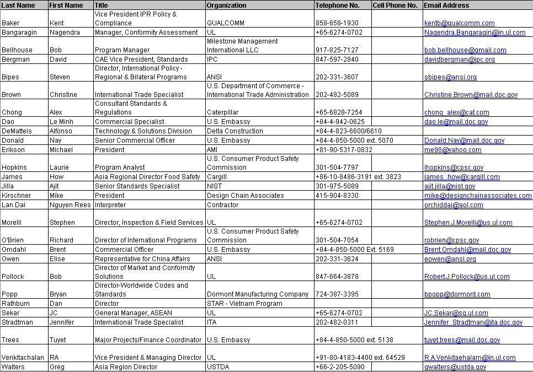

Vietnamese participants:
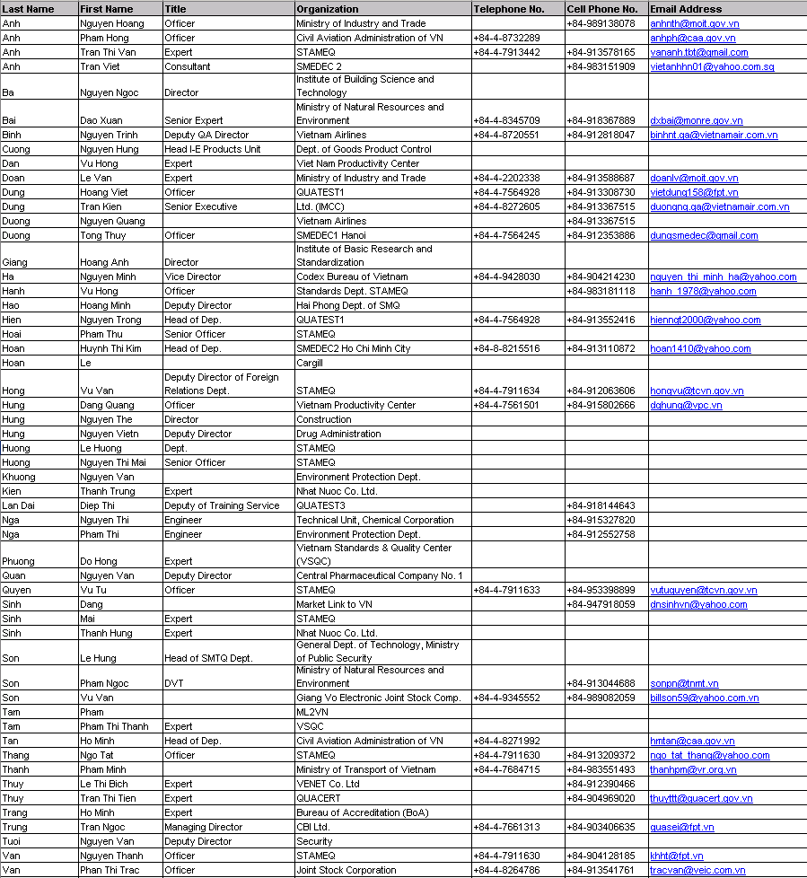

Appendix 4: VSTP Instructors’ Biographies
(Originally presented in the VSTP Intermediate Report)

STEVEN J. BIPES
Director of International Policy – Regional and Bilateral Programs
American National Standards Institute

Steven Bipes is ANSI’s Director of Regional and Bilateral Programs for the International Policy team and is responsible for coordinating U.S. policy and participation within several international and regional standardization bodies (e.g. COPANT, PASC, CEN, CENELEC, ETSI). Mr. Bipes leads ANSI’s bilateral relationships with over 150 national standards bodies as well as its government relations, policy development, education and outreach efforts with U.S. and foreign government agencies dealing with international trade. Internationally, this includes the Asia Pacific Economic Cooperation (APEC), the European Commission (EC) and the networks of various Free Trade Agreements (FTAs) throughout the Americas.
Prior to joining ANSI in 2003, Mr. Bipes worked in the telecom, manufacturing, and software industries for 10 years. He served as a member of U.S. delegations to the NAFTA Consultative Committee for Telecommunications (CCT) and the Inter-American Telecommunication Commission (CITEL) under the Organization of American States (OAS) and was previously a member of the American Chamber of Commerce in Brazil (AMCHAM) in São Paulo. He participated in the Telecommunication Industry Association’s (TIA) Regulatory Engineering Committees, coordinating with the U.S. Federal Communication Commission (FCC) in the deregulation of its various programs, and participated in the harmonization of Canadian and U.S. technical telecommunications and electrical safety requirements.
Mr. Bipes started his professional career working in the Quality Assurance Department for Siemens-Nixdorf in Paderborn - Germany. He has since worked with multinational organizations in the United States and Brazil. He holds a Bachelor’s degree in electrical engineering from Purdue University.
CHRISTINE BROWN
International Trade Specialist
Department of Commerce – Office of Trade Agreements and Compliance

Christine Brown is an international trade specialist with the Department of Commerce’s Office of Trade Agreements and Compliance, where she investigates foreign trade barriers faced by U.S. industry and represents the Department in trade negotiations. Ms. Brown specializes in issues related to the WTO Agreements focusing on technical barriers to trade, sanitary and phytosanitary measures, import licensing and information technology.

Prior to joining the Commerce Department, Ms. Brown previously served as Director of Congressional Affairs and Trade Policy at the Korea Economic Institute. She has also worked with C&M International, a trade and investment consulting firm in Washington, DC.

Ms. Brown holds a MA in International Relations and Economics from The Johns Hopkins School of Advanced International Studies (SAIS) and a BA in International Relations and German Area Studies from Tufts University.

AJIT JILLAVENKATESA
Senior Standards Specialist – Global Standards and Information Group
National Institute of Standards and Technology

Dr. Ajit Jillavenkatesa is a Senior Standards Specialist with the Global Standards and Information Group (GSIG) at the National Institute of Standards and Technology (NIST).

In this role, he specializes in tracking and analyzing standards and conformity assessment related policy issues in South Asia, Asia-Pacific and the Mid-East Asia regions. His primary responsibilities include providing standards and conformity assessment related policy and technical expertise to customers at NIST, the U.S. Department of Commerce, other US Government agencies and the private sector. He thus interacts extensively with standards experts in addressing the role of standards and conformity assessment in enabling trade and commerce, and the manifestation of standards and conformity assessment procedures as technical barriers to trade.

Dr. Jillavenkatesa also participates in international standards development activities in emerging areas such as radio-frequency identification (RFID) and nanotechnology. Dr. Jillavenkatesa contributes documentary standards and conformity assessment expertise to intra- and inter-governmental groups, bridging the worlds of standards, international trade and regulatory policy.

Dr. Jillavenkatesa is a materials scientist by training, having come to NIST in 1997, with a Ph.D. in Ceramics from Alfred University in New York. He has authored and co-authored books and peer reviewed publications related to physical and chemical characterization of materials.

MICHAEL G. KIRSCHNER
President & Managing Partner
Design Chain Associates, LLC

Michael Kirschner has been President and Managing Partner of Design Chain Associates, LLC since its inception in 2001 and is an internationally recognized expert in the analysis and impact of environmental regulation on electronic products. His primary duties include helping clients define and achieve their goals for environmental compliance as well as product development and supply chain efficiency. He has recently contributed two chapters to the "Governance, Risk, and Compliance Handbook", to be published by Wiley in 2008 and is featured in Mark Schapiro’s new book "Exposed: The Toxic Chemistry of Everyday Products and What's at Stake for American Power".

Prior to founding DCA Mr. Kirshner held Engineering and Engineering Management positions at Compaq, Tandem, Intel, and Intergraph, as well as at several start-ups in Component Engineering, Reliability, Quality Assurance, Software Development, and Product Design roles. His focus has always been on improving product quality, reliability, and performance while reducing both short- and long-term costs and environmental impact.

Mr. Kirshner received his Bachelor of Science in Electrical Engineering (BSEE) from Worcester Polytechnic Institute in Worcester, MA.

RICHARD W. O'BRIEN
Director of International Programs and Intergovernmental Affairs
U.S. Consumer Product Safety Commission

Mr. Richard O’Brien is a career federal employee with over 23 years’ service and draws from a diverse government and private-sector background. At the Consumer Product Safety Commission, he oversees the regulatory agency’s international activities aimed at ensuring the safety of imported consumer products. He also coordinates efforts with other U.S. and foreign government agencies on international consumer product safety issues.

Mr. O’Brien is a retired career U.S. Foreign Service Officer. Immediately prior to joining CPSC, he served as director for U.S. bilateral telecommunications policy at the Department of State for the countries of East Asia and the Pacific region. Before joining the Foreign Service, he worked in trade promotion at the Commerce Department's International Trade Administration and earlier, at the Agriculture Department’s Foreign Agricultural Service, the department’s export agency.

A background in multiple federal agencies has given Mr. O’Brien broad experience in international standards policy, product safety, foreign market access, and market development for a range of goods and services, including electronics, food, agricultural, and consumer products, as well as media, telecommunications, energy, financial, and professional services. Before entering federal service, he held a variety of positions in the public relations and marketing field, including agency account executive, consultant, and regional public relations director for The Salvation Army.

Mr. O’Brien holds a Master’s Degree in International Affairs from George Washington University and a Bachelor’s Degree in Mass Communications from Towson State University. A veteran of both the U.S. Air Force and the U.S. Coast Guard Reserve, he has lived and worked in the Netherlands, the United Kingdom, South Korea, Germany, and Switzerland. Mr. O’Brien serves on the Public Safety Committee of the City of Bowie, Maryland.

ELISE M. OWEN
Representative for China and India Affairs
American National Standards Institute

Elise Owen serves as ANSI's Representative for China and India and is responsible for increasing ANSI’s expansion into other priority markets in Asia. In this facility, Ms. Owen is actively working to communicate and promote U.S. positions for standardization and conformity assessment, to ensure that standards facilitate trade, and to promote the U.S. approach to standards and its benefits.
Previously, Ms. Owen worked for the U.S. Department of Commerce, International Trade Administration. As an International Trade Specialist, she worked to facilitate U.S. exports and to resolve individual and systemic bilateral concerns on foreign regulations and policies that hindered U.S. market access. In this capacity, Ms. Owen worked to ensure that U.S. industry perspectives and positions were represented in the World Trade Organization Technical Barriers to Trade Agreement, participating in the development of U.S. policy document for the TBT Committee and working to address TBT-related compliance and enforcement issues.
Ms. Owen is proficient in Mandarin Chinese and Japanese, graduating with honors and certified by the Defense Language Institute and Foreign Language Center, where she served in the United States Army. She holds an MBA from the University of Hawaii at Manoa and earned her undergraduate degree at Regent's College, graduating with honors from both.

ROBERT J. POLLOCK
Director of Market and Conformity Surveillance
Underwriters Laboratories

Robert (Bob) Pollock is the Underwriters Laboratories (UL) Director of Market and Conformity Surveillance and has served in this position since 2003. In this role, Mr. Pollock develops and directs all strategic initiatives, plans and programs related to preserving the ongoing integrity of all UL’s Certification Marks. In addition, he assures that corrective actions identified during the investigation of field incidents and markets surveillance activities are implemented corporate-wide.
UL is an architect of the U.S. safety system, having developed more than 1,000 safety standards, and participates actively in national and international standards development. UL tests more than 19,200 types of products, and 21 billion UL Marks appear in the marketplace each year. UL works closely with customers, regulators, insurers, retailers and consumers on research, technology and safety initiatives.
Mr. Pollock began his career at UL in 1977 in UL’s Santa Clara, Calif., USA division. He was responsible for conducting product safety evaluations, developing test programs and determining compliance with UL Standards. From 1994 to 2001, Mr. Pollock was the manager of Regulatory Services, focusing on developing and implementing strategies for increasing global acceptance of UL Conformity Assessment Services by regulatory authorities. As director of Field Reports and Regulatory Services, a position he held from March 2001 to December 2002, Mr. Pollock strengthened policies for protection of UL Mark integrity through vigorous investigation and enforcement and improved UL’s corrective action system to resolve incidents of non-compliance of UL Certified products. A reorganization in June 2004, returned responsibility for Regulatory Services to Bob.

Mr. Pollock earned a Bachelor of Science in Electrical Engineering/Engineering and Public Policy from Carnegie Mellon University in Pittsburgh, Pennsylvania and a Masters of Business Administration (MBA) from San Jose State University, San Jose, California. He is a Registered Professional Engineer (PE) and holds many professional memberships including the Institute of Electrical and Electronic Engineers (IEEE) and the National Fire Protection Association (NFPA). He has also received two UL Professional Engineering certifications.
JENNIFER STRADTMAN
International Trade Specialist – Office of International Trade Administration (ITA)
U.S. Department of Commerce

Ms. Jennifer Stradtman has been working on issues related to standards and technical regulations for the Department of Commerce for three years. She currently works for the ITA Standards Liaison on the Secretary’s Standards Initiative. Ms. Stradtman has also served as the Department’s lead specialist on the WTO Technical Barriers to Trade Committee. She has served on ISO and Codex committees and has worked on compliance issues related to the Sanitary and Phytosanitary Agreements. Prior to working for the Department, Ms. Stradtman worked as a section director for American Council of Independent Laboratories focusing on issues related to conformity assessment, regulations and accreditation.

Ms. Stradtman was also a state and local lobbyist for the Buffalo Niagara Partnership, a regional economic development organization. Ms. Stradtman earned her Master’s degree in International Trade from the State University of New York, University at Buffalo and her Bachelor’s degree in Political Science from State University of New York, College at Fredonia.
Instructors’ Contact Information:
Instructor/Expert | Title | Organization | Telephone | Email
Steven Bipes | Director, International Policy - Regional and Bilateral Programs | ANSI | 202-331-3607 | sbipes@ansi.org
Elise Owen | Representative to China | ANSI | 202-331-3624 | eowen@ansi.org
Jennifer Stradtman | International Trade Specialist | Office of International Trade Administration (ITA) | 202-482-0311 | Jennifer.Stradtman@mail.doc.gov
Bob Pollock | Director, Market & Conformity Surveillance | Underwriters Laboratories, Inc.(UL) | 847-664-3878 | Robert.J.Pollock@us.ul.com
Christine Brown | Office of Trade Agreements and Compliance | Department of Commerce | 202-482-5089 | Christine.Brown@mail.doc.gov
Richard O’Brien | Director of International Programs and Intergovernmental Affairs | US Consumer Product Safety Commission (CPSC) | 301-504-7054 | robrien@cpsc.gov
Ajit Jilla, Ph.D. | Senior Standards Specialist, Global Standards and Information Group | National Institute of Standards and Technology (NIST) | 301-975-5089 | ajit.jilla@nist.gov
Michael Kirshner | President | Design Chain Associates, LLC | 415-904-8330 | mike@designchainassociates.com
Amy Michel | Program Administrator | ANSI | 202-331-3625 | amichel@ansi.org
Alfonso L. DeMatteis | General Director | Delta Construction Management Company | +84-4-823-6600/6610 | n/a
Michael J. Erickson | President | Aviation Management Inc., LLC | +81-90-5317-0832 | me98@yahoo.com
Bryan Popp | Director-Worldwide Codes and Standards | Dormont Manufacturing | 724-387-3395 | bpopp@dormont.com
James How | Asia Regional Director Food Safety & Regulatory | Cargill | +86-10-84863191 ext. 3823 | james_how@cargill.com
David Bergman | CAE Vice President, Standards, Technology and International Relations | IPC | 847-597-2840 | davidbergman@ipc.org

Appendix 5: Agendas for Virtual Sessions
(Originally presented in the VSTP Intermediate Report)

VS1: Overview of the U.S. Standards and Conformity Assessment System

Time |  | Speaker
8:00 – 8:20 | Welcome and Opening Remarks | Steven Bipes – Director of International Policy, Regional and Bilateral Programs, ANSI  Henry Steingass – Regional Director, USTDA  Ngo Tat Thang – Director of the International Cooperation Department, STAMEQ  Ngo Quy Viet – Director General, STAMEQ
8:20 – 9:20 | Lecture | Elise Owen – Representative for China and India Affairs, ANSI
9:20 – 9:50 | Questions and Answers | Elise Owen – Representative for China and India Affairs, ANSI
9:50 – 10:00 | Closing Remarks | Ngo Tat Thang – Director of the International Cooperation Department, STAMEQ  Elise Owen – Representative for China and India Affairs, ANSI

VS2: Overview of the Vietnamese Standards and Conformity Assessment System

Time |  | Speaker
8:00 – 8:20 | Welcome and Opening Remarks | Steven Bipes – Director of International Policy, Regional and Bilateral Programs, ANSI  Tran Van Hoc – Director of the Standards Department, STAMEQ
8:20 – 9:20 | Lecture | Tran Van Hoc – Director of the Standards Department, STAMEQ  Nguyen Nam Hai – Deputy Director of QUACERT, STAMEQ  Vu Xuan Thuy – Director of the Bureau of Accreditation, STAMEQ
9:20 – 9:50 | Questions and Answers | Tran Van Hoc – Director of the Standards Department, STAMEQ  Nguyen Nam Hai – Deputy Director of QUACERT, STAMEQ  Vu Xuan Thuy – Director of the Bureau of Accreditation, STAMEQ
9:50 – 10:00 | Closing Remarks | Ngo Tat Thang – Director of the International Cooperation Department, STAMEQ  Steven Bipes – Director of International Policy, Regional and Bilateral Programs, ANSI

Backup Communications and Restoration Plan
VS1 and VS2

The US Vietnam Standards Training Program (US-VSTP) will begin on {Tuesday January 15th EDT at 8PM} {Wednesday, January 16th Hanoi at 8AM}, with a live video conference session between Washington DC and Hanoi, Vietnam. Additional sessions will be held on the next two consecutive days at the same times.

ANSI has arranged for digital video conference links between Washington and Hanoi, using the World Bank’s Global Development Learning Network (GDLN) state of the art and highly reliable facilities.

In the very unlikely event that GDLN audio or video capabilities are interrupted and respecting the people who will be participating in these sessions, ANSI and GDLN has developed this Backup Communications and Restoration plan.
- Technical management and the overall quality of the GDLN signal and facilities during the VSTP sessions is the responsibility of GDLN staff.
  - GDLN contacts for technical in Washington is Lorenzo, 202 458 7549.
  - GDLN contacts for technical in Hanoi are:
Ms. Nuong: +844-9346600 ext. 706. Cellular: +84982417435
Mr. Chu Tuan Anh: +844-9346600 ext. 240 or ext. 250
- The senior ANSI or STAMEQ person present in Washington or Hanoi will determine if audio and video is satisfactory. These individuals will be supported by VSTP local coordinators who will able to communicate by cell phone.
  - The VSTP Local Coordinator in Washington is Amy Michel, mobile: 202-344-5228
  - The VSTP VS Training Coordinator in Hanoi is Tam Pham, cellular number: +84 98906747
- In the event there is a problem, immediately notify on-site GDLN technical support.
- In the event that only the video signal between the two GDLN sites fails, it may be possible to continue using only audio communications.
- In the event that only the audio signal between the two GDLN sites fails, it may be possible to continue using telephone communications.
  - The conference phone number at the GDLN facility in Washington is 202 458 7549.
  - The conference phone number at the GDLN facility in Hanoi is +8449346600 ext 708
- It may also be possible to continue the session using webcast access. The webcast URL for these sessions is http://vcg01.worldbank.org/vc/.
- VSTP Local coordinators will work with GDLN during the dry run to determine the feasibility of these and other solutions to service disruption.
Appendix 6: Agenda for Intensive Sessions
(Originally presented in the VSTP Intermediate Report)

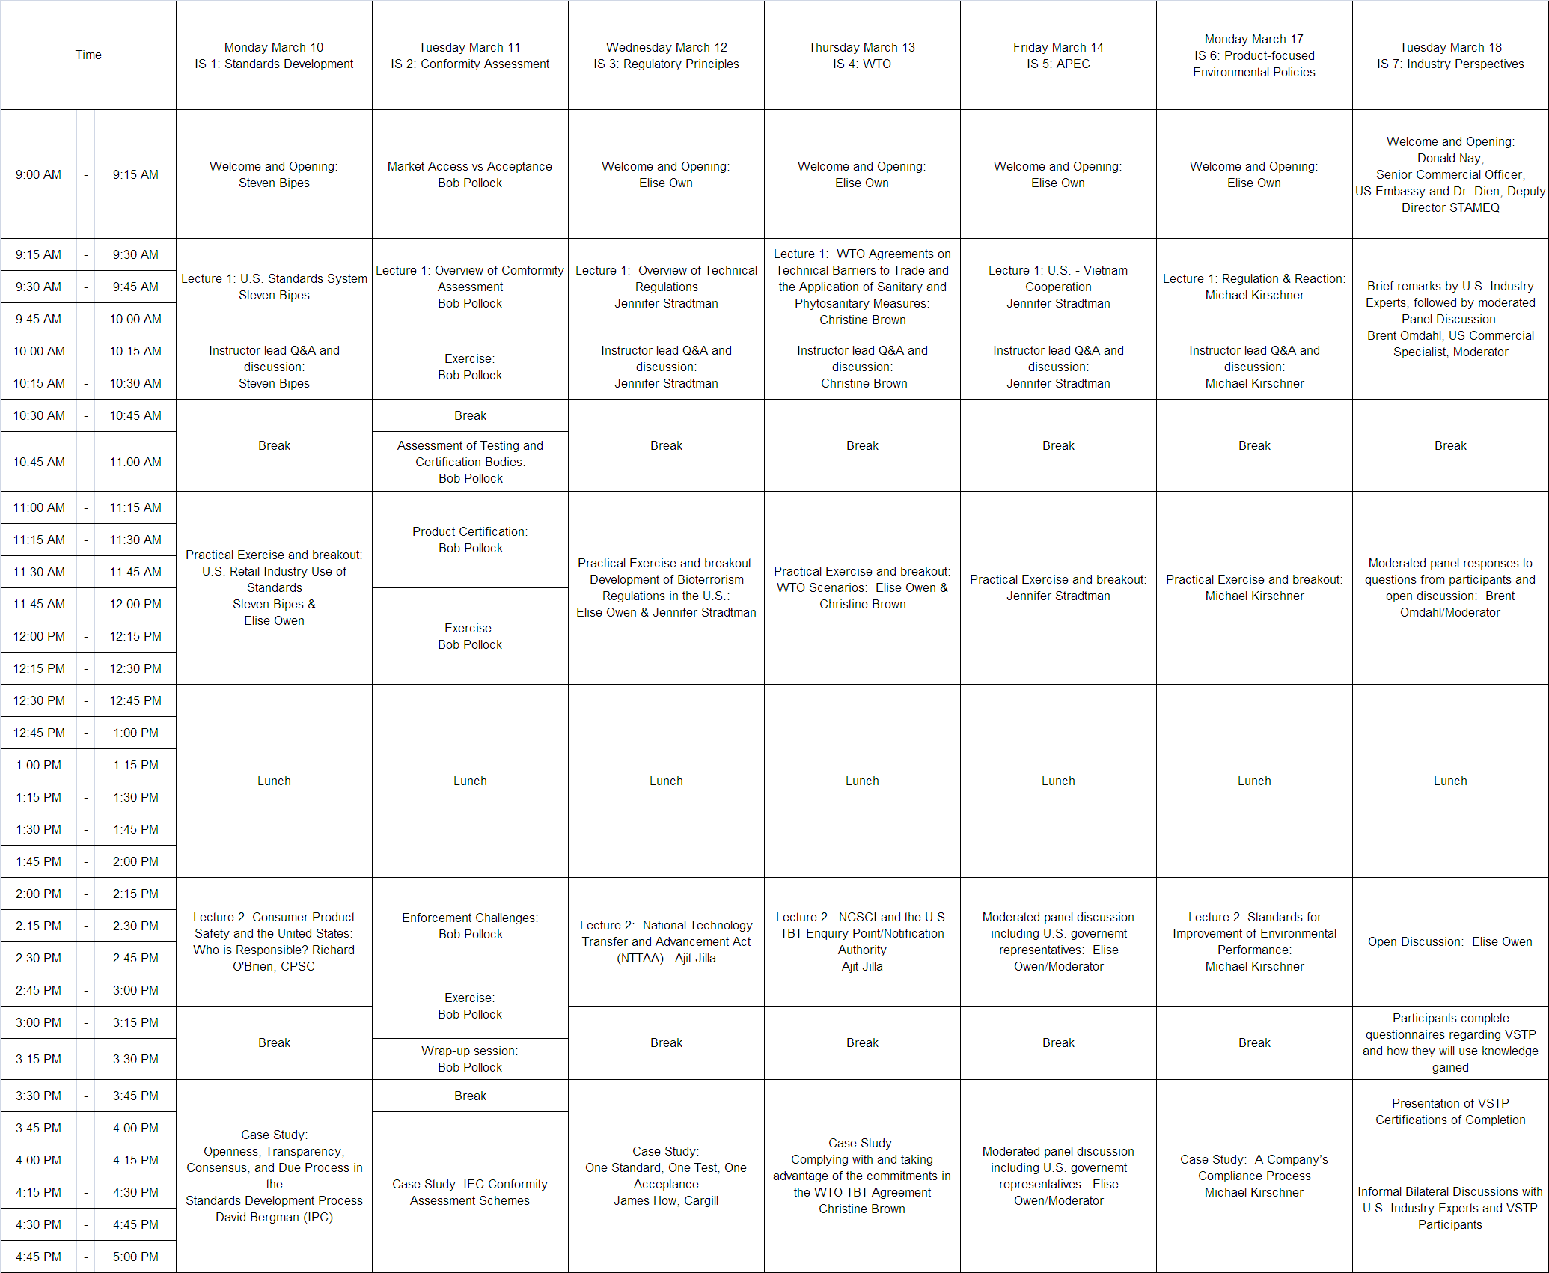

Appendix 7: Intensive Session Course Overviews and Teaching Points
(Originally presented in the VSTP Intermediate Report)

Intensive Session 1: Standards development
Course Overview and Key Teaching Points

Background and context for this seminar:

Around the world, traditional barriers to trade are being progressively eliminated, making the role of standards increasingly relevant as potential technical barriers to international trade.

Properly structured and applied, international standards can help facilitate international trade and increase the competitiveness of a country’s domestic market. On the other hand, the development and adoption of country-unique standards can stall a country’s technological development, entrench its market in inferior technologies, and inhibit its long-term trade potential.

Countries using international standards are granted entry into markets that use international standards because their specifications for products, services, and systems are internationally recognized. This reduces costs, enables commerce and trade between countries via the interoperability of technologies, and promotes innovation and economic growth.

Seminar description:

This seminar, “Standards”, seeks to provide VSTP participants with the information necessary to understand how international standards are globally relevant. In addition, since there are instances where national standards may be necessary, information is provided on how to implement national standards in a manner that is least disruptive to international trade.

Drawing from U.S. experiences and perspectives, this seminar will:
- Provide a detailed explanation of how standards can be developed, used and referenced by regulations in a market-driven and voluntary consensus standards system.
- Discuss the roles of government and the roles of the private sector in a market-driven standards system.
- Provide information on organizations that develop international standards and recommendations on how Vietnamese stakeholders (both public- and private- sector) can be more actively involved in international standards development activities.
- Include a detailed discussion of:
  - The difference between standards and technical regulations;
  - How governments can incorporate voluntary standards into technical regulations and procurement bids; and
  - How governments can use voluntary standards to support other programs and initiatives.
- Use the U.S. National Technology Transfer and Advancement Act (NTTAA) and related policies such as OMB Circular A-119 as examples.

Concerning the implementation of national standards, this seminar will also:
- Identify instances in which such standards may be necessary;
- Outline the WTO “Code of Good Practice for Standards Development” and how it can be applied in national standards development processes; and
- Identify mechanisms that can be used to phase-in international standards.
Intensive Session 2: Conformity Assessment
Course Overview and Key Teaching Points

Background and context for this seminar:

Significant media attention throughout the world regarding quality and safety issues in recent months has highlighted the necessity for globalized economies to establish an effective conformity assessment system.

Implementing a flexible conformity assessment system with a risk-based approach can increase competitiveness and facilitate trade. Ensuring that the level of rigor of conformity assessment requirements correlates directly to the level of risk of a given product ensures global confidence in product quality and safety. Participation in multilateral conformity assessment schemes encourages reciprocal flexibility in other globalized economies.

Seminar description:

The “Conformity Assessment” seminar is designed to provide participants with the critical information needed to implement an open and transparent Conformity Assessment system incorporating good regulatory practices and will:
- Explain the difference between Market Access and Market Acceptance.
- Discuss the types of Conformity Assessment Mechanisms and Demand Drivers.
- Identify ISO Guidelines that cover Conformity Assessment Systems and Certification Bodies.
- Determine methods for assessing Testing and Certification Bodies.
- Describe the types of product conformity assessment approaches, including Third-Party and SDoC.
- Explain the key steps in a Third-Party Product Certification Program.
- Choose appropriate Data Acceptance Methods.
- Analyze the benefits and challenges with Pre- and Post- Market Surveillance Programs.
- Identify means for controlling the misuse of Marks of Conformity and implementing appropriate Corrective Actions.
- Distinguish between legal and market requirements.
Intensive Session 3: Regulatory

Course Overview and Key Teaching Points

This course will outline a regulatory approach that effectively safeguards the environment as well as the health and safety (EHS) of consumers without unnecessarily impeding trade. Emphasis will be placed on one regulatory approach which encourages public-private partnerships where government, industry, consumers, NGOs and other stakeholders work together to achieve common objectives.

The course materials will use the World Trade Organization (WTO)/Technical Barriers to Trade (TBT) Agreement definition for “technical regulation” and the U.S. Administrative Procedures
Act will be referenced to demonstrate the following key concepts:
- Stakeholder Input: The U.S. system provides regulators with a clear process to gather, review, and address comments submitted by U.S. industry and other stakeholders. Once a regulation is adopted, companies are given reasonable notice and ample time to incorporate any new requirements into their manufacturing and business processes and to address any concerns or obstacles associated with compliance, before regulations go into effect.
- Cost/Benefit Analysis: The use of cost/benefit analysis ensures that proposed regulations are introduced only when voluntary mechanisms alone will not address EHS concerns and when it has been demonstrated that the proposed regulation will effectively meet its purpose. This practice encourages the use of regulations that can be enforced evenly on domestic and foreign industry.
- Private-Sector Delivery of Conformity Assessment Procedures: Most U.S. regulators administer their accreditation and/or certification and testing responsibilities by using qualified and approved private-sector conformity assessment organizations. This allows regulators to accommodate the growing volume of products and services on the market while also encouraging compliance and efficiency for manufacturers.
- Interagency Coordination: Regular communication and coordination efforts between regulatory bodies (i.e. Government Agencies) helps to avoid overlap or duplication in regulations and ensures that critical areas related to EHS are not overlooked.
- Transparency: U.S. regulators are required to follow an open and transparency process; The Code of Federal Regulations (CFR) and a Federal Register (FR) are used to ensure that information is consistently available to all stakeholders in central location
- Public-Private Communication: U.S. regulators maintain regular communication with the private sector and have processes in place to encourage continuous reporting and information exchange. As a result of this practice, problems can be detected and addressed early, reducing threats to public safety and the need for excessive punishment for manufacturers that proactively work with regulators to address issues.
Intensive Session 4: WTO/TBT
Course Overview and Key Teaching Points

Background and context for this seminar:

As international trade expands, countries have to keep up by working to implement standards, conformity assessment and technical regulations (SCATR) approaches to ensure product safety and quality. In some cases, these approaches are not harmonized to international standards and instead they are burdensome or protectionist in nature. Commonly referred to as “technical barriers to trade”, these can harm both domestic and foreign industry’s ability to conduct business internationally. To ensure that countries avoid these situations the World Trade Organization Technical Barriers to Trade agreement (WTO/TBT) upholds the following principles for WTO members: (1) avoidance of unnecessary obstacles to trade, (2) non-discrimination and national treatment, (3) harmonization, (4) equivalence of technical regulations, (5) mutual recognition of conformity assessment procedures and (6) transparency. In addition to the TBT agreement, another fundamental WTO agreement addressing standards and technical regulations is the Sanitary and Phytosanitary Agreement (SPS), covering food safety and animal and plant health specifically.

Seminar description:

The WTO seminar will review the TBT and SPS agreements, include a discussion of their requirements, and recommend procedures that can be used to help countries meet their obligations. Specifically, this seminar will:
- Explain the WTO’s TBT agreement and SPS agreement obligations.
- Identify the differences between SPS and TBT.
- Recommend how procedures can be implemented to ensure compliance with WTO/TBT-related obligations including notifications and information.

Intensive Session 5: Asia-Pacific Economic Cooperation
Course Overview and Key Teaching Points

Background and context for this seminar:

Established in 1989, the Asia-Pacific Economic Cooperation (APEC) is the only inter-governmental organization operating on the basis of non-binding commitments. It offers the 21 member economies a forum to facilitate economic growth, cooperation, trade and investment. The member economies account for approximately 41% of the world’s population, 56% of the world’s GDP and 49% of world trade. APEC has worked to reduce tariffs and other trade barriers, creating efficient domestic markets and dramatically increasing exports. APEC also works to create an environment for the safe and efficient movement of goods, services and people across borders through policy alignment and economic and technical cooperation.

APEC has achieved these goals through a bottom-up approach to standards and conformity assessment (referred to as “conformance” in the APEC context), which helps member economies achieve the greatest benefit not only for trade, but also for protection of the environment health and safety. APEC established the Sub-Committee on Standards and Conformance (SCSC) to advise the APEC Committee on Trade and Investment on how to reduce the negative effects on trade caused by differing standards and conformance arrangements among Member Economies. The bottom-up approach used within the SCSC fosters industry innovation, supports market relevance and leverages the input of all stakeholders – public and private – for the benefit of all APEC members.

Seminar description:

In January 2007, Vietnam proposed enhanced interaction between the Vietnamese private sector and SCSC. Responding to this specific request, this training session will explain how the Vietnamese private sector can maximize its country’s membership to:
- Effectively engage with the SCSC and other APEC member private-sector representatives;
- Benefit from increased engagement with the APEC SCSC;
- Leverage APEC Specialist Regional Bodies (SRBs), the SCSC, and the APEC Business Advisory Council (ABAC) to advance U.S. and Vietnamese economic and social objectives; and
- Effectively participate in APEC SCSC and ABAC activities, using this experience to enhance participation in other regional and international organizations and activities (e.g., ASEAN, WTO, etc.).
Intensive Session 6: Product-focused Environmental Policies
Course Overview and Key Teaching Points

The Environmental Performance of products, defined along three lines of substance hazard and risk, energy use throughout the lifecycle, and waste generation throughout the lifecycle, has become a hot topic in regulatory and, thus, in industrial circles. Regulators in the European Union, responding to growing environmental challenges and long term health cost issues, were the first to identify the environmental aspects of everyday products as a target for regulation as a method of forcibly improving their environmental performance. Industry, having never really considered environmental performance, was caught off-guard and has spent the better part of this decade reacting to regulation rather than participating in its development in a positive manner. Now these regulations are starting to appear in different countries around the world, while industry and some governments, such as the US government (EPA and NIST, specifically), are working on voluntary standards and approaches.

Lecture 1 will cover:
- The real and perceived issues of Environmental Performance of Products
- What is the problem?
- What were the regulatory solutions?
- A brief overview of where these regulations are around the world and why they’ve been implemented
- RoHS, WEEE, EuP, REACH, CA SB20/50 and AB1109, etc.
- How the European Union's regulatory regimen forcibly drives perceived and actual environmental improvement
- Industry Response and Challenges
- Resulting Company activities, including supply chain, in-country, out-of-country impacts and costs
- Which comes first: standards or regulation?
- Enforceability hampered by a lack of industry standards

Lecture 2 will cover:
- Voluntary approaches to environmental performance - what they are, when they work, and when they fail (standards, conformity assessment)
- iNEMI/IPC 2-18 (IPC 1752)
- IEC TC111
- NEPSI
- EPA Non-halogen flame retardants for printed circuit boards
- EPEAT
- EnergyStar
- Lead in toys
- IEC 62368 - open flame standard requiring BFRs
- ASTM F40
- Private Sector Conformity Assessment to ISO9001/14001, IECQ 080000, IPC Leadfree Process Certification
- What's needed for real environmental performance improvement - joint Government/Industry approaches
- Problem identification and pareto
- Tight coordination between Governments, Standards bodies, Industry, and NGOs/activists

Key Teaching Points

Attendees will learn:
      - How and why product-focused environmental regulations target manufacturing industries, chemical substances, and real/perceived problems
      - How industry responds to product-focused environmental regulations, why it responds this way, and how it impacts supply chains both in- and out- of country; how industry responds to standards
      - What works and what doesn't work in regulation and in voluntary standards
      - Key challenges to industry in complying with these regulations, and the role standards will play
      - How regulators, standards bodies, and industry can work together in order to address and solve these problems
Appendix 8: List of Intensive Session Training Materials |  | (Originally presented in the VSTP Intermediate Report)
All Training Materials are posted at www.standardsportal.org/vstp

Course | Document title | ANSI Library Folder name
IS1 | Biography IS1 E.Owen (English) | VSTP Finalized Training Materials/Intensive Sessions/Training Materials Part I - Intro, IS1, IS2
 | Biography IS1 E.Owen (Vietnamese)_STAMEQ | VSTP Finalized Training Materials/Intensive Sessions/Training Materials Part I - Intro, IS1, IS2
 | Biography IS1 S. Bipes (English) | VSTP Finalized Training Materials/Intensive Sessions/Training Materials Part I - Intro, IS1, IS2
 | Biography IS1 S. Bipes (Vietnamese)_STAMEQ | VSTP Finalized Training Materials/Intensive Sessions/Training Materials Part I - Intro, IS1, IS2
 | Biography R. O'Brien (English) | VSTP Finalized Training Materials/Intensive Sessions/Training Materials Part I - Intro, IS1, IS2
 | Biography R. O'Brien (Vietnamese)_STAMEQ | VSTP Finalized Training Materials/Intensive Sessions/Training Materials Part I - Intro, IS1, IS2
 | Course Overview for IS1 FINAL (English) | VSTP Finalized Training Materials/Intensive Sessions/Training Materials Part I - Intro, IS1, IS2
 | Course Overview for IS1 FINAL (Vietnamese)_STAMEQ | VSTP Finalized Training Materials/Intensive Sessions/Training Materials Part I - Intro, IS1, IS2
 | IS1 Case Study - IPC (English) | VSTP Finalized Training Materials/Intensive Sessions/Training Materials Part I - Intro, IS1, IS2
 | IS1 Case Study - IPC (Vietnamese)_STAMEQ | VSTP Finalized Training Materials/Intensive Sessions/Training Materials Part I - Intro, IS1, IS2
 | IS1 Lecture 1 - General Overview (English) | VSTP Finalized Training Materials/Intensive Sessions/Training Materials Part I - Intro, IS1, IS2
 | IS1 Lecture 1 - General Overview (Vietnamese)_STAMEQ | VSTP Finalized Training Materials/Intensive Sessions/Training Materials Part I - Intro, IS1, IS2
 | IS1 Lecture 2 - CPSC (English) | VSTP Finalized Training Materials/Intensive Sessions/Training Materials Part I - Intro, IS1, IS2
 | IS1 Lecture 2 - CPSC (Vietnamese)_STAMEQ | VSTP Finalized Training Materials/Intensive Sessions/Training Materials Part I - Intro, IS1, IS2
 | IS1 Practical Exercise - Standards and Retail (English) | VSTP Finalized Training Materials/Intensive Sessions/Training Materials Part I - Intro, IS1, IS2
 | IS1 Practical Exercise - Standards and Retail (Vietnamese)_STAMEQ | VSTP Finalized Training Materials/Intensive Sessions/Training Materials Part I - Intro, IS1, IS2
 | Three key questions to be answered by IS1 (English) | VSTP Finalized Training Materials/Intensive Sessions/Training Materials Part I - Intro, IS1, IS2
 | Three key questions to be answered by IS1 (Vietnamese)_STAMEQ | VSTP Finalized Training Materials/Intensive Sessions/Training Materials Part I - Intro, IS1, IS2
IS2 | Biography B. Pollock (English) | VSTP Finalized Training Materials/Intensive Sessions/Training Materials Part I - Intro, IS1, IS2
 | Biography B. Pollock (Vietnamese)_STAMEQ | VSTP Finalized Training Materials/Intensive Sessions/Training Materials Part I - Intro, IS1, IS2
 | Biography IS2 S. Bipes (English) | VSTP Finalized Training Materials/Intensive Sessions/Training Materials Part I - Intro, IS1, IS2
 | Biography IS2 S. Bipes (Vietnamese)_STAMEQ | VSTP Finalized Training Materials/Intensive Sessions/Training Materials Part I - Intro, IS1, IS2
 | Course Overview for IS2 FINAL (English) | VSTP Finalized Training Materials/Intensive Sessions/Training Materials Part I - Intro, IS1, IS2
 | Course Overview for IS2 FINAL (Vietnamese)_STAMEQ | VSTP Finalized Training Materials/Intensive Sessions/Training Materials Part I - Intro, IS1, IS2
 | IS2 Case Study - IECCB Scheme (English) | VSTP Finalized Training Materials/Intensive Sessions/Training Materials Part I - Intro, IS1, IS2
 | IS2 Case Study - IECCB Scheme (Vietnamese) | VSTP Finalized Training Materials/Intensive Sessions/Training Materials Part I - Intro, IS1, IS2
 | IS2 Lecture - Conformity Assessment (English) | VSTP Finalized Training Materials/Intensive Sessions/Training Materials Part I - Intro, IS1, IS2

 | IS2 Lecture - Conformity Assessment (Vietnamese)_STAMEQ | VSTP Finalized Training Materials/Intensive Sessions/Training Materials Part I - Intro, IS1, IS2
 | Three key questions to be answered by IS2 (Vietnamese)_STAMEQ | VSTP Finalized Training Materials/Intensive Sessions/Training Materials Part I - Intro, IS1, IS2
 | Three key questions to be answered by IS2 FINAL (translated) | VSTP Finalized Training Materials/Intensive Sessions/Training Materials Part I - Intro, IS1, IS2
IS3 | Course Overview for IS3 - FINAL (English) | Training Materials Part II - IS3, IS4
 |  | VSTP Finalized Training Materials/Intensive Sessions/Training Materials Part II - IS3, IS4
 | Course Overview for IS3 - FINAL (Vietnamese)_STAMEQ | Training Materials Part II - IS3, IS4
 |  | VSTP Finalized Training Materials/Intensive Sessions/Training Materials Part II - IS3, IS4
 | IS3 Case Study - Cargill (English) | Training Materials Part II - IS3, IS4
 |  | VSTP Finalized Training Materials/Intensive Sessions/Training Materials Part II - IS3, IS4
 | IS3 Case Study - Cargill (Vietnamese)_STAMEQ | Training Materials Part II - IS3, IS4
 |  | VSTP Finalized Training Materials/Intensive Sessions/Training Materials Part II - IS3, IS4
 | IS3 Lecture 1 Overview of Technical Regulations (English) | Training Materials Part II - IS3, IS4
 |  | VSTP Finalized Training Materials/Intensive Sessions/Training Materials Part II - IS3, IS4
 | IS3 Lecture 1 Overview of Technical Regulations (Vietnamese)_STAMEQ | Training Materials Part II - IS3, IS4
 |  | VSTP Finalized Training Materials/Intensive Sessions/Training Materials Part II - IS3, IS4
 | IS3 Lecture 2 - NTTAA (English) | Training Materials Part II - IS3, IS4
 |  | VSTP Finalized Training Materials/Intensive Sessions/Training Materials Part II - IS3, IS4
 | IS3 Lecture 2 - NTTAA (Vietnamese)_STAMEQ | Training Materials Part II - IS3, IS4
 |  | VSTP Finalized Training Materials/Intensive Sessions/Training Materials Part II - IS3, IS4
 | IS3 Practical Exercise - Bioterrorism (English) | Training Materials Part II - IS3, IS4
 |  | VSTP Finalized Training Materials/Intensive Sessions/Training Materials Part II - IS3, IS4
 | IS3 Practical Exercise - Bioterrorism (Vietnamese) | Training Materials Part II - IS3, IS4
 |  | VSTP Finalized Training Materials/Intensive Sessions/Training Materials Part II - IS3, IS4
 | Three key questions to be answered by IS3 (English) | Training Materials Part II - IS3, IS4
 |  | VSTP Finalized Training Materials/Intensive Sessions/Training Materials Part II - IS3, IS4
 | Three key questions to be answered by IS3 (Vietnamese) | Training Materials Part II - IS3, IS4
 |  | VSTP Finalized Training Materials/Intensive Sessions/Training Materials Part II - IS3, IS4
IS4 | Biography - A. Jilla (English) | Training Materials Part II - IS3, IS4
 |  | VSTP Finalized Training Materials/Intensive Sessions/Training Materials Part II - IS3, IS4
 | Biography - A. Jilla (Vietnamese)_STAMEQ | Training Materials Part II - IS3, IS4
 |  | VSTP Finalized Training Materials/Intensive Sessions/Training Materials Part II - IS3, IS4
 | Biography - C. Brown (English) | Training Materials Part II - IS3, IS4
 |  | VSTP Finalized Training Materials/Intensive Sessions/Training Materials Part II - IS3, IS4
 | Biography - C. Brown (Vietnamese)_STAMEQ | Training Materials Part II - IS3, IS4
 |  | VSTP Finalized Training Materials/Intensive Sessions/Training Materials Part II - IS3, IS4

 | Biography - E. Owen (English) | Training Materials Part II - IS3, IS4
 |  | VSTP Finalized Training Materials/Intensive Sessions/Training Materials Part II - IS3, IS4
 | Biography - E. Owen (Vietnamese)_STAMEQ | Training Materials Part II - IS3, IS4
 |  | VSTP Finalized Training Materials/Intensive Sessions/Training Materials Part II - IS3, IS4
 | Biography - J. Stradtman (English) | Training Materials Part II - IS3, IS4
 |  | VSTP Finalized Training Materials/Intensive Sessions/Training Materials Part II - IS3, IS4
 | Biography - J. Stradtman (Vietnamese)_STAMEQ | Training Materials Part II - IS3, IS4
 |  | VSTP Finalized Training Materials/Intensive Sessions/Training Materials Part II - IS3, IS4
 | Course Overview and Key Teaching Points for IS 4 (Vietnamese)_STAMEQ | Training Materials Part II - IS3, IS4
 |  | VSTP Finalized Training Materials/Intensive Sessions/Training Materials Part II - IS3, IS4
 | Course Overview for IS4 (English) | Training Materials Part II - IS3, IS4
 |  | VSTP Finalized Training Materials/Intensive Sessions/Training Materials Part II - IS3, IS4
 | IS4 Case Study (English) | Training Materials Part II - IS3, IS4
 |  | VSTP Finalized Training Materials/Intensive Sessions/Training Materials Part II - IS3, IS4
 | IS4 Case Study (Vietnamese) | Training Materials Part II - IS3, IS4
 |  | VSTP Finalized Training Materials/Intensive Sessions/Training Materials Part II - IS3, IS4
 | IS4 Lecture 1 - (English) | Training Materials Part II - IS3, IS4
 |  | VSTP Finalized Training Materials/Intensive Sessions/Training Materials Part II - IS3, IS4

 | IS4 Lecture 1 - (Vietnamese)_STAMEQ | Training Materials Part II - IS3, IS4
 |  | VSTP Finalized Training Materials/Intensive Sessions/Training Materials Part II - IS3, IS4
 | IS4 Lecture 2 (English) | Training Materials Part II - IS3, IS4
 |  | VSTP Finalized Training Materials/Intensive Sessions/Training Materials Part II - IS3, IS4
 | IS4 Lecture 2 (Vietnamese)_STAMEQ | Training Materials Part II - IS3, IS4
 |  | VSTP Finalized Training Materials/Intensive Sessions/Training Materials Part II - IS3, IS4
 | IS4 Practical Exercise - WTO Scenarios (English) | Training Materials Part II - IS3, IS4
 |  | VSTP Finalized Training Materials/Intensive Sessions/Training Materials Part II - IS3, IS4
 | IS4 Practical Exercise - WTO Scenarios (Vietnamese)_STAMEQ | Training Materials Part II - IS3, IS4
 |  | VSTP Finalized Training Materials/Intensive Sessions/Training Materials Part II - IS3, IS4
 | Three key questions to be answered by IS4 (English) | Training Materials Part II - IS3, IS4
 |  | VSTP Finalized Training Materials/Intensive Sessions/Training Materials Part II - IS3, IS4
 | Three key questions to be answered by IS4 (Vietnamese)_STAMEQ | Training Materials Part II - IS3, IS4
 |  | VSTP Finalized Training Materials/Intensive Sessions/Training Materials Part II - IS3, IS4
IS5 | Biography - E. Owen (English) | VSTP Finalized Training Materials/Intensive Sessions/Training Materials Part III - IS5, IS6, IS7
 | Biography - E. Owen (Vietnamese)_STAMEQ | VSTP Finalized Training Materials/Intensive Sessions/Training Materials Part III - IS5, IS6, IS7
 | Biography - J. Stadtman (English) | VSTP Finalized Training Materials/Intensive Sessions/Training Materials Part III - IS5, IS6, IS7
 | Biography - J. Stadtman (Vietnamese)_STAMEQ | VSTP Finalized Training Materials/Intensive Sessions/Training Materials Part III - IS5, IS6, IS7
 | Course Overview and Key Teaching Points for IS5 (English) | VSTP Finalized Training Materials/Intensive Sessions/Training Materials Part III - IS5, IS6, IS7
 | Course Overview and Key Teaching Points for IS5 (Vietnamese) | VSTP Finalized Training Materials/Intensive Sessions/Training Materials Part III - IS5, IS6, IS7
 | IS5 lecture 1 US - Vietnam Cooperation (English) | VSTP Finalized Training Materials/Intensive Sessions/Training Materials Part III - IS5, IS6, IS7
 | IS5 lecture 1 US - Vietnam Cooperation (Vietnamese)_STAMEQ | VSTP Finalized Training Materials/Intensive Sessions/Training Materials Part III - IS5, IS6, IS7
 | IS5 Practical Exercise (English) | VSTP Finalized Training Materials/Intensive Sessions/Training Materials Part III - IS5, IS6, IS7
 | IS5 Practical Exercise (Vietnamese) | VSTP Finalized Training Materials/Intensive Sessions/Training Materials Part III - IS5, IS6, IS7
 | Three Key questions to be answered by IS5 (English) | VSTP Finalized Training Materials/Intensive Sessions/Training Materials Part III - IS5, IS6, IS7
 | Three Key questions to be answered by IS5 (Vietnamese) | VSTP Finalized Training Materials/Intensive Sessions/Training Materials Part III - IS5, IS6, IS7
IS6 | 90 Minute Exercise Description for IS6 (English) | VSTP Finalized Training Materials/Intensive Sessions/Training Materials Part III - IS5, IS6, IS7
 | 90 Minute Exercise Description for IS6 (Vietnamese)_STAMEQ | VSTP Finalized Training Materials/Intensive Sessions/Training Materials Part III - IS5, IS6, IS7
 | Bibliography for IS6 (english) | VSTP Finalized Training Materials/Intensive Sessions/Training Materials Part III - IS5, IS6, IS7
 | Biography - M. Kirshner (Vietnamese)_STAMEQ | VSTP Finalized Training Materials/Intensive Sessions/Training Materials Part III - IS5, IS6, IS7
 | Biography - M. Kirshner FINAL (English) | VSTP Finalized Training Materials/Intensive Sessions/Training Materials Part III - IS5, IS6, IS7
 | Case Study Description for IS6 (English) | VSTP Finalized Training Materials/Intensive Sessions/Training Materials Part III - IS5, IS6, IS7

 | Case Study Description for IS6 (Vietnamese)_STAMEQ | VSTP Finalized Training Materials/Intensive Sessions/Training Materials Part III - IS5, IS6, IS7
 | Course Overview and Key Teaching Points for IS6 (English) | VSTP Finalized Training Materials/Intensive Sessions/Training Materials Part III - IS5, IS6, IS7
 | Course Overview and Key Teaching Points for IS6 (Vietnamese)_STAMEQ | VSTP Finalized Training Materials/Intensive Sessions/Training Materials Part III - IS5, IS6, IS7
 | IS6 Case Study - Company Compliance Process (English) | VSTP Finalized Training Materials/Intensive Sessions/Training Materials Part III - IS5, IS6, IS7
 | IS6 Case Study - Company Compliance Process (Vietnamese)_STAMEQ | VSTP Finalized Training Materials/Intensive Sessions/Training Materials Part III - IS5, IS6, IS7
 | IS6 Lecture 1 - Regulation and reaction (English) | VSTP Finalized Training Materials/Intensive Sessions/Training Materials Part III - IS5, IS6, IS7
 | IS6 Lecture 1 - Regulation and reaction (Vietnamese)_STAMEQ | VSTP Finalized Training Materials/Intensive Sessions/Training Materials Part III - IS5, IS6, IS7
 | IS6 Lecture 2 - Standards for Improvement of Environmental Performance (English) | VSTP Finalized Training Materials/Intensive Sessions/Training Materials Part III - IS5, IS6, IS7
 | IS6 Lecture 2 - Standards for Improvement of Environmental Performance (Vietnamese)_STAMEQ | VSTP Finalized Training Materials/Intensive Sessions/Training Materials Part III - IS5, IS6, IS7
 | key questions to be answered by IS6 (English) | VSTP Finalized Training Materials/Intensive Sessions/Training Materials Part III - IS5, IS6, IS7
 | Three Key questions to be answered by IS6 (Vietnamese)_STAMEQ | VSTP Finalized Training Materials/Intensive Sessions/Training Materials Part III - IS5, IS6, IS7
IS7 | Biography M. Eirkson (English) | Biographies IS7 Panel
 |  | VSTP Finalized Training Materials/Intensive sessions/Biographies - IS7 Panel
ISFU | ANSI Essential Requirements | IS Follow-up.zip
 |  | VSTP Finalized Training Materials/IS Follow-up.zip
 | Course Overview for IS Follow-up | IS Follow-up.zip
 | Course Overview for IS Follow-up (English) | VSTP Finalized Training Materials/IS Follow-up.zip
 | TSCI | IS Follow-up.zip
 |  | VSTP Finalized Training Materials/IS Follow-up.zip
 | U.S. Resources | IS Follow-up.zip
 |  | VSTP Finalized Training Materials/IS Follow-up.zip
T3 | Key Points of Training Administration (English) | T3 Training Material.zip
 |  | VSTP Finalized Training Materials/Train the trainer
 | Train the Trainers Course Overview and Key Teaching Points | T3 Training Material.zip
 |  | VSTP Finalized Training Materials/Train the trainer (T3)
 | Training Methods | T3 Training Material.zip
 |  | VSTP Finalized Training Materials/Train the trainer (T3)
 | VSTP Key Objectives | T3 Training Material.zip
 |  | VSTP Finalized Training Materials/Train the trainer (T3)
 | VSTP Key Teaching Points | T3 Training Material.zip
 |  | VSTP Finalized Training Materials/Train the trainer (T3)
VS1 | Biography - E. Owen FINAL (translated) | Virtual Sessions 1 and 2/VS1
 | Course overview and key teaching Points for VS1 FINAL (translated) | Virtual Sessions 1 and 2/VS1
 | NCAL Second edition | Virtual Sessions 1 and 2/VS1
 | Three key questions to be answered by VS1 - Final (translated) | Virtual Sessions 1 and 2/VS1
 | U.S. Standardization System - 07 | Virtual Sessions 1 and 2/VS1
 | USSS-2005 - FINAL | Virtual Sessions 1 and 2/VS1
 | VS1 US Standards Approach - FINAL (translated) | Virtual Sessions 1 and 2/VS1
VSTP | Course layout | VSTP Finalized Training Materials/Intensive Sessions/Training Materials Part I - Intro, IS1, IS2
 | Glossary | VSTP Finalized Training Materials/Intensive Sessions/Training Materials Part I - Intro, IS1, IS2
 | Overview of ANSI | VSTP Finalized Training Materials/Intensive Sessions/Training Materials Part I - Intro, IS1, IS2

 | Overview of USTDA | VSTP Finalized Training Materials/Intensive Sessions/Training Materials Part I - Intro, IS1, IS2
 | TOC | VSTP Finalized Training Materials/Intensive Sessions/Training Materials Part I - Intro, IS1, IS2
 | VSTP Flyer 11-07 | Vietnam Standards Training Program Flyer
 | VSTP Key Teaching Points 1 | VSTP Finalized Training Materials/Intensive Sessions/Training Materials Part III - IS5, IS6, IS7
 | Welcome Letter | VSTP Finalized Training Materials/Intensive Sessions/Training Materials Part I - Intro, IS1, IS2

Appendix 9: Student Questions and Comments from Intensive Sessions

Vietnam Standards Training Program
Participant Interaction

VSTP presentations generated a great deal of interest, as shown by the extensive number of questions raised and comments made by the participants. Notes were taken during these discussions and examples of questions raised by Vietnamese participants are shown in italics below:

Intensive Session 1: Standards

Lecture 1 – General Overview
- Is it true that international standards are developed by other organizations in addition to ISO and IEC?
- How many international standards are there?
- Suppose Vietnam wants to develop an international standard, what is the process to follow? For example, STAMEQ only develops national standards for Vietnam. How do we present a standard for approval as an international standard?
- How do the principles work together to ensure openness and transparency?
- The U.S. is a member of WTO and still uses its own vocabulary for standards. Vietnam has recently joined the WTO but has had to adjust our laws to comply with WTO. Why does the U.S. not have to change its vocabulary to comply with WTO?
Lecture 2 – Consumer Product Safety in the U.S.
- How fast does CPSC react to a hazard identified by, for example, data from hospitals?
- In addition to CPSC, are there other organizations involved in ensuring the safety of consumer product?
- Besides CPSC at the federal level, is there a legal network supporting us at other levels of government?
- If a big retailer like Wal-Mart were to import something that meets federal safety standards, does that automatically mean that the relevant state standards are also met?
Intensive Session 2: Conformity Assessment
- Is the first party for CA usually the supplier?
- The explanation of 1st party on slide 9 is confusing.
- Regarding slide 11, is Supplier’s Declaration of Conformity strictly restricted to very low levels of risk?
- As an importer, should we ask international suppliers to provide more comprehensive conformity assessment assurances than we would if we were working with a domestic supplier?
- One student was confused about the interrelationship between suppliers’ declaration of conformity and 3rd party, based on the trends in global markets.
- Going back slide 12, using example of shrimp producer (exporter to U.S.) how would this apply?
- Once I meet all of the requirements, I still need to know what type of requirements the markets will have. Also, does what you are saying (about electrical) also apply to other products?
- Going back to slide 17, do these products already have CE marks?
- What is the ratio of samples for certification (Much discussion on this, general opinion was that 3 samples was inadequate)?
Intensive Session 3: Regulatory Principles

Lecture 1 – Overview of Technical Regulations
- Do all U.S. government agencies have the right to promulgate Technical Regulations?
- Who has the authority to define which agencies can issue Technical Regulations?
- It appears there is disruption between regulations at the federal and state level. How is this resolved?
- Is there a mechanism to minimize the adverse effect of discrepancies between the state and federal level?
- Regarding slide 17, 3rd paragraph, “only 30 days allowed”, is this in conflict with the WTO’s 6 month requirement?
- I am confused because in my working relationship with the U.S. and in TBT, the time allowed for comment under the APA is 30 days, while the TBT requires that countries leave 60 days for comment.
- In slide 22, there was a line that said “should not create unnecessary obstacle to trade”. But, if something is passed, it should have a purpose. What is the intent and context for this?
- Before you start the process of promulgating a technical regulation, do you have a way to measure the impact before and after?
- Can a foreign government agency take a U.S. regulatory agency to U.S. court?
- Regarding slide 15, what about official vs. unofficial procedures?
Lecture 2 – National Technology Transfer and Advancement Act (NTTAA)
- You mention that Congress has the ultimate authority to override (federal) rules. What impact does this have on states?
- You have faced 9/11, and we have faced the Avian Flu. We appointed task forces at all levels to address the issues. The first unit addresses how to locate the threat; the second deals with how to fix the problem. We need to stop it from spreading and we need to collect statistics, and provide treatment for patients. We also have to take punitive action against those who violate the laws. This is how we try to control the situation. We also have hotlines to get information from the public. On preventive measures, we look at issues where there may be vulnerability. We assess the impact on various sectors.
- Can only American National Standards be referenced in U.S. regulations?
- Are there “standard standards” and “non-standard standards” (e.g. “official standards” and “unofficial standards”)
- Once a standard is referenced in a technical regulation, there may be a problem of fairness based on the technical competence of the standards developing organization; in other words, sometimes a “bad”, or technically inappropriate, standard is referenced. What can be done to prevent this situation?
- If in the standards development process, the voting goes against a proposed standard. Can it still be referenced?
- Given the benefits of government participation in standards development, suppose the private sector’s interests are not being addressed by government action.
- Is there a lot of lobbying before the standard is set.
- So, if we are using all of these means, then the standard will only serve a small group of stakeholders?
- What is the procedure to select a standard for a technical regulation?
- Concerning the case study on Cargill, if there is already an international standard, why go to the trouble of creating a new standard?

Intensive Session 4: WTO/TBT

Lecture 1: WTO Agreements on Technical Barriers to Trade (TBT) and the Application of Sanitary and Phytosanitary Measures (SPS)
- Who decides which standards are international and which standards are not international? Does the WTO do this? Does the WTO lay out criteria for evaluating the “international-ness” of standards?
- A document is needed to bring the issue of how standards bodies can work together.
Lecture 2: National Center for Standards and Certification Information (NCSCI) and the U.S. TBT Enquiry Point/Notification Authority
- I’ve been working with 4 staff members from NIST (U.S. TBT Enquiry Point) and I’m very pleased with the assistance you have given us. Thank you for your support. It’s wonderful to meet you
- Your presentation has opened many doors and has given us a lot of knowledge. What additional support can NIST (U.S. TBT Enquiry Point) provide to STAMEQ?
- Once you have proposed a regulation do you post them on the website? How can we find out whois affected by U.S. Technical Regulations?
- So how do you find out if a proposed technical regulation has ultimately become effective?
- Since our IT system has not developed to the point of yours, and it takes a year to notify, can we learn from you how to enhance our capacity?

Intensive Session 5: APEC

- How can we find information online now about product requirements in the U.S.?
- The Vietnam garment industry has been able to address the requirements and now has growing trade with the U.S.
- There is a continuing need for U.S. consultants to help guide us.
- The noodle soup industry now has received a license to export to the U.S.
- Is there a road map to increase trade between our countries?
- I heard there was a German officer (Dr. Husser) participating in this project, who said there would be an online system for us. The suggestion was made at the SPS meeting.
- The garment industry has a good success story exporting to the U.S. Is there any other industry that could increase its exports to the U.S.?
- Can you provide specific guidance for exporting food products to the U.S.?
- What about the BaSa fish dispute?
- U.S. business must also experience difficulty with Vietnam standards. The ones we are aware of are very similar to your concerns. U.S. businesses want to know exactly what the requirements are in order to export to Vietnam. Some problems arise because of the language barrier. But it can be very difficult navigating the requirements.
- During APEC 2006, China expressed an interest in exporting motorbikes into Vietnam. Some countries drive on the left, others on the right. How do you solve this issue? Once we received a shipment that was constructed for left-hand side driving. I believe these bikes were produced in the U.S.
- When a U.S. business wants to do business in Vietnam, what is the process for doing so?

Intensive Session 6: Product-focused Environmental Policies

- Please explain and give us an example about integrated product policy (IPP).
- So IPP is very complex. Suppose we are at the design phase, and we have to bear in mind all of the environmental impacts, so it does not exclude other environmental policies.
- For example, we are producing tires for cars. The life cycle, say after five years, the tire may be worn out. What do you do?
- I am confused about the “life cycle” vs. “useful life” of a product. What is the difference?
- Is it true that there are documents that cover life cycle issues? Is it a legal framework?
- Regarding the third bullet of slide 8, “companies have 40 months…”, what actions would be taken if they do not comply with this requirement?
- Please explain the “R” and “G” symbols under Japan’s recycling marking requirements.
- I want to make sure that the list of six chemicals does not represent a complete ban. I think PCB’s are supposed to be banned by 2025. Can you be more specific?
- Many countries will try to eliminate the use of PCB, for example Canada and Southeast Asia countries. Is this true?
- Regarding electronics waste, who assumes the cost?
- In Vietnam, the government assumes responsibility for e-waste. Suppose there is a manufacturer who is interested in recycling e-waste. Is there a model in any other country for such a company to get financial assistance from the government?
- Cost of environmental performance is high. In the U.S., how is the government involved in helping the private sector or with performing government-led initiatives?
- I generally understand that U.S. companies follow voluntary standards. But with regard to environmental standards, private sector and public sector may not reach an agreement. In this case, does the government have any way to enforce the requirement through technical regulations or through a regulatory framework. If companies do not comply, how does the government enforce its requirements?
- I just want to make a comment. Companies want to sell their products on the market and the final market decision is made by the consumer. However, the market recognition and therefore advantage that comes from meeting a government standard should not be overlooked.
Intensive Session 7: Industry perspectives

The final session of VSTP was a panel gathering together four local industry experts from well-known U.S.-based organizations in high-priority sectors for the Vietnamese and U.S. import-export markets. With critical assistance from the Foreign Commercial Service staff based in Vietnam, this session was the most successful of the VSTP recruiting the highest levels of staff from the public and private sectors and inspiring discussion and debate during the session, breaks, and after its completion. While some of the questions asked of panelists are captured below, this session ran over its allotted time and it is clear that many questions were asked of panelists after the break of the session as well.

Intensive Session 7 began with opening remarks by Mr. Donald Nay, Senior Commercial Officer (SCO), U.S. Department of Commerce and was followed by a panel discussion and Q&A including the individuals named below.

James Chia, General Manager, Cisco Systems Vietnam, Ltd.:
- What is your assessment of e-commerce and e-government in Vietnam?
- Can you identify to any documentation for us?

Alfonso DeMatteis, Chairman & General Director, Delta Construction Management Company:
- Where is your testing laboratory located, and what specific products can you test?
- What is the unit cost of testing construction materials?
- What can we learn from the recent collapse the Can Tho Bridge?
- Do you also do market surveillance for construction companies.
- Can you give an example of environmental construction standards

Alycia Draper Director, Policy and External Affairs, Merck Sharp & Dohme (Asia) Limited, Vietnam Representative Office:
- How do you apply good distribution practices for all of the distributors of pharmaceutical products in the U.S.?
- Is ISO 9001:2000 used in regulatory practice of this industry? (Mr. Pham Van Quam, Vice Director, Central Pharmaceutical Company)
- Is the bio-equivalent testing standards a WTO requirement
- Does Merck have assistance and support for Vietnam to develop improved bio-equivalent testing?
- The cost of importing pharmaceutical products is high, and does not reconcile with the ability of Vietnamese people to pay for these drugs. How can this be addressed?
- How is the standards system used in the US for pharmaceutical products?
- What is your advice for Vietnam to develop standards based on market requirements?

Mike Erikson, President, Aviation Management Inc., LLC:
- Vietnam plans to open direct flights to the US. Can you facilitate this process to help Vietnam to meet all FAA and DSA requirements?
- Please give some examples of standards and technical requirements in aviation in the areas of supply and services.
- Do you have the capability to assist us with the transition from state-owned airlines to privately owned?
- Do we see harmonization in standards from the US and standards from EU?
- Why does Vietnam has to reformat our standards system to meet the requirements of the US. (Before, we tried to reformat to meet EU requirements and this resulted in a great deal of confusion.)
- Please address testing, monitoring and conformity in the aviation industry.

General questions asked to all panelists during this session:
- In your opinion, how can STAMEQ help private industry to develop their production in the globalized framework and markets? What are the incentives to get private companies and industry to use standards in their business activities?
- What is the role of government in drawing the private sector into standards development?
- How can the private sector participate in developing standards?
- How can we be more engaged?
Appendix 10: Overview of Private Sector Panel
(Originally presented in the VSTP Intermediate Report)

Questions For Panel

Private sector panelists were asked to address the following questions in their opening remarks:

- What is some initial information that Vietnamese stakeholders will need in order to work with your company?
- In which standards development or conformity assessment fora does your company participate? How have they been able to participate in these fora?
- Which standards and conformity assessment procedures does your company and/or industry sector use most often?
- How does your company work cooperatively with U.S. regulatory agencies?
- Which technical regulations apply to your company and/or industry sector?
- Has your company faced difficulties with technical barriers to trade in foreign markets? How did your company address these issues?
- What policies and practices does your company implement to leverage the trade benefits of the WTO/TBT and/or SPS agreements?
- Has your company worked directly with APEC’s Sub-Committee on Standards and Conformance or with the APEC Business Advisory Council? How can they assist private-sector companies?
- What policies and practices does your company implement to address Environment, Health, and Safety (EHS) concerns?
- In your opinion, what additional steps could your company (or is your company taking) take to improve its advancement of EHS?

Panelist Biographies

MICHAEL J. ERICKSON
President
Aviation Management, LLC

Michael Erickson served 21-years as FAA & US Military Air Traffic Control Chief & Airport Operations Manager at more than 10 Airports around the USA and throughout Asia-Pacific. He worked for several years at Naval Air Systems Command in Washington, DC; then worked at Aeronautical Radio Inc (ARINC) in Maryland. At that time, he was in charge of the international Aeronautical Electrical Engineering Committee (AEEC), where he led efforts for the development & Standardization of Air-Ground, and Ground-Ground, aircraft avionics & telecommunications development. He was Secretariat of the AEEC Data Link Systems Subcommittee and ATN Working Groups. In 2001 he moved to Tokyo, Japan where he supported Japan Civil Aviation Bureau (JCAB) and the Japanese aviation industry. In 2003 Mr. Erickson created Aviation Management Inc. (AMI) and has been helping Asia-Pacific Civil Aviation Authorities (CAA) ever since. In September 2004, Mr. Erickson was here in Hanoi, when together with Vietnam CAA, Vietnam Aviation Institute (VAI), and Vietnam Airlines, he provided the nationwide government/industry CNS/ATM Technology Seminar. Mr. Erickson continues to lead Aviation Standardization and Infrastructure Support throughout Asia through his company AMI.

Alycia S. Draper
Director, Policy and External Affairs
MSD Vietnam

Alycia Draper is Director, Policy and External Affairs at MSD Vietnam, part of a global research-driven pharmaceutical company dedicated to putting patients first. Alycia is responsible for representing MSD's interests before government organizations and in trade and industry associations, as well as advancing healthcare reform initiatives, corporate responsibility programs and communications. She is actively involved in promoting a constructive dialogue on healthcare and pharmaceutical policies in government and non-governmental settings.

Alycia is a member of the research-based pharmaceutical associations in Vietnam and the US, the American Chamber of Commerce and the US-ASEAN Business Council.

In her previous role Alycia was Associate Director, HIV and Health Policy for MSD China, based in Beijing. She was responsible for the development and execution of HIV/AIDS initiatives and negotiated a $30 million HIV/AIDS partnership with the Government of China.

Alycia joined Merck & Co., Inc. in 1999, working to establish the Public and Industrial Policy function in Asia Pacific. She was responsible government relations, regional health and trade policy initiatives, including health system reform; pricing and reimbursement policy; intellectual property protection; and access to medicines in the developing world.

Prior to joining Merck & Co., Inc., Alycia was Director of New Project Development for Intercon International, was responsible for developing market entry strategies for US companies in Russia and the former Soviet Union

Alycia holds a Masters of Business Administration from Georgetown University McDonough School of Business and received a Bachelor of Arts in International Relations from Johns Hopkins University.

James Chia
General Manager
Cisco Systems Vietnam

James Chia is the leader of Cisco’s business in Vietnam. His role is to develop Cisco’s sales, partner relationships, government and public relations in Vietnam. James oversees a business employing 50 staff, in one of the fastest growing operations in Asia Pacific for Cisco.

James has been in Cisco for more than nine years. He joined Cisco Systems in Singapore in 1998 as an Account Manager, and eventually headed the business as Managing Director for Cisco Singapore. James then took on the role as regional sales development manager for South Asia, responsible for the development of Advanced Technology and Commercial business for South Asia. He joined the Cisco Vietnam team in 2005.

Prior to Cisco, James spent seven years at IBM Singapore, primarily involved in a client management role in the Finance sector, managing the largest accounts for IBM Singapore. During his time in IBM, James won several top awards, including the prestigious Golden Circle award in 1994.

In his current role as Country Manager of Cisco Systems Vietnam, James is a prominent member within the Vietnam ICT community. He serves as a Founding Member of the Vietnam Forum for ICT Promotion (government-led body), Executive Committee member for the Singapore Business Association Vietnam, member of the ICT Club (private body), the CEO-CIO Club, and member of the American Chamber of Commerce. James is also highly sought after as a spokesman for Cisco by various television and press media.

James graduated from the National University of Singapore with a Bachelor’s of Business Administration degree. He lives in Hanoi, Vietnam, and is married with no children. In his spare time, James enjoys reading, listening to music, wine-tasting, and an occasional round of golf.

Alfonso Leon DeMatteis
Chairman & General Director
Delta Construction Management Company

Nationality: American

Birth Date: July 30,1935

Present Position: Chairman & General Director
Delta Construction Management Company

Managing Director of DeMatteis International Group

Parent Company: DeMatteis International Group (USA)

Past Employment: Partner and General Superintendent of the DeMatteis Organizations, a major developer-builder in the New York City Metropolitan area.

General Director of DeMatteis Arabia Ltd which constructed a $240 Million Military Complex in Saudi Arabia

Investment: Investor in the $30 Million Nam Hai villa/ resort development in Quang Nam Province

Investor in the $ 15 Million Bodhi Tree Resort & Spa in Ha Tay Province

Investor in the $10 Million West Lake International Tower in Hanoi

Shareholder in several local enterprises.

Awards & Nominations: Received Certificate of Commendation from the U.S. Navy for design-build of Homeport, New York

Nominated for Engineer of the Year by Engineering News Record Magazine

Recipient of Special Citation for U.S. Secretary of State’s Award for Corporate Excellence

Recipient of a plaque from the U.S. Diplomatic Security Services as Honorary Special Agent
Appendix 11: Data from Intensive Session Questionnaires
(Originally presented in the VSTP Intermediate Report)

Questionnaires were developed to capture individuals’ understanding of the material presented in VSTP and how this relates to the Vietnamese standards regime. In order to benchmark the impact of the VSTP, the questionnaires were implemented at the beginning of each day and a final questionnaire containing the concepts found to be most challenges for IS students was delivered at the end of the Intensive Sessions in Hanoi. The following tables show responses to the daily questionnaires based upon the key teaching points for each day. The circled questions were included in the final questionnaire.
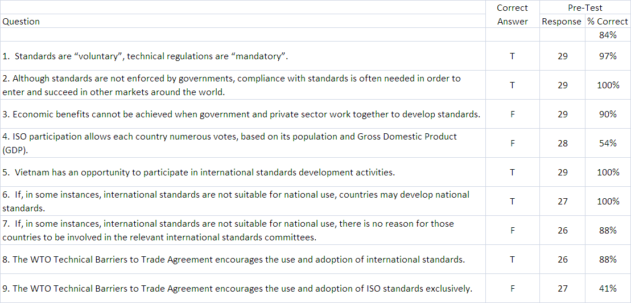
IS1:

IS2:
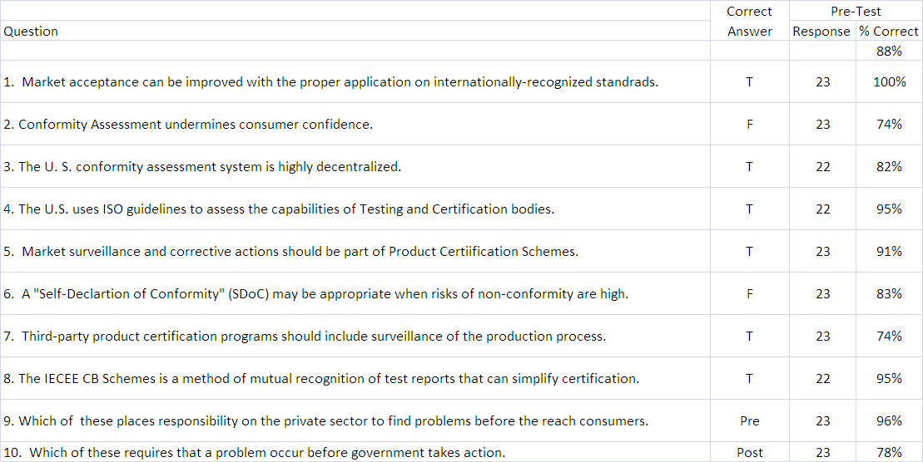
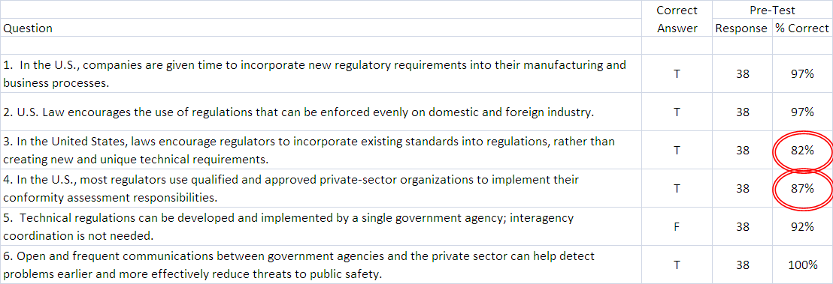
IS3:

IS4:
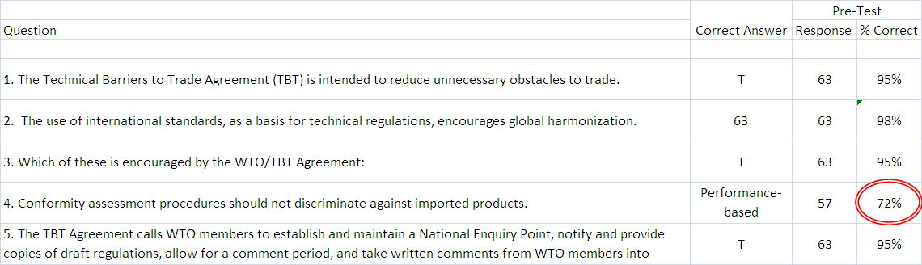
IS5:

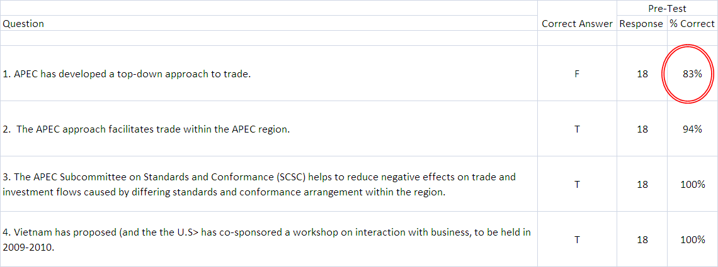
IS6:

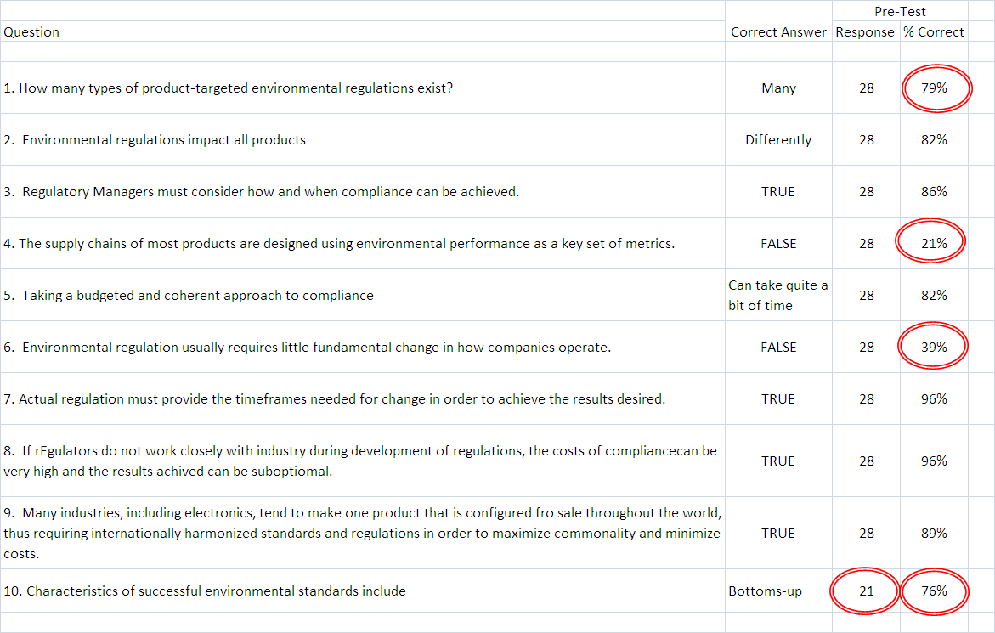
The next table shows the results of the Final Exam. In all but two cases, significant improvements were observed. In one case, dealing with performance-based versus design-based approaches, no significant improvement occurred; approximately 75% of respondents provided the correct answer. In the second case, the percentage of correct responses actually decreased from 78% to 42%, however a number of participants commented that the Vietnamese version of the question on the post-VSTP questionnaire was unclear. This is supported by the fact that only 60% of respondents attempted to answer the question.

Post VSTP:
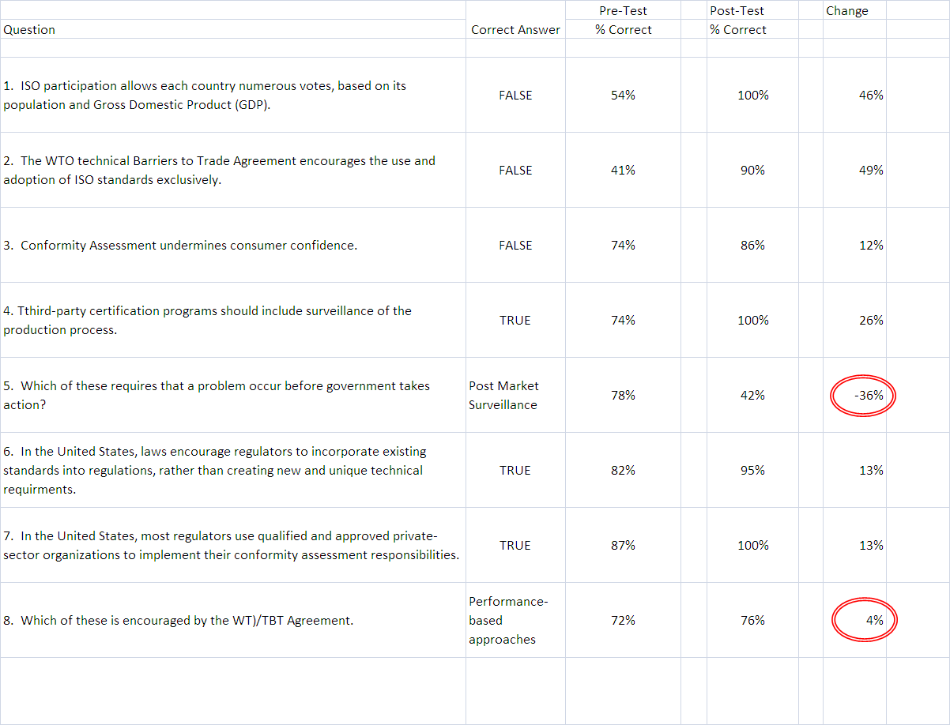

Appendix 12: Summary of VSTP Follow-Up Interviews

The following section summarizes follow-up interviews which were conducted in Hanoi and Ho Chi Minh City, Vietnam in August 2008. These interviews included VSTP students who attended all days of intensive training (many went on to become T3 instructors) as well as representatives of U.S. and other international stakeholders active in Vietnam.

Discussions with VSTP Students

QUATEST 3, STAMEQ, Ms. Lan Diep Thi  QUATEST 3 Director Dung also participated in this discussion. QUATEST 3 sees a priority for more training on developing standards for Vietnamese companies that follow the international principles of openness, transparency, balance, due process, etc. QUATEST 3 would also like more training on the ANSI Essential Requirements, and on ways to contribute toward and to apply standards developed by U.S. – based organizations such as ASTM International.  While training materials prepared for the VSTP are currently being used in divisions of STAMEQ, including QUATEST 3, there is currently no unified training approach or methodology for across STAMEQ divisions, which means that each division is independently creating and delivering its own materials. For this reason, VSTP materials are being used extensively, but in an ad hoc way. | 
Standards Department, STAMEQ, Ms. Vu Thi Hong Hahn and SMEDEC 1, STAMEQ, Ms. Nguyen Thi Hai Yen  Many small and medium-sized companies in Vietnam are aware that they must differentiate themselves based on their ability to deliver quality to but are not always certain of how to accomplish this task. SMEDEC 1 receives many requests from these companies for assistance.  Using training materials which were derived in part by those presented during the VSTP and information shared throughout the program (as well as by materials from ISO, Germany, and Japan), especially related to conformity assessment, SMEDEC 1 already started conducting training with Vietnamese companies to convince them of the long-term benefits of investing in quality. However, SMEDEC 1 has witnessed that follow-up measures by companies to implement what they have learned needs improvement.  Apart from conformity assessment, representatives from SMEDEC 1 found the VSTP training sessions covering Product-focused Environmental Policies and Regulatory Standards of particular value for company training. SMEDEC 1 generally conducts three seminars each per year on quality, customer satisfaction, and customer relations. They foresee an increasing need for training materials in 2009 on specific industry sectors, environmental issues, conformity assessment, and customer relations. |   
QUACERT, STAMEQ, Ms. Ba Tran Thien Thuy and QUATEST 1, STAMEQ, Mr. Nguyen Trong Hien  The principle duties of QUACERT and QUATEST 1 consist of tracking Vietnamese national standards and verifying consensus before they are submitted for Ministerial approval. These divisions work less directly with enterprises and more on policy issues related to standards, conformity assessment, and implementing aspects of the World Trade Organization Technical Barriers to Trade agreement.  To date, they have organized two seminars on standardization, including one for internal staff within STAMEQ and one for enterprises. The seminars have included content on the U.S. approach to standardization and market-driven solutions and information on how to access U.S. resources. The VSTP training materials have been presented to senior-level STAMEQ officials, who have studied them carefully.  STAMEQ is also considering additional means to motivate companies to adopt [international] standards. They have identified the following needs: tools to convince enterprises of the value of standards, methods for developing technical regulations conforming to the U.S. approach, methods for assessing the impact of regulations, and a template for technical regulations. They expect a new law on technical regulations to be finalized in the near future. |   

Vietnam Airlines, Mr. Trinh Nguyen Binh, Deputy Director and Mr. Nguyen Quang Duong, Quality Director  The principle concern for Vietnam Airlines is the company’s ability to comply with standards required by the Federal Aviation Administration (FAA) in order to fly routes to the U.S. as well as to Melbourne and Sydney. This would not only benefit Vietnam Airlines, but would also create significant export opportunities for U.S. equipment and services. However, this requires that the Civil Aviation Administration of Vietnam (CAAV) comply with FAA Circular AC-42. Other requirements include meeting U.S. security requirements and specific aircraft registration requirements with the FAA.  The U.S. has recently given funding to CAAV to assist its harmonizing Vietnamese standards to FAA standards. However, the CAAV needs more technical expertise and capabilities to guide procedural development. They are currently borrowing Vietnam Airlines staff for this purpose. One idea for assisting Vietnam Airlines is to organize opportunities for ANSI to work directly with CAAV. | 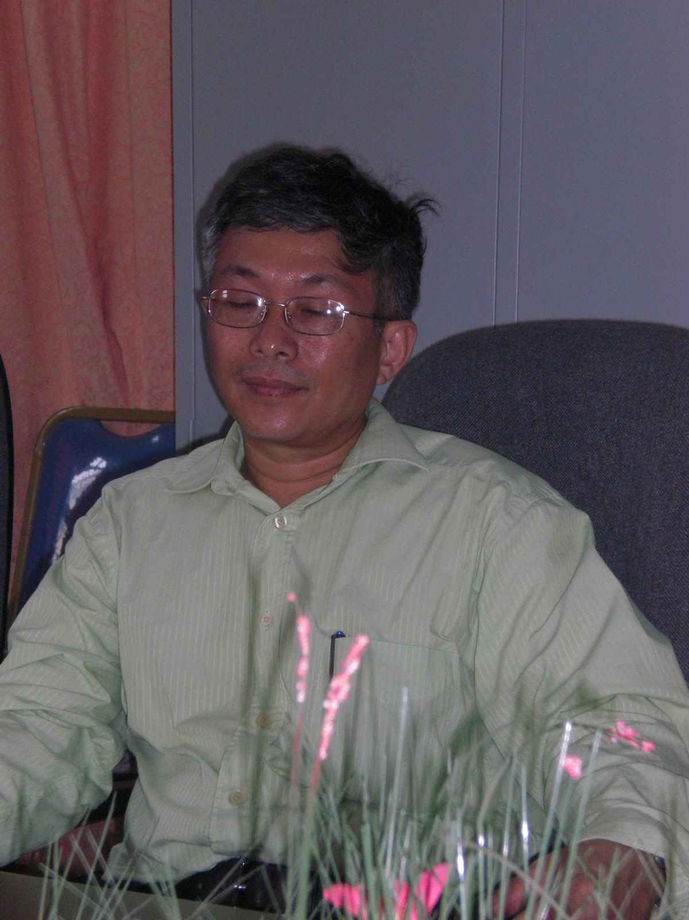  
Quality Management Systems Consultant, Mr. Viet Ahn  Viet Ahn assists companies in obtaining certification to international standards such as ISO 9000, ISO 14000, etc. For each company assignment, Viet Ahn is responsible for preparing the training materials and has used the materials prepared for VSTP to this end. These training materials have been particularly useful in explaining the U.S. approach to standardization and the structure of the U.S. and international standardization and conformity assessment systems, and led to a request for additional information on the step-by-step process for exporting to the United States and on the market access (mandatory, regulatory) versus market acceptance (voluntary, private sector) requirements necessary to enter the U.S. market. | 
Standards Department, STAMEQ, Mr. Nguyen Khoi  Mr. Khoi is responsible for screening draft technical regulations developed by other ministries before they are approved and draft national standards for petroleum, conformity assessment, transportation, etc. While the ministries have autonomy in what they develop within their respective areas of authority, STAMEQ is responsible for reviewing and reporting its opinions through the Ministry of Science and Technology.  In August 2008, Mr. Khoi noted that Vietnamese companies are now placing greater emphasis on developing “company standards” which go above and beyond the requirements of Vietnamese national standards. This approach raises issues concerning copyright protection of the enterprise standard. As of March 2009, Mr. Khoi has cooperated with colleagues to research regulations and practices for international standards regarding copyright protection. Based on this research, STAMEQ’s Standards Department plans on developing a draft Rule for Protection of Standards Copyright.  Mr. Khoi suggested that future initiatives include more training on bottom-up versus top-down models of standardization, training on technical regulations and standardization laws and policies (focusing on the implementation), training on how to issue technical effective technical regulations that meet their legitimate objectives, promotion of company operating procedures for implementation of standards, etc. | 
TBT Office, STAMEQ, Ms. Pham Thi Kim Yen  The TBT Office serves as Vietnam’s national WTO/TBT Enquiry Point, and also has a role in Free Trade Agreements. The Office has already led workshops at the provincial level to share what was learned in VSTP. These were organized by the Ministry of Science and Technology and used materials provided in VSTP training sessions. The training carried out by STAMEQ was videotaped and available at http://www.tbtvn.org/EnglishTBT/default.aspx along with the VSTP training materials.  Following the VSTP training, the TBT Office a Vietnamese WTO/TBT notification for the first time in June 2008 (to date, Vietnam has issued five notifications), and indicated that information provided during the VSTP (particularly the session on WTO/TBT Enquiry Points let by NIST) was very helpful in supporting this development. Additional training on technical regulations and interagency coordination (including communicating the value of the WTO/TBT in general and notification in particular to other ministries) would be particularly helpful. | 
QUACERT, STAMEQ, Ms. Tran Thi Tien Thuy  QUACERT’s Director is making arrangements for the development of training for Vietnamese companies on the U.S. standards process, including standards development and conformity assessment. VSTP materials would be used in this training. Training to help enterprises recognize the value of the WTO/TBT agreement would be very helpful. In the future, QUACERT would like to have closer partnerships with international conformity assessment bodies such as Underwriters’ Laboratories, InterTek, STR, BV, Washington Laboratories, etc. | 
QUACERT, STAMEQ, Ms. Tran Thi Van Ahn  Thi Van Ahn stated that the most interesting point learned in VSTP was that the U.S. has one central point of contact for TBT notification as opposed to the network of ministerial offices dealing with TBT currently operating in Vietnam. In Vietnam, ministries must legally work through STAMEQ but, in practice, STAMEQ only serves a liaison function. Coordination with STAMEQ is not enforced. While VSTP training materials have been very helpful in conducting internal training, it is more complicated to apply the theories and concepts. More information on how to prepare for WTO/TBT committee meetings (and the Triennial Review in particular), and training to help Vietnam address the challenges of coordinating relevant ministries would be useful. | 

CBI, Ltd., Mr. Tran Ngoc Trung  CBI, Ltd. has been providing coaching to enterprises using the training materials from VSTP T3 sessions. In September 2008, Mr. Trung anticipated doing standards training seminars in cooperation with free lance subject matter experts. He wanted to include information on how to set up management systems, internal control systems, and address training materials from the T3 sessions. He was also preparing a workshop on how to develop human resources and foresaw the possibility of another workshop on business re-engineering. Mr. Trung had noted that there is still room for improvement in the Vietnamese public sector in these areas but that it is lacking in expertise to effect change. Efforts by Deutsche Gesellschaft für Technische Zusammenarbeit (GTZ) GmbH and the World Bank to improve public sector expertise have been ineffective, with the exception of major industry sectors exporting to the United States or to the European Union (e.g. fisheries).  As of March 2009, CBI has already held three training seminars using VSTP training materials: the first on business processes on September 25-26, 2008 for 20 participants, the second on business strategy on October 17-18, 2008 for 40 participants, and a final training seminar on lean application on December 27, 2008 for 40 participants. | 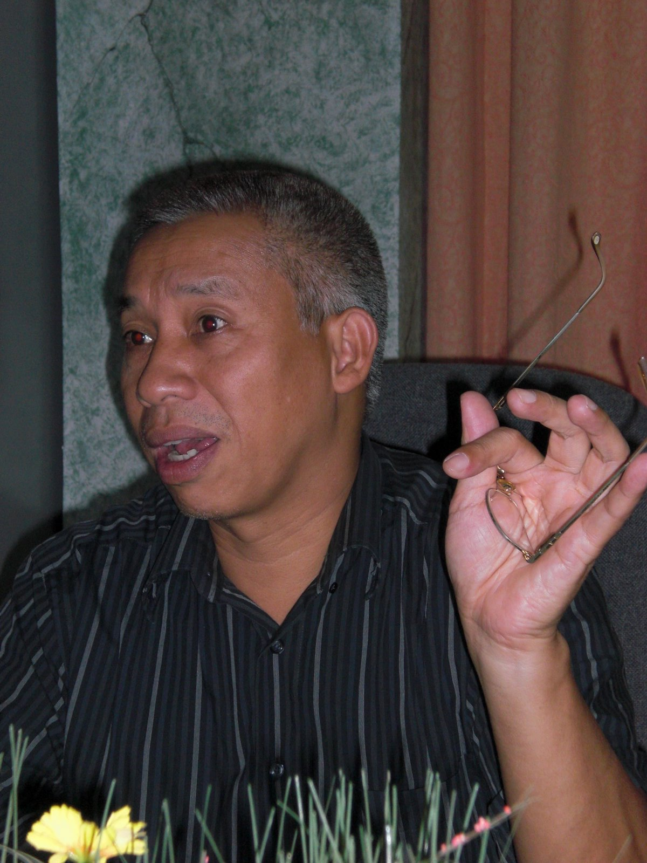

Discussions with U.S. and Other International Stakeholders Operating in Vietnam

As part of the VSTP follow-up, ANSI interviewed several U.S. and international organizations with operations in Vietnam to gain their perspectives on advances that have been made in the area of standards and conformance, and outstanding needs for training and development in Vietnam.

International Trade Commission, Trade Promotion Adviser, Sylvie Bétemps Cocin
The International Trade Commission is an independent federal agency that investigates trade practices in third countries that are potentially harmful to U.S. enterprise. ITC assists locally operating businesses in several industry sectors in identifying trade policy issues and presenting these to Vietnamese stakeholders on three levels, including (1) at the policy and ministerial level (e.g. Ministry of Commerce), (2) with trade institutes and business associations, and (3) directly through commercial enterprises.

ANSI met with the ITC’s Trade Promotion Adviser in Vietnam to discuss opportunities for bilateral cooperation in the Asia Pacific region and elsewhere. ITC expressed interest in a complementary partnership with ANSI on projects such as business-to-business sector promotions. ITC recently conducted a “match-making” event in Malaysia in which they worked to identify similarities in trade issues throughout the full spectrum of the supply and value chains.

American Chamber of Commerce, Ho Chi Minh City, Herb Cochran
Product standards are not yet a strategic priority for most AMCHAM members in Vietnam, as standards and regulatory work is primarily focused by company representatives based in Singapore who have responsibility over the broader Southeast Asia region. The majority of AmCham Ho Chi Minh City representatives are in charge of running on-site company operations for 2-3 years, mostly in resourcing of goods and materials. However, the development of a qualified labor pool, including personnel credentialing and certification is a priority. The supply chain model for most U.S. companies operating in Vietnam is U.S. buyer, Korean or Taiwanese factory owner, and local worker. In the past, the issue of “staff-snatching” has arisen as qualified local employees sought higher wages. In some industry sectors, especially in high tech sectors, the issue of local employees sharing intellectual property when they change positions is a significant concern. Further work in promoting personnel standards and credentialing/ certification in key industry sectors could contribute to building a qualified work force in Vietnam.

General Electric Capital, Sanjay Gupta
General Electric has invested $70 million in Vietnam, a marginal amount for the company. Improving standardization in Vietnam would be most valuable to GE Capital in financial control, increasing transparency and improving regulatory regimes and enforcement. At the moment, it seems that Vietnamese stakeholders are trying to apply foreign models, especially the Chinese model, which is premature in the current Vietnamese phase of development. Future actions should include coordinating the development of a standard on how to make regulations including measures for performing required data collection and analysis, obtaining and considering comments before drafting regulations, etc. and organizing similar VSTP training for targeted engagement with decision makers.

World Bank, Knowledge Manager, Diep Ha
The World Bank operates at the ministerial level. The International Finance Corporation branch of the World Bank cooperates with individual companies. The World Bank has several lending and non-lending projects, including 5-10% of lending projects funding technical assistance to project management units and beneficiaries and non-lending projects funding technical assistance programs to develop capacity in government ministries. There are also pools of trust funds, working with universities, think tanks, WTO (e.g. pre-accession and post-accession training programs), etc. There are typically three-year country assistance programs.

Vietnam’s Ministry of Science and Technology would have to come to the World Bank with a proposal. This could be for bilateral and multilateral support. World Bank is not yet lending to the Ministry of Science and Technology but the current timing for conducting ad hoc training is good. The key to getting World Bank funding is working through either the Ministry of Finance or the Ministry of Planning and Investment to build a case for how standardization contributes to poverty reduction.

Appendix 13: Data from Final VSTP Participant Survey

In May 2009, approximately 12 months after the conclusion of VSTP training, ANSI created an online survey to gauge the impact of the training one year after its conclusion. ANSI contacted each of the 120 VSTP participants by email and telephone, inviting them to complete the online survey. (See Appendix 3 for a complete list of VSTP participants including contact information) Ten percent of all participants completed the survey, and the results are tabulated below.

U.S.-Vietnam Standards Training Program (VSTP)
Response Status: Completes
Apr 22, 2009 7:30 AM PST
Part 1: Please indicate whether the following developmental goals have been advanced as a result of the VSTP: Core Session I: Standards
1. Harmonization of Vietnamese standards to globally relevant international standards wherever practicable.
 |  |  | U.S.  Participants | Vietnamese  Participants | Total
This goal has been advanced a great deal |  |  | 0% | 57% | 4 | 33%
This goal has been somewhat advanced |  |  | 40% | 14% | 3 | 25%
Progress on this goal is underway |  |  | 60% | 29% | 5 | 42%
This goal has not been advanced at all |  |  | 0% | 0% | 0 | 0%
I don’t know |  |  | 0% | 0% | 0 | 0%
Total |  |  | 100% | 100% | 12 | 100%
2. Official and/or legal recognition of “international standards”
 |  |  | U.S.  Participants | Vietnamese  Participants | Total
This goal has been advanced a great deal |  |  | 20% | 57% | 5 | 42%
This goal has been somewhat advanced |  |  | 0% | 29% | 2 | 16%
Progress on this goal is underway |  |  | 80% | 14% | 5 | 42%
This goal has not been advanced at all |  |  | 0% | 0% | 0 | 0%
I don’t know |  |  | 0% | 0% | 0 | 0%
Total |  |  | 100% | 100% | 12 | 100%

3. Vietnam has a plan to "phase in" international standards within a set time frame, and should accept international standards as equivalent to the corresponding national standards in the mean time.
 |  |  | U.S.  Participants | Vietnamese  Participants |  | Total
This goal has been advanced a great deal |  |  | 0% | 57% |  | 4 |  | 33%
This goal has been somewhat advanced |  |  | 80% | 43% |  | 7 |  | 58%
Progress on this goal is underway |  |  | 20% | 0% |  | 1 |  | 8%
This goal has not been advanced at all |  |  | 0% | 0% |  | 0 |  | 0%
I don’t know |  |  | 0% | 0% |  | 0 |  | 0%
Total |  |  | 100% | 100% |  | 12 |  | 100%
4. Vietnam follows the Code of Good practice for standards development as outlined in the World Trade Organization (WTO) / Technical Barriers to Trade (TBT) Agreement.
 |  |  | U.S.  Participants |  | Vietnamese  Participants |  | Total
This goal has been advanced a great deal |  |  | 20% |  | 29% |  | 3 |  | 25%
This goal has been somewhat advanced |  |  | 0% |  | 14% |  | 1 |  | 8%
Progress on this goal is underway |  |  | 80% |  | 43% |  | 7 |  | 58%
This goal has not been advanced at all |  |  | 0% |  | 0% |  | 0 |  | 0%
I don’t know |  |  | 0% |  | 14% |  | 1 |  | 8%
Total |  |  | 100% |  | 100% |  | 12 |  | 100%

Part 2: Please indicate whether the following developmental goals have been advanced as a result of the VSTP: Core Session II: Conformity Assessment
5. Conformity assessment requirements and procedures should be driven by the characteristics of individual industry sectors and the associated risks of specific products.
 |  |  | U.S.  Participants | Vietnamese  Participants |  | Total
This goal has been advanced a great deal |  |  | 20% | 29% |  | 3 |  | 25%
This goal has been somewhat advanced |  |  | 20% | 29% |  | 3 |  | 25%
Progress on this goal is underway |  |  | 20% | 43% |  | 4 |  | 33%
This goal has not been advanced at all |  |  | 0% | 0% |  | 0 |  | 0%
I don’t know |  |  | 40% | 0% |  | 2 |  | 16%
Total |  |  | 100% | 100% |  | 12 |  | 100%
6. Equal access to the Vietnamese market is provided for all conformity assessment bodies, both foreign and domestic.
 |  |  | U.S.  Participants |  | Vietnamese  Participants |  | Total
This goal has been advanced a great deal |  |  | 20% |  | 71% |  | 6 |  | 50%
This goal has been somewhat advanced |  |  | 20% |  | 14% |  | 2 |  | 16%
Progress on this goal is underway |  |  | 40% |  | 14% |  | 3 |  | 25%
This goal has not been advanced at all |  |  | 0% |  | 0% |  | 0 |  | 0%
I don’t know |  |  | 20% |  | 0% |  | 1 |  | 8%
Total |  |  | 100% |  | 100% |  | 12 |  | 100%

7. The criteria for conformity assessment bodies should be open, transparent and based on applicable international standards.
 |  |  | U.S.  Participants | Vietnamese  Participants |  | Total
This goal has been advanced a great deal |  |  | 0% | 71% |  | 5 |  |  |  |  | 42%
This goal has been somewhat advanced |  |  | 20% | 0% |  | 1 |  |  |  |  | 8%
Progress on this goal is underway |  |  | 80% | 29% |  | 6 |  |  |  |  | 50%
This goal has not been advanced at all |  |  | 0% | 0 |  | 0 |  |  |  |  | 0%
I don’t know |  |  | 0% | 0 |  | 0 |  |  |  |  | 0%
Total |  |  | 100% | 100% |  | 12 |  |  |  |  | 100%
8. Suppliers' Declaration of Conformity (SDoC) is accepted for appropriate product sectors (e.g. earthmoving and agricultural machinery, Information and Communication Technologies (ICT), etc.)
 |  |  | U.S.  Participants | Vietnamese  Participants |  |  | Total
This goal has been advanced a great deal |  |  | 0% | 29% |  |  | 2 |  |  |  |  | 16%
This goal has been somewhat advanced |  |  | 40% | 14% |  |  | 3 |  |  |  |  | 25%
Progress on this goal is underway |  |  | 20% | 29% |  |  | 3 |  |  |  |  | 25%
This goal has not been advanced at all |  |  | 0% | 0% |  |  | 0 |  |  |  |  | 0%
I don’t know |  |  | 40% | 29% |  |  | 4 |  |  |  |  | 33%
Total |  |  | 100% | 100% |  |  | 12 |  |  |  |  | 100%
9. Vietnam has joined (or is in the process of joining) the IECEE/CB Scheme and other IEC conformity assessment schemes and will accept IECEE test results in the mean time.
 |  |  | U.S.  Participants | Vietnamese  Participants |  |  |  | Total
This goal has been advanced a great deal |  |  | 20% | 0% |  |  |  | 1 |  |  |  |  | 8%
This goal has been somewhat advanced |  |  | 40% | 29% |  |  |  | 4 |  |  |  |  | 33%
Progress on this goal is underway |  |  | 20% | 29% |  |  |  | 3 |  |  |  |  | 25%
This goal has not been advanced at all |  |  | 0% | 0% |  |  |  | 0 |  |  |  |  | 0%
I don’t know |  |  | 20% | 43% |  |  |  | 4 |  |  |  |  | 33%
Total |  |  | 100% | 100% |  |  |  | 12 |  |  |  |  | 100%
Part 3: Please indicate whether the following developmental goals have been advanced as a result of the VSTP: Core Session III: Technical Regulations
10. Vietnam has adopted a consistent and accepted definition, based on definition outlined the World Trade Organization(WTO)/Technical Barriers to Trade (TBT) Agreement, for what constitutes a “technical regulation.”
 |  |  | U.S.  Participants | Vietnamese  Participants |  |  |  |  | Total
This goal has been advanced a great deal |  |  | 40% | 86% |  |  |  |  | 8 |  |  |  |  | 67%
This goal has been somewhat advanced |  |  | 20% | 14% |  |  |  |  | 2 |  |  |  |  | 16%
Progress on this goal is underway |  |  | 40% | 0% |  |  |  |  | 2 |  |  |  |  | 16%
This goal has not been advanced at all |  |  | 0% | 0% |  |  |  |  | 0 |  |  |  |  | 0%
I don’t know |  |  | 0% | 0% |  |  |  |  | 0 |  |  |  |  | 0%
Total |  |  | 100% | 100% |  |  |  |  | 12 |  |  |  |  | 100%
11. Vietnam has developed and implemented a comprehensive Vietnamese Code of Federal Regulations (CFR) and Federal Register (FR) mechanism.
 |  |  | U.S.  Participants |  | Vietnamese  Participants |  |  |  |  | Total
This goal has been advanced a great deal |  |  | 0% |  | 0% |  |  |  |  | 0 |  |  |  |  | 0%
This goal has been somewhat advanced |  |  | 40% |  | 14% |  |  |  |  | 3 |  |  |  |  | 25%
Progress on this goal is underway |  |  | 40% |  | 14% |  |  |  |  | 3 |  |  |  |  | 25%
This goal has not been advanced at all |  |  | 20% |  | 43% |  |  |  |  | 4 |  |  |  |  | 33%
I don’t know |  |  | 0% |  | 29% |  |  |  |  | 2 |  |  |  |  | 16%
Total |  |  | 100% |  | 100% |  |  |  |  | 12 |  |  |  |  | 100%

12. Vietnam has developed and implemented procedures to consider and address stakeholder input on proposed regulations.
 |  |  | U.S.  Participants | Vietnamese  Participants | Total
This goal has been advanced a great deal |  |  | 0% | 14% | 1 |  |  | 8%
This goal has been somewhat advanced |  |  | 20% | 29% | 3 |  |  | 25%
Progress on this goal is underway |  |  | 60% | 29% | 5 |  |  | 42%
This goal has not been advanced at all |  |  | 20% | 14% | 2 |  |  | 16%
I don’t know |  |  | 0% | 14% | 1 |  |  | 8%
Total |  |  | 100% | 100% | 12 |  |  | 100%
13. Vietnam has implemented cost/benefit analysis for all proposed technical regulations.
 |  |  | U.S.  Participants | Vietnamese  Participants |  | Total
This goal has been advanced a great deal |  |  | 0% | 0% |  | 0 |  |  | 0%
This goal has been somewhat advanced |  |  | 20% | 14% |  | 2 |  |  | 16%
Progress on this goal is underway |  |  | 40% | 57% |  | 6 |  |  | 50%
This goal has not been advanced at all |  |  | 0% | 14% |  | 1 |  |  | 8%
I don’t know |  |  | 40% | 14% |  | 3 |  |  | 25%
Total |  |  | 100% | 100% |  | 12 |  |  | 100%
14. Vietnam ensures effective enforcement for all technical regulations. Enforcement is consistent for domestic and foreign companies.
 |  |  | U.S.  Participants | Vietnamese  Participants |  |  | Total
This goal has been advanced a great deal |  |  | 20% | 57% |  |  | 5 |  |  | 42%
This goal has been somewhat advanced |  |  | 0% | 29% |  |  | 2 |  |  | 16%
Progress on this goal is underway |  |  | 40% | 14% |  |  | 3 |  |  | 25%
This goal has not been advanced at all |  |  | 40% | 0% |  |  | 2 |  |  | 16%
I don’t know |  |  | 0% | 0% |  |  | 0 |  |  | 0%
Total |  |  | 100% | 100% |  |  | 12 |  |  | 100%
15. Vietnam has developed and implemented polices allowing regulators to use voluntary consensus standards as a foundation for their regulations.
 |  |  | U.S.  Participants | Vietnamese  Participants |  |  | Total
This goal has been advanced a great deal |  |  | 0% | 57% |  |  | 4 |  |  |  | 33%
This goal has been somewhat advanced |  |  | 20% | 14% |  |  | 2 |  |  |  | 16%
Progress on this goal is underway |  |  | 40% | 29% |  |  | 4 |  |  |  | 33%
This goal has not been advanced at all |  |  | 20% | 0% |  |  | 1 |  |  |  | 8%
I don’t know |  |  | 20% | 0% |  |  | 1 |  |  |  | 8%
Total |  |  | 100% | 100% |  |  | 12 |  |  |  | 100%
Part 4: Please indicate whether the following developmental goals have been advanced as a result of the VSTP: Core Session IV: World Trade Organization (WTO)/Technical Barriers to Trade (TBT) Agreement
16. Vietnam consistently notifies the WTO Secretariat of proposed Vietnamese technical regulations that would significantly affect trade.
 |  |  | U.S.  Participants | Vietnamese  Participants |  |  | Total
This goal has been advanced a great deal |  |  | 0% | 43% |  |  | 3 |  |  |  |  | 25%
This goal has been somewhat advanced |  |  | 40% | 29% |  |  | 4 |  |  |  |  | 33%
Progress on this goal is underway |  |  | 60% | 14% |  |  | 4 |  |  |  |  | 33%
This goal has not been advanced at all |  |  | 0% | 14% |  |  | 1 |  |  |  |  | 8%
I don’t know |  |  | 0% | 0% |  |  | 0 |  |  |  |  | 0%
Total |  |  | 100% | 100% |  |  | 12 |  |  |  |  | 100%

17. Vietnam has developed and implemented procedures to disseminate WTO notifications and other TBT-related information to Vietnamese stakeholders.
 |  |  | U.S.  Participants | Vietnamese  Participants | Total
This goal has been advanced a great deal |  |  | 20%
This goal has been somewhat advanced |  |  | 20%
Progress on this goal is underway |  |  | 40%
This goal has not been advanced at all |  |  | 20%
I don’t know |  |  | 0%
Total |  |  | 100%
18. Vietnam has developed and implemented procedures to collect broad Vietnamese stakeholder input to support the development of Vietnamese positions in the WTO/TBT Committee.
This goal has been advanced a great deal |  | 1 | 20%
This goal has been somewhat advanced |  | 0 | 0%
Progress on this goal is underway |  | 2 | 40%
This goal has not been advanced at all |  | 1 | 20%
I don’t know |  | 1 | 20%
Total |  | 5 | 100%
19. There is a clear understanding of WTO/TBT requirements among Vietnamese trade agencies, standards officials, regulators and industry.
This goal has been advanced a great deal |  | 1 | 20%
This goal has been somewhat advanced |  | 0 | 0%
Progress on this goal is underway |  | 3 | 60%
This goal has not been advanced at all |  | 0 | 0%
I don’t know |  | 1 | 20%
Total |  | 5 | 100%

Part 5: Please indicate whether the following developmental goals have been advanced as a result of the VSTP: Core Session V: Asia Pacific Economic Cooperation (APEC)
20. Vietnam has developed and implemented procedures to coordinate broad Vietnamese industry input, support and participation in APEC-Sub Committee on Standards and Conformance (SCSC), as well as the in the Pacific Area Standards Congress, a Specialist Regional Body (SRB) of APEC.
This goal has been advanced a great deal |  | 0 | 0%
This goal has been somewhat advanced |  | 1 | 20%
Progress on this goal is underway |  | 3 | 60%
This goal has not been advanced at all |  | 0 | 0%
I don’t know |  | 1 | 20%
Total |  | 5 | 100%
Part 6: Please indicate whether the following developmental goals have been advanced as a result of the VSTP: Elective Session I: Product-focused Environmental Policies - March 17
21. Vietnamese policy makers understand and consider the potential supply-chain-wide impact of environmental regulations targeted at end-user (consumer/business) products.
This goal has been advanced a great deal |  | 0 | 0%
This goal has been somewhat advanced |  | 1 | 20%
Progress on this goal is underway |  | 1 | 20%
This goal has not been advanced at all |  | 2 | 40%
I don’t know |  | 1 | 20%
Total |  | 5 | 100%

22. Vietnam understands how voluntary programs can support product-focused environmental policies and relies on such programs in lieu of mandatory regulations wherever possible.
This goal has been advanced a great deal |  | 1 | 17%
This goal has been somewhat advanced |  | 0 | 0%
Progress on this goal is underway |  | 3 | 50%
This goal has not been advanced at all |  | 0 | 0%
I don’t know |  | 2 | 33%
Total |  | 6 | 100%
23. Vietnam uses applicable international standards (e.g. IEC, ASTM International, IPC, etc.) as a foundation for voluntary and mandatory chemical management programs.
This goal has been advanced a great deal |  | 0 | 0%
This goal has been somewhat advanced |  | 1 | 17%
Progress on this goal is underway |  | 2 | 33%
This goal has not been advanced at all |  | 0 | 0%
I don’t know |  | 3 | 50%
Total |  | 6 | 100%
24. Vietnam uses and accepts private sector conformity assessment for voluntary and mandatory product-focused environmental management programs.
This goal has been advanced a great deal |  | 0 | 0%
This goal has been somewhat advanced |  | 1 | 17%
Progress on this goal is underway |  | 2 | 33%
This goal has not been advanced at all |  | 1 | 17%
I don’t know |  | 2 | 33%
Total |  | 6 | 100%
Part 7: Do the participants have familiarity with the various aspects of the U.S. approach to standards and technical regulations as described in the VSTP?
To what extent did the VSTP make you familiar with the following aspects of the U.S. approach to standards and technical regulations?
25. Harmonization of standards to globally relevant international standards wherever practicable.
The VSTP greatly increased my familiarity with this aspect of the U.S. approach |  | 1 | 17%
The VSTP somewhat increased my familiarity with this aspect of the U.S. approach |  | 4 | 67%
The VSTP did not increase my familiarity with this aspect of the U.S. approach |  | 1 | 17%
Total |  | 6 | 100%
26. The Code of Good practice for standards development as outlined in the WTO/TBT Agreement.
The VSTP greatly increased my familiarity with this aspect of the U.S. approach |  | 2 | 33%
The VSTP somewhat increased my familiarity with this aspect of the U.S. approach |  | 4 | 67%
The VSTP did not increase my familiarity with this aspect of the U.S. approach |  | 0 | 0%
Total |  | 6 | 100%
27. Conformity assessment requirements and procedures are driven by the characteristics of individual industry sectors and the associated risks of specific products.
The VSTP greatly increased my familiarity with this aspect of the U.S. approach |  | 3 | 50%
The VSTP somewhat increased my familiarity with this aspect of the U.S. approach |  | 3 | 50%
The VSTP did not increase my familiarity with this aspect of the U.S. approach |  | 0 | 0%
Total |  | 6 | 100%
28. The criteria for conformity assessment bodies should be open, transparent and based on applicable international standards.
The VSTP greatly increased my familiarity with this aspect of the U.S. approach |  | 1 | 17%
The VSTP somewhat increased my familiarity with this aspect of the U.S. approach |  | 3 | 50%
The VSTP did not increase my familiarity with this aspect of the U.S. approach |  | 2 | 33%
Total |  | 6 | 100%
29. Suppliers’ Declaration of Conformity (SDoCIS) is accepted for appropriate product sectors.
The VSTP greatly increased my familiarity with this aspect of the U.S. approach |  | 2 | 33%
The VSTP somewhat increased my familiarity with this aspect of the U.S. approach |  | 2 | 33%
The VSTP did not increase my familiarity with this aspect of the U.S. approach |  | 2 | 33%
Total |  | 6 | 100%
30. Has a comprehensive Code of Federal Regulations (CFR) and Federal Register (FR) mechanism.
The VSTP greatly increased my familiarity with this aspect of the U.S. approach |  | 3 | 50%
The VSTP somewhat increased my familiarity with this aspect of the U.S. approach |  | 2 | 33%
The VSTP did not increase my familiarity with this aspect of the U.S. approach |  | 1 | 17%
Total |  | 6 | 100%
31. Have procedures to consider and address stakeholder input on proposed regulations.
The VSTP greatly increased my familiarity with this aspect of the U.S. approach |  | 1 | 17%
The VSTP somewhat increased my familiarity with this aspect of the U.S. approach |  | 3 | 50%
The VSTP did not increase my familiarity with this aspect of the U.S. approach |  | 2 | 33%
Total |  | 6 | 100%
32. Requires a cost/benefit analysis for all proposed technical regulations.
The VSTP greatly increased my familiarity with this aspect of the U.S. approach |  | 1 | 20%
The VSTP somewhat increased my familiarity with this aspect of the U.S. approach |  | 3 | 60%
The VSTP did not increase my familiarity with this aspect of the U.S. approach |  | 1 | 20%
Total |  | 5 | 100%
33. Consistently notifies the WTO Secretariat of proposed Vietnamese technical regulations that would significantly affect trade.
The VSTP greatly increased my familiarity with this aspect of the U.S. approach |  | 2 | 33%
The VSTP somewhat increased my familiarity with this aspect of the U.S. approach |  | 3 | 50%
The VSTP did not increase my familiarity with this aspect of the U.S. approach |  | 1 | 17%
Total |  | 6 | 100%
34. Has procedures to disseminate WTO notifications and other TBT-related information to Vietnamese stakeholders.
The VSTP greatly increased my familiarity with this aspect of the U.S. approach |  | 3 | 50%
The VSTP somewhat increased my familiarity with this aspect of the U.S. approach |  | 1 | 17%
The VSTP did not increase my familiarity with this aspect of the U.S. approach |  | 2 | 33%
Total |  | 6 | 100%
35. Policy makers understand and consider the potential supply-chain-wide impact of environmental regulations targeted at end-user (consumer/business) products.
The VSTP greatly increased my familiarity with this aspect of the U.S. approach |  | 2 | 33%
The VSTP somewhat increased my familiarity with this aspect of the U.S. approach |  | 2 | 33%
The VSTP did not increase my familiarity with this aspect of the U.S. approach |  | 2 | 33%
Total |  | 6 | 100%
36.: Have the projections you made at the end of the VSTP, with regard to teaching standards and conformity been realized?
A great deal |  | 2 | 33%
Somewhat |  | 3 | 50%
Not at all |  | 1 | 17%
Total |  | 6 | 100%

Appendix 14: U.S. Company Testimonials

Caterpillar, Inc.
Caterpillar, a global manufacturer and major exporter from the USA, considers Vietnam to be one of the key emerging markets in Southeast Asia, and was pleased to see that the VSTP addressed ways for Vietnam to further open its trade to American companies. Standards, conformity assessment and technical regulations, and their related policies, play a very important role in our company’s ability to export. We see the VSTP as a critical foundation for long-term U.S. engagement to encourage policies that help keep the door open for companies like Caterpillar to do business in Vietnam, and in the broader Southeast Asia region. Caterpillar played an active role in the VSTP, dispatching Alex Chong, who handles regulations and compliance in our Product Development Center of Excellence Department, to participate in a week of VSTP training sessions. In addition to the medium- and longer-term policy changes that we anticipate in Vietnam as a result of the VSTP, Caterpillar also gained significant short-term benefit from the opportunity to establish contacts and relationships with key decision makers from within the Vietnamese government. Our experience doing business around the world has shown that knowing the right leader to talk to, and having a positive relationship with key leaders is a key factor in enabling companies to address potential issues or concerns before they become trade barriers. Vietnam's economic growth rate is encouraging, as projected by the Asian Development Bank from current 4.5 percent in 2009 to 6.5 percent next year due to continued increase in Foreign Direct Investment. The economic reforms and further opening of its economy will increase confidence of foreign investors. Over the period during which the VSTP has been implemented, Caterpillar’s exports businesses continues to benefit from its progressive policy changes for a more open economy.
-Dan Roley, Director of Standards and Regulations, Caterpillar

QUALCOMM
With worldwide business revenues in 2008 of $11.14 billion, QUALCOMM considers Southeast Asia to be a strategic growth market, and Vietnam to be particularly important in this region. Technology and business model neutrality and effectiveness of national standardization policies around the world directly impact our ability to do business internationally, and proactive engagement with governments and other stakeholders in standardization is critical to ensuring our ongoing ability to do business. We appreciated that the Vietnam Standards Training Program (VSTP) addressed ways for Vietnam to further open its trade to American companies, and participated in the training sessions focusing on standards. We feel that this session laid an important foundation of concepts that will encourage Vietnamese policy makers to continue to consider industry input when developing standards, to take a wide view of the types of standards that should be used in the Vietnamese market, and to avoid policies that would jeopardize the intellectual property rights (patents) and business models of U.S. companies like QUALCOMM. We also appreciated the opportunity to meet key leaders from within Vietnam’s standards community, and to hear and gain a better understanding of their objectives and challenges. We feel that these insights and relationships will serve us well in the future.
- Kent Baker, Vice President, Standards and Intellectual Property Rights, Government Affairs, QUALCOMM Incorporated

Underwriters Laboratories (UL)
On October 20th, 2008, we announced the opening of the UL Representative Office in Vietnam. This is our fourth office in the Southeast Asia, after Singapore, Malaysia and Thailand, and an indication of our commitment to expand in this growth market.

Concurrently, we also signed a very significant MOU with Quality Assurance and Testing Center 3 (Quatest 3), a Science-Technological Organization of Directorate of Standards and Quality (STAMEQ) under the Ministry of Science and Technology (MOST), Vietnam. The agreement lists out the areas of cooperation between UL and Quatest 3 and envisages the following: Quatest 3 entering UL's Data Acceptance Program (DAP) and becoming a CB Test Laboratory (CBTL) under UL, thereby dramatically expanding our capability to test products locally in Vietnam for Global Market Access. Products under harmonized categories entering the Vietnam market tested at UL laboratories worldwide and certified to UL standards will be considered fully compliant with local Vietnamese compulsory certification requirements. The MOU signing ceremony was held in the presence of Dr. Ngo Quy Viet, Director General of STAMEQ and Mr. William Marshak, Principal Commercial Officer, US Commercial Service, Vietnam. The event was covered extensively in the local media (Print, Radio as well asTV) and has given significant visibility and raised interest about UL's services.
This partnership with Quatest 3, the most reputed testing and certification organization in Vietnam, provides a win-win situation to our customers, UL and Quatest 3. By leveraging the additional testing capability of Quatest 3, customers can benefit from the local testing capabilities of Quatest 3 and thereby hasten their ability to get their products to global markets. For Quatest 3, this gives it ability to better serve the needs of customers as a single source for testing for local as well as international requirements.
This relationship also paves the way for a larger partnership with STAMEQ, with indications that Vietnam would be open to using UL standards for areas such as fire and security products, where standards are still under development in the country. We appreciate the opportunities ANSI's program allowed us to engage with counterparts, to feature our expertise in conformity assessment issues, and to find out more about the particular market needs in Vietnam.
-Erin Grossi, Manager, International Affairs, Underwriters Laboratories
Appendix 15: Summary of Vietnamese Requests for Follow-up Training

STAMEQ and other VSTP participants have put forward training requests in the following areas:

- Follow-up training for companies on how to implement quality control measures
- Industry-specific training covering environmental policies, conformity assessment and customer relations
- Company-targeted training on the value of standards and long-term benefits of investing in quality
- Training on impact assessment for technical regulations
- Training in the step-by-step process of exporting to the United States
- Additional training on the differences between market access and market acceptance requirements
- Additional training on bottom-up versus top-down models of standardization
- Training on preparation for WTO/TBT meetings with specific focus on Vietnam’s challenges in coordinating ministries
- Additional training on developing technical regulations that conform to the U.S. approach and how to issue them effectively
- Additional training for developing standardization laws
- Complying with the WTO/TBT and SPS agreements (various government mechanisms for implementation, case studies on compliance, etc.)
- The respective roles of the private and public sectors in the U.S. standards and conformity assessment systems (including practical information on how the public/private partnership is carried out in the U.S.)
- Practical guidance on how to meet the WTO’s key principles for the development of international standards (transparency, due process, openness, balance, etc.)
- Options for harmonizing Vietnam’s approach to standardization with the U.S. approach
- Industry-specific training for meeting U.S. market access and market acceptance requirements (particularly for Vietnam’s small and medium-sized enterprises)
- Training to help Vietnamese industry participate more effectively in national and international standards development
- Government mechanisms for using and referencing voluntary consensus standards in regulations
- Best practices for product risk assessment in relation to health, safety and environment when setting technical regulations
- Training on ANSI Essential Requirements and on the implementation and management of ANSI’s American National Standards (ANS) program, including guidance on how this program could be applied in Vietnam

To demonstrate the interest expressed by Vietnam in continuing training and engagement with the United States, outlined below are proposed training concepts that Vietnam proactively put forward to NIST following a “Standards in Trade” (SIT) program carried out for Vietnam in September 2008. Elements of these proposals were integrated into a second SIT workshop that will be carried out in September 2009 in Hanoi, Vietnam.

- Implementation of standards and technical regulations, codes on fire safety in design, construction and utilizing of building
- Fire safety and protection (especially in fire fighting techniques) for multistory buildings (over 100 m) and solutions for escape and rescue in the event of a fire
- Fire safety for underground construction (e.g. underground road trenches, underground vault systems and metro & subway stations, underground vehicle garages, underground shops and supermarkets, etc.)
- Fire safety for cooking gas supply systems in high-store apartment blocks
- Fire protection for steel (metal) construction and resistance to premature collapse
- Water supply solutions for firefighting inside and outside a building
- New fire safety and protection techniques and technologies for building

In addition, training was requested on Quality Management (QM) in construction and production of goods with fire safety requirements. The workshop would primarily be an information exchange between the U.S. and Vietnam to enable Vietnam’s stakeholders to understand and implement relevant fire safety measures.

This would cover topics such as:

- Legislative system for documentation of fire safety
- Management procedures in the U.S. and relevant experience applicable to Vietnam
- Fire safety activities in the U.S.
- U.S. consultancy agencies on fire safety (e.g. design, surveillance, etc.)
- List of goods with fire safety requirements
- Producers and/or traders of goods with fire safety requirements located in Vietnam
- Relevant agencies and organizations involved in ensuring fire safety requirements (e.g. testing labs, regulatory authorities, licensing authorities, inspection bodies, quality control during production and trading, etc.)
- How the above collaborate with one another
- Implementation procedures (e.g. production registration, business registration, testing and licensing authorization for circulating and trading goods, inspection & control in production and business)
- Basic requirements and best practices in fire safety for high-rise building and underground construction (e.g. metro, subway, garage, etc.)

Participants could include relevant regulatory authorities (e.g. MOPS, MOC, MOIT, STAMEQ, and industries), producers and business organizations, Quality Management System consultancy bodies, and others.

Topics could include:

- Current situation of fire safety in Vietnam including organizational chart, standards, technical regulations and codes, equipment, etc.
- Current situation on fire safety training & education in Vietnam including training and education methods, fire safety testing labs, professional education on fire safety, control and inspection agencies, educational capacity to respond to fire safety needs, and the corresponding situation in the U.S.
- Shortcomings in fire safety and protection in Vietnam;
- Orientations on fire safety and protection in Vietnam

Appendix 16: Reference Glossary of Standards and Conformance Terms
(The following appendix was originally presented in the VSTP Intermediate Report outlines unofficial definitions of commonly used terms that were provided to VSTP participants.)
- Accession: Becoming a member of the WTO, signing on to its agreements. New members have to negotiate terms bilaterally with individual WTO members and multilaterally, (1) to convert the results of the bilateral negotiations so that they apply to all WTO members, and (2) on required legislation and institutional reforms that are need to meet WTO obligations.
- APEC Business Advisory Council (ABAC): Council of business leaders that advise APEC on issues of concern to businesses.
- Accreditation: The procedure by which an authoritative body gives formal recognition that a body or person is competent to carry out specific tasks.
- Administrative Procedures Act (APA): U.S. Legal requirements and procedures to ensure transparent and Open Rule Making
- Audited Designator: An Audited Designator is an accredited standards developer who has been granted the authority to designate their standards as National Standards without such standards being reviewed and approved by the Board of Standards Review but such developer is subjected to additional audits.
- Commercial Inspection and Testing: Determines if products meet a customer’s expectations when the confidence needs of purchaser require inspection in addition to quality management systems.
- Conformity assessment: Any procedure used, directly or indirectly, to determine that relevant requirements in technical regulations or standards are fulfilled (e.g., testing, certification).
- Continuous maintenance: Continuous maintenance is defined as the maintenance of a standard by consideration of recommended changes to any part of it according to a documented schedule for consideration and action by the consensus body.
- Consensus: Consensus means substantial agreement has been reached by directly and materially affected interests. This signifies the concurrence of more than a simple majority, but not necessarily unanimity. Consensus requires that all views and objections be considered, and that an effort be made toward their resolution.
- Consensus body: The group that approves the content of a standard and whose vote demonstrates evidence of consensus.
- Field Report: A report that an product does not comply with an applicable standard, or that there is a safety problem with the product.
- First Party Conformity Assessment: Conformity Assessment performed by the supplier of a product.
- Harmonization: Process by which standards on the same subject (including requirements for conformity assessment) which are approved by different standardizing bodies establishes interchangeability of products, processes, and services, or mutual understanding of test results or information provided according to these standards.
- IECEE CB Scheme: International system for acceptance of test certificates dealing with the safety of electrical and electronic products.
- Informal Rulemaking Procedures: Provide an opportunity for interested persons to submit written data, views or arguments on a proposed standard.
- (Mandatory) technical regulation: Document which lays down product characteristics or their related processes and production methods, including the applicable administrative provisions, with which compliance is mandatory.
- Market Access: Openness of a country's markets to foreign goods and services.
- Market Acceptance: Condition in which a good or service satisfies the needs of a sufficiently large number of customers to continue or increase its production or availability.
- Market Surveillance Programs: Programs designed by public authorities in order to verify that a product is in conformity with relevant technical regulations.
- Marks of Conformity: Marks identifying the products, processes and services that meet the requirements of a standard in effect.
- National Center for Standards and Certification Information (NCSCI) (US organization): Provides free, expert, custom standards information services, and maintains and makes available research collections in online repositories, databases, and print publications.
- National Technology Transfer Act (U.S. law): Directs federal agencies to use voluntary consensus standards, both domestic and international, in lieu of government-developed regulations, except when inconsistent with the law or otherwise impractical
- Notice of proposed rulemaking: Informs the public of the proposal and requests public comment on it, and specifies a comment period.
- Periodic maintenance: Periodic maintenance is defined as the maintenance of a standard by review of the entire document and action to revise or reaffirm it on a schedule (in the U.S., not to exceed five years from the date of its approval).
- Product Certification includes two basic components: investigation (includes testing, comparing to requirements, and determining compliance) and surveillance: (among other things, unannounced and frequent product inspections, witnessing of production).
- Proxy: A written and signed document by which a voting member of a consensus body authorizes another person to vote in the member’s stead, if allowed by the developer’s procedures.
- Quality System Registration: a review of a procedure, an on-site assessment of the implementation of the procedure, and audits to verify continued implementation and to identify areas that could be improved.
- Resolved: A negative vote cast by a member of the consensus body or a comment submitted as a result of public review where the negative voter agrees to change his/her vote or the negative commenter accepts the proposed resolution of his/her comment.
- Second Party Conformity Assessment: Conformity assessment activities performed by purchaser or user of product including retailers or consumers; and in cases involving technical regulations, government.
- Standards: According to the WTO, a standard is a “voluntary” document, meaning that is not legally required or enforced by a government.
- Subcommittee on Standards and Conformance (SCSC): APEC subcommittee that works on reducing negative effects on trade and investment flows caused by differing standards and conformance arrangements in the region; and further developing open regionalism and market-driven economic interdependence.
- Substantive Change: A substantive change is one that directly and materially affects the use of the standard. Examples of substantive changes are: “shall” to “should” or “should” to “shall”; addition, deletion or revision of requirements, regardless of the number of changes; or addition of mandatory compliance with referenced standards.
- Suppliers’ Declaration of Conformity (SDoC): Compliance is self-declared by supplier of the product.
- Tariffs: Customs duties on merchandise imports. Levied either on an ad valorem basis (percentage of value) or on a specific basis (e.g. $7 per 100 kgs.). Tariffs give price advantage to similar locally-produced goods and raise revenues for the government.
- Third-Party Conformity Assessment: Processes used to demonstrate that a product (tangible) or a service or a management system or body meets specified requirements and that is performed by a third party (i.e. neither the provider nor the purchaser).
- Title IV of the Trade Agreements Act of 1979: Implements WTO Technical barriers to Trade Agreement
- Transparency: Degree to which trade policies and practices, and the process by which they are established, are open and predictable.
- Third Party: An entity independent of the interests of First and Second parties, used when the risks associated with non-conformity are moderate to high.
- Waiver: Permission granted by WTO members allowing a WTO member not to comply with normal commitments. Waivers have time limits and extensions have to be justified.
- World Trade Organization: (WTO) is the only international organization dealing with the global rules of trade between nations. Its main function is to ensure that trade flows as smoothly, predictably and freely as possible.
- Technical Barriers to Trade Agreements: Document that provides, for common and repeated use, rules, guidelines or characteristics for products or related processes and production methods, with which compliance is not mandatory.
- WTO TBT Enquiry Point: Point of enquiry ensured by Article 10 of the WTO’s agreement on technical barriers to trade agreement that is able to answer all reasonable enquiries from other Members and interested parties in other Members as well as to provide relevant documents.

Additional information can be found at:
http://www.wto.org/english/thewto_e/glossary_e/glossary_e.htm
Appendix 17: Standards and Conformance Acronyms
(Originally presented in the VSTP Intermediate Report)

- ANS: American National Standards
- ANSI: American National Standards Institute
- APEC: Asia Pacific Economic Cooperation
- ASME: American Society of Mechanical Engineers
- ASTM: American Society for Testing and Materials
- CB: Certification Body
- CFR: Code of Federal Regulations
- COTR: Commercial Officer’s Technical Representative
- CPSC: Consumer Product Safety Council
- FR: Federal Register
- ICT: Information and Communications Technologies
- IEC: International Electrotechnical Commission
- IECEE: International Electrotechnical Commission’s worldwide system for conformity testing and certification of Electrotechnical Equipment and components
- IPC: Association Connecting Electronics Industries
- IS: Intensive Sessions
- ISFU: Intensive Session Follow-up
- ISO: International Standards Organization
- NIST: National Institute for Standards and Technology
- NTTAA: National Technology Transfer and Advancement Act
- Q&A: Question and Answer
- SAE: Society of Automotive Engineers
- SCSC: Sub-Committee on Standards and Conformance
- SDoC: Suppliers’ Declaration of Conformity
- STAMEQ: Directorate for Standards and Quality
- T3: Train The Trainers
- TBT: Technical Barriers to Trade
- TCSI: Toy Safety Coordination Initiative
- TIA: Toy Industry Association
- UL: Underwriters Laboratories
- USTDA: United States Trade and Development Agency
- VS: Virtual Sessions
- VSTP: Vietnam Standards Training Program
- WTO World Trade Organization

