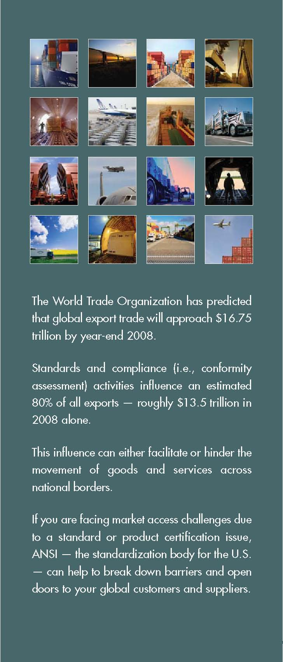
ANSI’s Role
As the coordinator or the U.S. standards system and a promoter and facilitator of the U.S. conformance system, the United States, the American National Standards Institute (ANSI) helps businesses increase their competitiveness by:

- Contributing to an open and fair trading environment; advancing policies and practices that reduce transaction costs and increase confidence in the market.

- Supporting individual companies in accessing new markets and ensuring acceptance of their products and services.

ITA’s Role
As the U.S. government agency responsible for supporting trade, the International Trade Administration (ITA) of the U.S. Department of Commerce helps U.S. businesses increase their competitiveness by:

- Ensuring foreign countries’ compliance with laws and international trade agreements

- Promoting U.S. trade and investment internationally

ANSI and ITA – Working Together for You
ANSI and ITA are committed to U.S. companies and ensuring their competitiveness internationally, bringing together ANSI’s network of 3.5 technical experts, and ITA’s network of 1500 trade policy professionals located in offices around the country – and around the world. ANSI and ITA help U.S. companies - especially small and medium-sized enterprises - navigate the global standards and conformance system and ensure their competitiveness domestically and internationally.

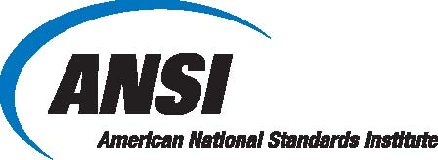
About ANSI

The American National Standards Institute (ANSI) is the coordinator of the U.S. standards system and promotes and facilitates the U.S. conformance system. A private, non-profit organization, ANSI is committed to supporting solutions that assure a fair and liberalized trading environment, interoperability of technologies, safety and health of consumers, and protection of the environment. ANSI facilitates the alignment of standards across borders. These international standards can be used by regulators to support harmonization of regulations and reduce the transaction costs of trade.

The ANSI federation represents the diverse interests of more than 125,000 companies and 3.5 million professionals worldwide. Its members include experts from industry, government agencies, consumer groups, academia, U.S. and international standards development organizations, and conformity assessment bodies.

For more information on how your company can get engaged, please contact us:
American National Standards Institute
Attn: Steven Bipes, Director – International Policy
1819 L Street, NW Sixth floor
Washington, DC 20036
T: +202.293.8020
F: +202.293.9287
E: intl@ansi.org
www.standardsportal.org
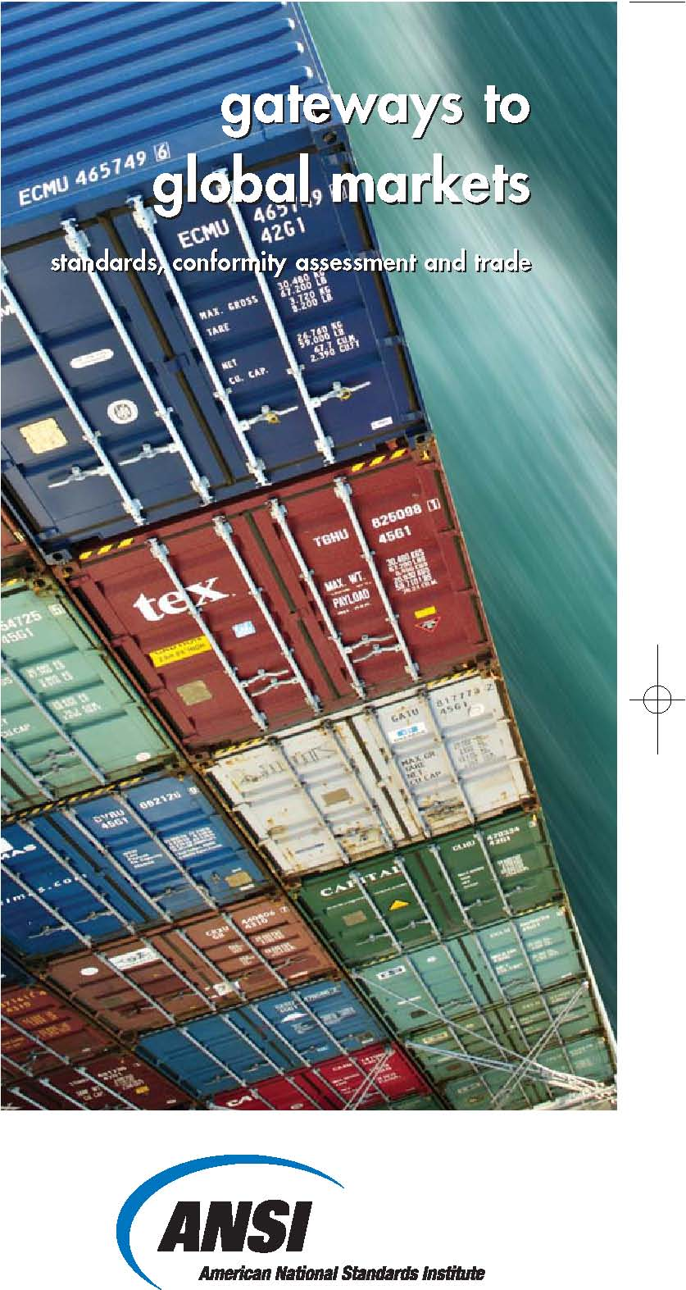
open doors to global markets

facilitating trade through standards and conformance



Standards and conformance have a direct impact on your company’s bottom line. These activities can either open doors to new markets and create gateways to a global supply chain, or they can serve as barriers to trade and hinder competition in foreign markets.

The cross-border flow of goods is influenced by three key factors: customer needs, industry- accepted guidelines and government-imposed requirements. Those who understand how to effectively influence this network will have the greatest success in the global marketplace.

Could your company be more
competitive internationally?

Examples of Standards and Conformance Issues:

- Different clients require different certifications
- Standards for my products vary across countries
- I can’t find consistent quality from my suppliers
- [Additional examples?]

Increasing U.S. Competitiveness Internationally through Standards and Conformance

How ANSI can help:

Market Intelligence
- Information on the technical requirements of your target market (e.g. standards, regulations, etc.), as well as the procedures required to demonstrate compliance with these requirements (e.g. testing, inspection, certification, etc.).
- Insights into emerging issues in domestic and global forums that affect your ability to do business internationally
Access
- Access to national, and international standards development fora, including ISO, IEC and over 400 others
- Strategic relationships with key officials and decision makers in more than 150 nations worldwide
Advocacy
- Ensuring that U.S. companies’ voices are heard and considered in the development of market requirements around the world
- Enabling the alignment of regulations across borders to reduce the transaction costs of trade

How ITA can help:

- Addressing foreign technical Regulations and other mandatory requirements that unfairly restrict companies’ access to global markets
- Ensure foreign governments’ compliance with the requirements of the World Trade Organization (WTO) and other trade agreements
- [Additional bullets?]

Your Company’s Role in Standards and Conformance

- Ensure that your needs and interests are represented in the development of standards that will be used in your target markets
- Gain an understanding of local rules, business practices and culture
- Identify and plan for changes to local technical requirements affecting your product
- Strengthen existing relationships and build a support network of local standards experts from government and industry
- Plan and set realistic goals and timeframes for gaining access to your target market (e.g., China, India, Brazil, etc.)
- Leverage ITA exporter services, including include market research, training, and early warning of technical regulations that could affect U.S. industry
- Engage actively with ANSI; capitalize on the Institute’s leverage and unique position as the focal point of the U.S. standards and conformity assessment systems
- Contact ANSI or ITA as early as possible if you encounter problematic standards, technical regulations, or conformance (e.g. testing, inspection, certification, etc.) requirements in foreign markets:
  - ANSI if your issues involves voluntary standards or conformance (intl@ansi.org)
  - ITA if your issues involves mandatory technical regulations or other legal requirements (tcc@mail.doc.gov)

