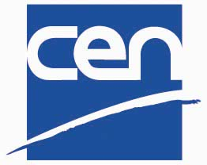

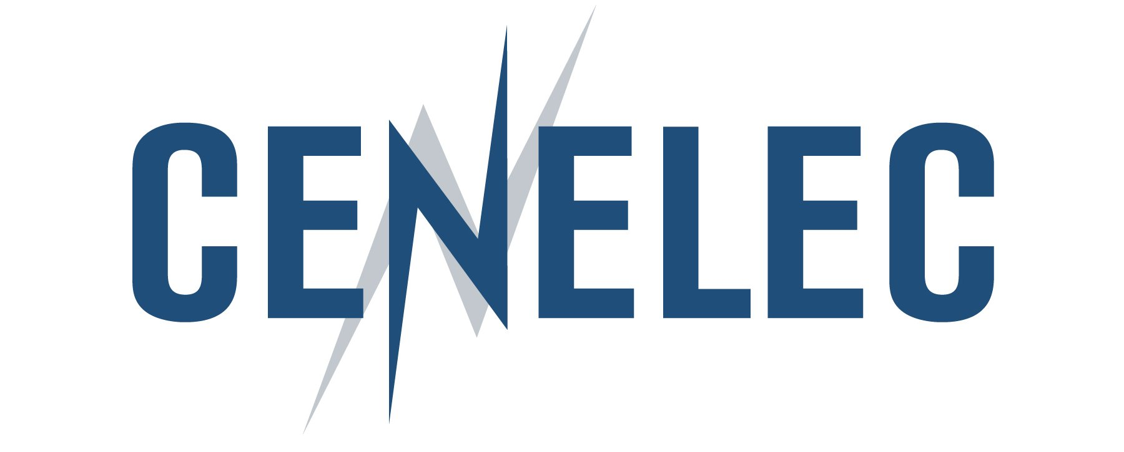

Interoperability: Key to International Business
The role of ICT Standards

Warsaw, Poland
6 – 7 February 2007



Temporary Picture

Call for contribution

Conference co-financed by Hosted by
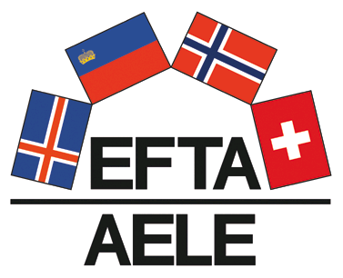

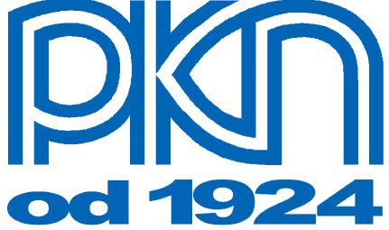
call for contribution
INTEROPERABILITY: A KEY TO INTERNATIONAL BUSINESS !
The CEN-CENELEC-ETSI-ANSI conference on interoperability provides a lively and outstanding forum where all stakeholders can discuss and exchange views on this key element for standardization, and can review the state of the art on standardised solutions to interoperability problems. This conference aims at enhancing the awareness of the needs to undertake standardisation activities in relation with the interoperability field. It will give the opportunity to all interested parties involved in interoperability and standardization activities to interlink their works, comparing and contrasting different solutions, and identifying future needs and possibilities.
Today, in one way or another, all stakeholders - governments, industry, consumers, and other social partners - have recognised the need for interoperability and recognise the benefits interoperability could bring. Interoperability is in brief the ability of two or more networks, systems, devices, applications or components to exchange information between them and to use the information so exchanged.
Given the increasing diversity of systems and applications, interoperability makes possible the development of a mass market and avoids the undesirable side effects of fragmentation.
Such fragmentation of course potentially destroys the “network effects” opportunity in the new converging services to boost European competitiveness, productivity, growth of GNP and high employment. Interoperability is a necessity for the crossborder trade in goods and services.
Of course, interoperability can be simply an agreement between two companies to exchange information on a particular basis. But in order for the new generation of markets to become a reality, standards are needed to ensure interoperability amongst as wide a group as possible. In effect, interoperability standards are a fundamental objective of all standardisation stakeholders, whether they are policy-makers, industrial players or users.

The standardization principles implemented by the European and American Standardization Bodies can guarantee a sustainable solution for an interoperable competitive environment. The European and American Standardisation Organisations, with close links to their global counterparts, offer open, transparent environments for standards making; they can therefore ensure interoperable solutions that are usable in the market, which frequently are not possible when specifications are developed only in the industry consortia.
In line with these objectives and challenges, the CEN/CENELEC/ETSI/ANSI Conference will provide a first class opportunity for delegates to discuss and exchange views on interoperability among different stakeholders, and to bring standardised solutions to interoperability problems. Due to its location in Central Europe, the size of its market and the importance that it should play in the future, the CEN/CENELEC/ETSI/ANSI Conference will be held in Warsaw, Poland. Moreover, this unique place will attract different partners in Central Europe.
CONTRIBUTIONS
Contributions are sought for the break-out sessions of Day 1 (see Annex 1: draft programme). There will be 6 parallel sessions focusing on the 6 different themes. We are seeking papers for the following range of topics and their relation to the theme of the conference: “Interoperability”. Submissions can cover all aspects of the topic. The break-out session will discuss the possible ways of ensuring the quality of the standards and the merits of the various methodologies used for their development. The implementation aspects for the rapid development of good quality products, the possible ways of demonstrating interoperability and the economical aspects (the cost of the non-interoperability) will also be discussed.
Theme 1: Home and Building Electronic Systems (HBES) (including “Smart Houses”)
The integration of a wide spectrum of applications in and around homes and buildings and the control thereof is a concept that has steadily grown to be a common concept in our daily lives. Network providers, manufacturers and users are to work together to develop the necessary media to ensure the interoperability of product-oriented solutions.

The theme will explore several key domains such as:

- HBES from the “Smart House” perspective: how can the needs of the future society be coped with, especially in terms of the migration of technologies and services?

- Standards for the interoperability of household appliances and their monitoring and control through common devices and terminals (e.g. television set) require in a first instance user-friendliness.

- Power line communication and its extension to the mains supply is a steadily growing technology. What is the asset and benefit of this development?

The superposition and interworking of different technologies, applications and services in the home is steadily growing to its culmination point. How can the cabling aspect be rationalized in order to allow co-habitation of media?

Theme 2: eBusiness Interoperability
Lack of interoperability of eBusiness standards has for a long while prevented the successful uptake of eBusiness software solutions, especially by SMEs and by those trading with different sectors. This is as much an issue concerning “semantic interoperability” as a technical issue, but both concern standards. The arrival of software solutions based on XML has compounded the problem, by making it easier to create new business solutions in isolated “islands”.

This break-out session will consider critical issues such as: who is trying to resolve them, and how to improve awareness of these issues within business. The issues will be debated with reference to current activities in several settings, among them the CEN/ISSS eBusiness Interoperability Forum in Europe and, internationally, the UN/CEFACT eBusiness standards process. In the US, the eBSC Forum seeks to accelerate communication, cooperation, harmonisation and convergence in the development of effective eBusiness standards and guidelines.

Theme 3: Radio Frequency Identification Devices (RFID)
RFID is a very promising technology and many companies have invested in RFID systems, in particular for tracking goods. However the systems implemented by different companies are still based on proprietary standards that prevent interoperability and the development of RFID applications outside a particular company. This happens in spite of a significant standardization activity in ISO, CEN, ETSI and the EPCglobal forum.

The break-out session will address the critical compatibility and interoperability issues that prevent the wide deployment of RFID applications. The break-out session will focus on technical issues such as supply chain tracking, inventory control and business process improvements, among others. While non technical issues such as personal identification information privacy (for applications such as ID cards, RFID enabled passports and electronic payment cards) and spectrum allocation are critical, they will not be included in this break-out session. The continued development of RFID technologies and applications hinges in differentiating between technical and non technical issues.

Theme 4: Entertainment (multimedia, digital TV)
Communication through electronic means is more and more part of our daily lives.

Even with the fact that computers are increasingly commonly used, the television set remains the centre of the home. The recent introduction of digital TV is the technology allowing upstream communication. CATV systems are the broadband medium to ensure this data exchange aspect.

Audio and video devices and their applications form part of our daily life. What is the future promising?

Theme 5: Case studies on interoperability - eHealth, eLearning, eSkills, eGovernment
Application software needs to be “interoperable” if the data it contains is to be shared between more than one company or organisation. An enormous effort is still needed to ensure the necessary standards are in place, or, where they are, that they can be used inter-operably. But “interoperability” in ICT can also imply “interoperability of people” – that is, ensuring that the necessary skills for the information society to achieve its full potential are recognised across European frontiers.

This break-out session will examine examples of standards initiatives and issues in the applications area, with recent or forthcoming overview reports on standards interoperability issues in eHealth and eGovernment and technical work on eLearning. In the US, there are more than 20 eGovernment initiatives ongoing now, in 5 major categories: government to citizen, government to business, internal efficiency, and e-authentication. The agreement on a standardised “European ICT skills framework” will also be addressed. The major standards obstacles still preventing interoperability will be identified and solutions proposed.
Theme 6: Technical Interoperability Demonstration and Testing and Quality of Standards

Interoperability between equipments implementing the same standard is the ultimate goal and proof of success of standardization. Experience however demonstrates that there may be a number of reasons why this is not currently being achieved. Possible ambiguities left and options included in the standard may contribute to this difficulty, and more generally raises the issue of the quality of the standard. Validation of the standards may be provided with the use of formal description languages (UML, SDL, MSC, TTCN, ASN.1..) and development of test strategies. Both Europe and the US have a long experience of conformance testing and interoperability testing. High quality, validated test standards are a prerequisite for the broad acceptance of test results from either third party testing and certification or manufacturer’s declaration of conformity.

SUBMISSIONS

All submissions must be in English. Paper submissions will be made by email to info@cenelec.org with a brief overview of how you want to develop the subject.
Please note that the dates are firm.

Important Dates
Deadline for submission of papers | 30 May 2007
Review of results and notification | 4 July 2007
Submission of Speakers bio | 24 August 2007
Submission of draft presentation | 20 October 2007
Submission of final presentation | 15 December 2007

For assistance contact:

Sarah PENNY, CENELEC Communication Manager

Tel: +32 2 519 68 89

Fax: +32 2 519 69 19

eMail: info@cenelec.org
Annex 1: Provisional Conference Programme

Day One – 6 February 2008
Morning | Plenary Session
9.00-10.20 | - Introduction by Dr Spindler (CENELEC President)  - Introduction by (the European Commission)  - Introduction by (the Polish MEP)  - Introduction by (the American government representative)  - General Discussion
10.50-12.20 | - * Polish government  - *Industry  - Introduction to interoperability (case study)  QUESTIONS AND ANSWERS
Afternoon | Break-out Session
13.50-15.40 | Theme 1:  Home and Building Electronic Systems | Theme 2:  eBusiness Interoperability | Theme 3:  Radio Frequency Identification Devices
16.05-18.00 | Theme 4:  Entertainment applications | Theme 5:  Case studies on interoperability - eHealth, eLearning, eSkills, eGovernment | Theme 6:  Technical Interoperability and Quality of Standards

Day Two – 7 February 2008
Morning | Round table on Break-Out Session Findings and Results
9.00-12.00 | - Reporting on findings and results  - Panel Discussion and conclusions  - Closing remarks

End of day 2 and Conference

Annex 2: CONFERENCE PARTNERS
The European Committee for Standardization (CEN) is a business facilitator in Europe, removing trade barriers for European industry and consumers. Its mission is to foster the European economy in global trading, the welfare of European citizens and the environment. Through its services it provides a platform for the development of European Standards and other technical specifications.
CEN’s 30 National Members work together to develop voluntary European Standards (ENs) in various sectors to build a European Internal Market for goods and services and to position Europe in the global economy. More than 60.000 technical experts as well as business federations, consumer and other societal interest organizations are involved in the CEN network that reaches over 460 million people.
For further information please visit: www.cen.eu
The European Committee for Electrotechnical Standardization - is officially responsible for standardization in the electrotechnical field.
In an ever more global economy, CENELEC fosters innovation and competitiveness, making technology available not only to major businesses but also to SMEs through the production of voluntary standards. CENELEC creates market access at the European level but also at the international level through its cooperation agreement with the International Electrotechnical Commission (IEC).
Through the work of its 30 Members together with its experts, the industry federations and consumers, electrotechnical European Standards are created in order to help shape the European Internal Market, to encourage technological development, to ensure interoperability and to guarantee the safety and health of consumers, as well as the environmental protection.
Detailed information available at www.cenelec.org/
ETSI, the European Telecommunications Standards Institute, is officially recognized for the standardization of Information and Communication Technologies (ICT), with a particular emphasis on telecommunications, broadcasting and related electronic communications.
An independent organization based in Sophia Antipolis, France, ETSI unites almost 700 member companies from 59 countries inside and outside Europe, including manufacturers, network operators, administrations, service providers, research bodies and users – in fact, all the key players in the ICT arena. ETSI's focus extends well beyond Europe, as the Institute plays a major role in developing a wide range of standards and specifications including conformance testing methods as a European contribution to world-wide ICT standardization.
For more information: www.etsi.org/
The American National Standards Institute (ANSI) is a private, non-profit organization that administers and coordinates the U.S. voluntary standardization and conformity assessment system. ANSI provides a neutral forum for organizations from both the U.S. private and public sectors to come together and work cooperatively to enhance the global competitiveness of U.S. business and the American quality of life. ANSI accredits organizations that develop voluntary national consensus standards and American National Standards guided by the Institute’s cardinal principles of consensus, due process and openness. ANSI is the sole U.S. representative to the International Organization for Standardization (ISO) and the International Electrotechnical Commission (IEC), via the U.S. National Committee.
Additional information is available at www.ansi.org

