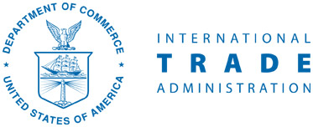
Department of Commerce
Ministry of Commerce & Industry
Government of India

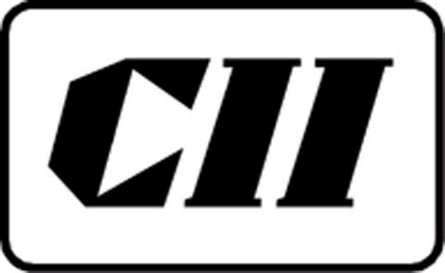
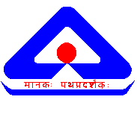
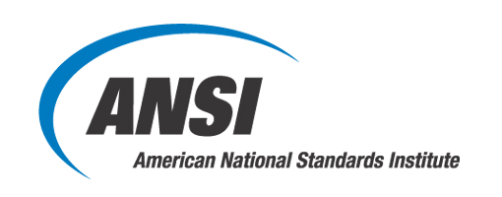

U.S. – India Commercial Dialogue
Branding in India: Leveraging the WTO/TBT Agreement
New Delhi, India – 11 September 2008
Agenda

Venue: India Habitat Centre Starting at 0900
Room: Casurina Hall Closing at 1600
Address: Lodhi Road, New Delhi 11003

Agenda Item | Time | Title
1 | 0900 | Registration and Networking
2 | 1000  1010  1020 | Welcome/Opening Remarks  Mr. Anil Mukim, Joint Secretary, Department of Commerce, Ministry of Commerce & Industry, GoI  Mr. Dale Tasharski, Deputy Counselor for Commercial Affairs, U.S. Embassy-New Delhi  Presentation  Key Note Address  Mr. Rakesh Verma, Additional Director General, Bureau of Indian Standards
3 | 1035  1105  1130 | Key Principles of the WTO/TBT Agreement  Moderator: Mr. T V Shiva Rao  Mr. Bryan O’Byrne, U.S. Department of Commerce  Presentation  Mr Chanchal Sirkar, Deputy Director,Department of Commerce, Ministry of Commerce & Industry  Presentation  Q&A
4 | 1150 | Tea/Coffee
5 | 1215  1230  1245 | Perspectives on Key Principles  Moderator: Mr. T V Shiva Rao, CII  Ms Rachna Seghal, Joint Director, BIS  Presentation  Dr R K Bajaj, Head, International Relations, BIS  Ms. Elise Owen, ANSI Representative for China and India Affairs  Presentation  Q&A and Discussion
6 | 1315 | Introduction of CII-ANSI-BIS Standards Portal  Dr R K Bajaj, Head, International Relations, BIS  Presentation
7 | 1320 | LUNCH
8 | 1420  1440  1500  1515 | Industry Round Table Discussion  Moderator: Ms. Leslie McDermott, ANSI  Industry sectors:  - Pharmaceutical/Chemical  Mr D P Mishra  Director General, Indian Chemical Council  Presentation  - Information & Communication Technology (ICT)  Mr Arun Golas  Deputy Director General, Telecom Engineering Centre  Presentation  - Electrical/Electronic  Mr P K Mukerjee  Head, Electro-technical Division, BIS  Presentation  Discussion and Q&A with panellists from U.S. and India on these sector specific aspects
9 | 1540  1545 | Closing Remarks  Dr. Ajit Jillavenkatesa, Sr. Standards Specialist, National Institute of Standards and Technology (NIST)  Mr. T V Shiva Rao, Chairman, CII Standards Action Committee
10 | 1600 | Tea & Coffee/Conclusion of Workshop

