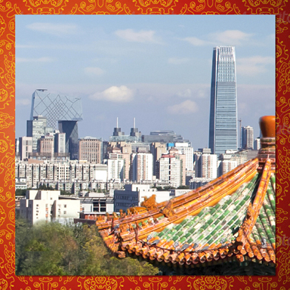 |  | 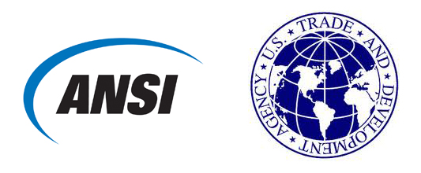  COMMERCIAL BENEFIT QUESTIONNAIRE  FOR WORKSHOPS  U.S.-China Standards and Conformity Assessment Cooperation Program  www.StandardsPortal.org/US-ChinaSCCP
Please include as much detail on this form as possible.

1 | CONTACT INFORMATION  Who is the best point of contact at your company for follow-up on potential participation with this workshop? | Name  Title  Organization  Telephone  Email

2 INDUSTRY SECTOR/TOPIC OF INTEREST
Please indicate in the space provided the industry sector(s) related to your workshop proposal.

3 OBJECTIVES OF WORKSHOP
What are your objectives for the workshop? How would organizing such a workshop help further these objectives?

4 OPPORTUNITIES IN THE CHINA MARKET
Do you see near or long-term opportunities for your company/organization in the China market? What does that opportunity look like for your company/organization?

5 POTENTIAL EXPORT BENEFIT
This section is intended to help ANSI and USTDA evaluate the commercial benefit of the proposed workshop. Please provide as much detail as possible, including not just your direct sales but also potential exports that might be impacted by standards or conformity assessment topics discussed at the workshop.
- What products or services would you (or workshop attendees) hope to gain sales leads for by participating in this workshop?
- What is the U.S. content of these products/services?
- What is the size (USD value) or identified opportunity of the addressable China market for these products/services?
- Who are your primary customers in the China market (company name/country of origin)?

6 STANDARDS-RELATED PRIORITY
How do the objectives of the activity relate to standards, conformity assessment, and/or technical regulations? Is there a particular opportunity or challenge that would be addressed?

7 TIMETABLE AND LOCATION
Please indicate possible dates and location in China for the proposed workshop. If the dates are flexible, please indicate your preferred timetable for conducting the workshop.

8 PRIVATE SECTOR CONTRIBUTION
USTDA seeks to demonstrate that its investment in each activity is matched by contributions from the U.S. private sector. Please indicate the sources and approximate amount, if known, of expected contributions for the activity. These may be in the form of sponsorship or in-kind through donation of a venue or materials, expert time, and/or travel expenses. Please also list U.S. companies that may support the activity either through content development, participation, or both.

9 ADDITIONAL INFORMATION
Please include any additional information about your proposed workshop, including:
- Proposed Chinese partner or counterpart
- Topics for discussion or draft agenda
- Expected participants or list of proposed invitees

