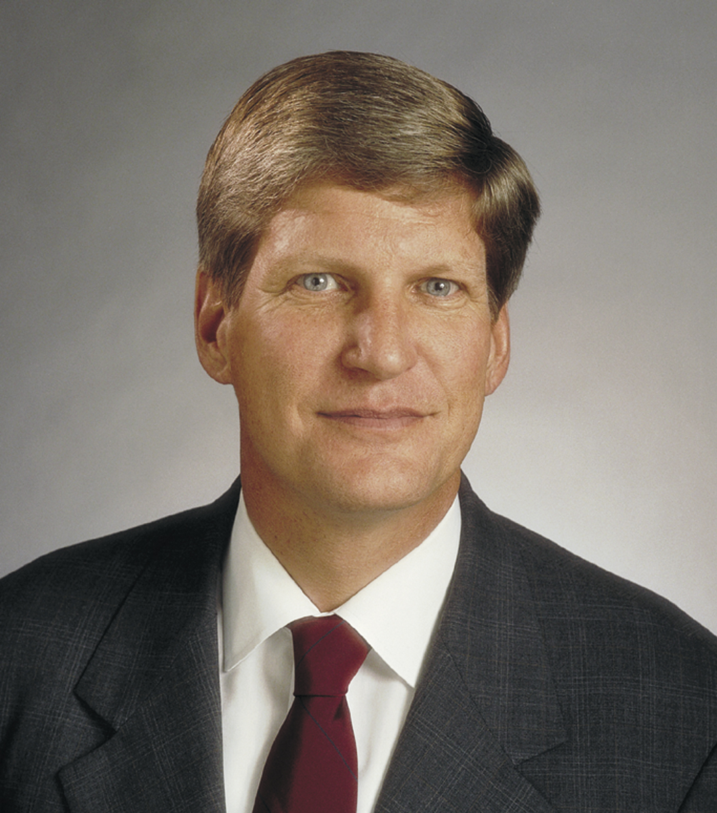

James A. Thomas
ASTM
100 Barr Harbor Drive
West Conshohocken, PA 19428
610/832-9598
Fax: 610-832-9599
E-mail: jthomas@astm.org

James A. Thomas is president of ASTM International, one of the world’s largest organizations for the development of international voluntary consensus standards. His professional career is concentrated on association management and the issues facing voluntary standardization.

In 1972, Thomas began his career at ASTM International, formerly known as the American Society for Testing and Materials. He continued to serve in positions of increasing responsibility involving ASTM standards development until 1983 when he was promoted to vice president of Standards Development. In this position, he was responsible for all ASTM technical committee operations, including guiding new technical committees in the early stages of their development and for representing ASTM International in standards development activities with other organizations.

In 1987, Thomas was appointed executive vice president of the Society. His responsibilities included directing the development and implementation of operating policies, and the analysis and evaluation of operations to assess the attainment of growth and financial objectives. In 1992, Thomas was named ASTM president.

As president of ASTM International, Thomas has been a staunch proponent of the multiple path approach to voluntary standards development. He is frequent speaker advocating openness and transparency in international standardization.

Thomas is a member of the Standards Engineering Society, which awarded him the Leo B. Moore medal in 2004, the Council for Engineering and Scientific Society Executives, the American Society of Association Executives, and the Industry Trade Advisory Committee on Standards and Technical Trade Barriers.

He also serves on the board of directors of the American National Standards Institute (ANSI) and the Clinical and Laboratory Standards Institute (CLSI). Thomas has contributed to the development of the first National Standards Strategy for the United States and he served on the United States Standards Strategy Committee in updating the document in 2005.

Thomas holds a Bachelor of Science degree in industrial relations and a master’s degree in organization and management, both from LaSalle University. He is a native of Philadelphia, Pennsylvania.

