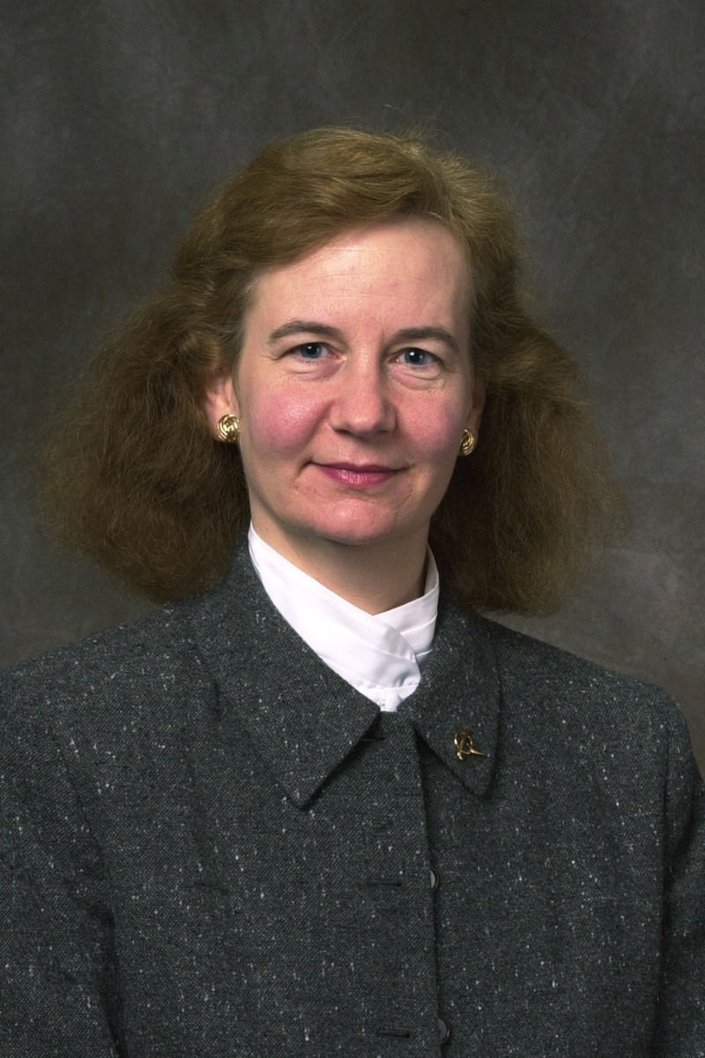

Laura E. Hitchcock
Senior Standards Specialist
External Standards Management, Strategy and Policy
The Boeing Company

As Senior Standards Specialist and Corporate Project Manager for External Standards Management, Strategy and Policy, Laura Hitchcock serves as The Boeing Company’s enterprise-wide focal for issues regarding government, industry and international standards activities and has responsibility for external standards policy and strategy for the company. She has been working with standards for over 30 years, the last 22 with Boeing’s Corporate Standards Organization. For the last 13 years, Laura has been responsible for administration and coordination of Boeing’s participation in the development of external standards and their use and integration into the Boeing Standards System. Laura is leading company efforts to develop strategic standardization management plans and policies that leverage Boeing’s standards activities to support corporate goals. Laura is also responsible for copyright licensing for access to industry standards and for conducting benchmarking of standards activities with other companies. Laura is a member of the Boeing Product Standards Management Council, and also a member of the External Technical Affiliations Integration Board which works to help Boeing manage its relationships with technical organizations (many of which develop standards).

To support Boeing’s goals to pro-actively manage and leverage the external standards systems, Laura serves on a number of standards related governing bodies. Laura is a member of the Board of Directors of the American National Standards Institute and has served as Boeing’s representative to the ANSI’s Company Member Forum for the last eleven years. She is also Chair of SAE International’s Technical Standards Board, and is vice-chair of the SAE Aerospace Council (the governing body over the largest aerospace standards program in the world). She was instrumental in founding and is the current Secretary for SAE’s Commercial Jet Transport Standardization Committee, which seeks to standardize non-competitive parts and materials for the commercial aviation industry. Laura currently represents Boeing on the Industry Cooperation on Standards and Conformity Assessment (ICSCA), the NAM International Standards and Conformity Assessment Working Group, and Chairs the US TAG to ISO/TC20, Aircraft and Space Vehicles. Laura was Chair of the Aerospace Industries Association’s Special Working Group on the Future of Aerospace Standardization and was the prime author on the group’s groundbreaking report on the Future of Aerospace Standardization. She was elected by the AIA Board of Governors to Chair the Strategic Standardization Forum for Aerospace which was chartered to provide a venue for the industry to address aerospace standardization issues. Laura has also served on the Homeland Security Standards Panel and ISO activities on standards for Corporate Social Responsibility. Laura is a past member of the IEEE Standards Association’s Board of Governors and of ASTM International’s Board of Directors.

Laura has a BA in English with post-graduate work towards an MS in Human Factors Engineering. She is a member of SAE, ASTM, IEEE, and the Standards Engineering Society.

Current Address: The Boeing Company
P.O. Box 3707 M/S 6R6-04
Seattle, WA 98124-2207
Phone: (425) 373-2124
Fax: (425) 965-9976
e-mail: laura.e.hitchcock@boeing.com

