June 25, 2024

To whom it may concern:

It is a pleasure to recommend Anna Roessing-Zewe as a candidate for the 2024 USNC IEC Young Professionals.

I have known Anna through my time working at UL Standards & Engagement (ULSE). Anna brings an extensive background and knowledge base to ULSE that I believe are great assets for IEC Young Professionals.

Anna is a passionate and driven standards professional which is evident in her current role as a ULSE Project Manager in our Building, Life, Safety Technologies (BLST) team. From mentoring other staff to engaging global stakeholders to driving ULSE’s mission forward, she has shown that she truly values our public safety mission. Even as a colleague and leader within our organization, I have found myself impressed by her and it is this kind of passion for standardization that sets her apart from anyone else that I know.

As a ULSE Project Manager, my Data Science & Engineering team has had the opportunity to work with Anna to identify ways in which we can advance the rigor and technical relevance of our standards. Utilizing a hazard-based safety engineering approach, Anna has been instrumental in helping us identify key indicators within her area of expertise to drive a more holistic approach to developing and maintaining standards. Although new to the area of standardization, Anna has used her technical background to advance our standards by using her expertise to ask questions and provide thought-provoking inquiries on topics concerning our standards and standards development process. I truly believe that she will be a tremendous asset to the Young Professionals program.

In closing, I am in full support of Anna Roessing-Zewe as one of the USNC IEC Young Professionals. She has the technical background and passion for standards that will bring perspective and empowerment to the USNC representatives. I also believe her participation will be an opportunity for her to grow and mature as a standardization professional.

If you should need any additional information regarding Anna, please feel free to contact me at any time by telephone at 910-309-8778 or via email at [denice.durrant@ul.org](mailto:denice.durrant@ul.org)

Sincerely,

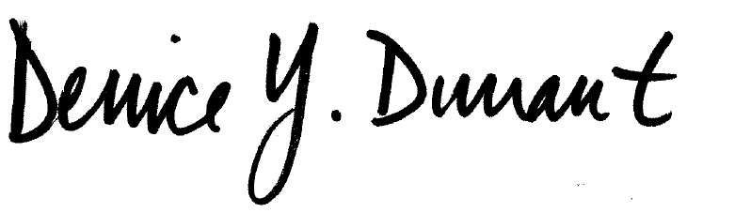

Dr. Denice Y. Durrant

Director of Data Science & Engineering, UL Standards & Engagement