
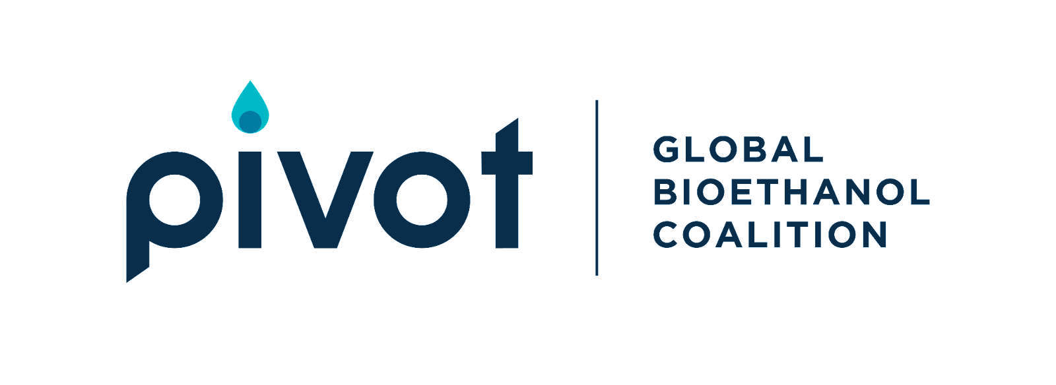
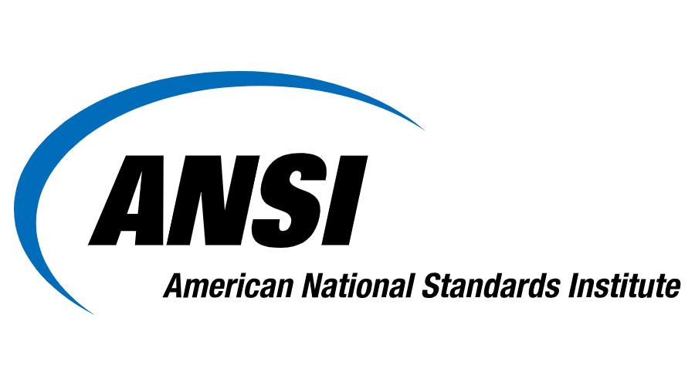


Bioethanol Standardization Web-series:
#5 Implementation of Bioethanol Fuel and Clean Cookstove Businesses

February 24, 2023
15:30 – 17:00 EAT
12:30 – 14:00 WAT
7:30 – 9:00 EST

Event Programme:

15:30 | Opening Remarks

15:35 | Business Model and Supply Chain Considerations within Bioethanol Businesses  Simba Mudimbu, Senior Portfolio Manager, Market Strengthening Team, Clean Cooking Alliance  This segment will examine the various business models within clean cooking systems, and shed insight on supply chain dynamics and financing opportunities

15:55 | Practical Steps to Establishing a Bioethanol Cooking Business  Mohammed Kadhi, Director of Strategy and Business Development, Consumer’s Choice  This segment will demonstrate the practical steps toward establishing and growing a bioethanol clean cooking business, looking at the importance of incorporating policy and standards, involving local cooking organizations, sourcing materials and running operations.
16:15 | Financing Opportunities and Carbon Markets  Peter George, Investment Director and ESG Director, Spark+ Africa Fund  This segment will demonstrate the funding opportunities available to emerging clean cooking businesses, and also discuss the benefits of bioethanol within ESG priorities and carbon financing.
16:35 | Open Question and Answer Session
16:55 | Closing Remarks


Simba Mudimbu, Senior Portfolio Manager, Market Strengthening Team, Clean Cooking Alliance

Simba primarily works within the CCA Venture Catalyst Program, a sector focussed technical assistance program that provides support to clean cooking enterprises across various technologies and fuels. The objective of the Venture Catalyst program is to build a pipeline of scalable businesses capable of delivering affordable, appropriate, high-quality clean cooking solutions that can attract more investment into the clean cooking sector.

Simba’s work experience includes various roles the banking, management consulting, and impact investing sectors over the last 14 years. He holds an MPhil in Development Finance (Cum Laude) from the University of Stellenbosch in South Africa, an MSc in Finance from Manchester Business School, and a bachelor’s degree in International Business, Finance and Economics from the University of Manchester in the UK. Simba is based in Johannesburg, South Africa.

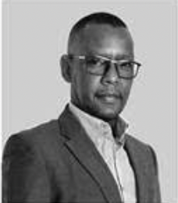
Mohammed Kadhi, Director of Strategy and Business Development, Consumer’s Choice

Mohammed has been a leader in establishing Consumer’s Choice, a bioethanol clean cooking business based in Tanzania. Mohammed has over 12 years of experience in the clean cooking sector, and has played key roles in optimizing manufacturing and supply chain networks, is knowledgeable in current policy, economic, and standards issues, has developed and disseminated new products in emerging markets, and engaged in negotiations with government, private sector, and local and international organizations to promote bioethanol cooking businesses in East Africa.

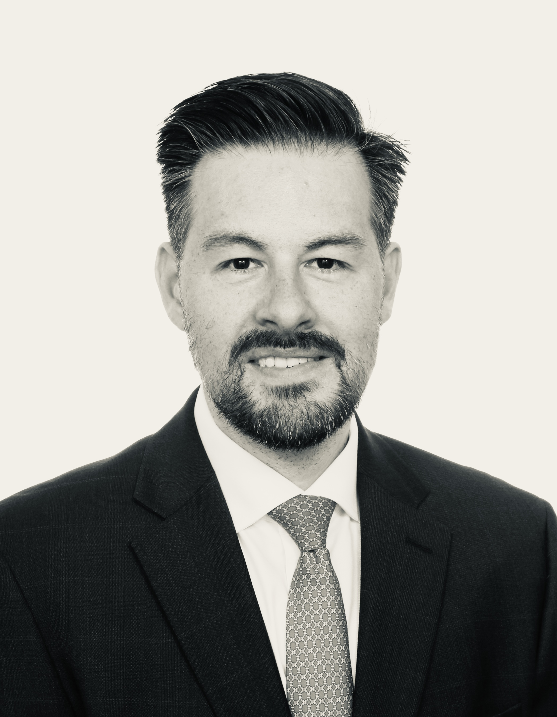
Peter George, Investment Director and ESG Director, Spark+ Africa Fund
In his former role as Senior Director responsible for private sector and investment programs at the Clean Cooking Alliance, Peter George co-led the structuring and successful fundraising of Spark+ Africa Fund, a $54 million ($70 million target) impact fund investing in clean and modern cooking energy solutions in Africa. Upon the fund’s launch in March 2022, Peter departed CCA to co-manage the Luxembourg-domiciled 7-year debt and quasi-equity fund investing across the value chains of LPG, ethanol, biomass, biogas, and electric appliances. Peter’s 17-year career in the renewable and traditional energy sector spans a number of advisory and principal investing roles in impact investment, development finance, and private sector development in frontier markets, as well as bulge-bracket investment banking, private equity, and project finance in the United States.

