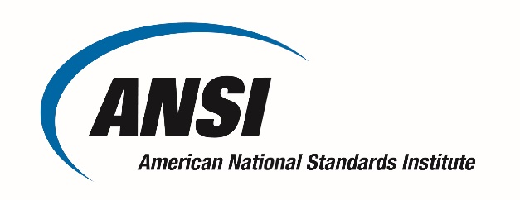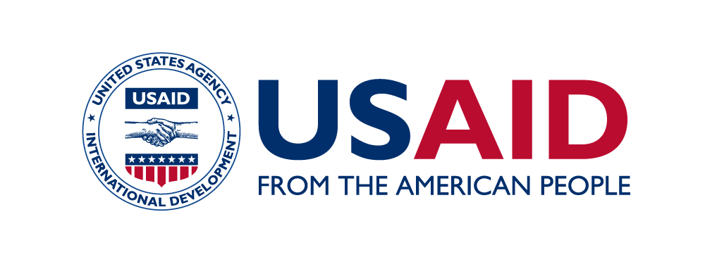

**Standards Alliance Phase II Trip Report**

*Please complete within 5 business days following travel and submit to the relevant Program Administrator*

|  |  |  |  |
| --- | --- | --- | --- |
| Name(s) | James P Olshefsky | | |
| Destination(s) | Nigeria | | |
| Project Name | West African Petroleum Standards | | |
| Inclusive Travel Dates | **Start: 7/3/22** |  | **End: 7/8/22** |
| Trip Purpose and Short Summary | Held a four-day Workshop in coordination with the Standards Organization of Nigeria (SON). Day 1 - SON Laboratory Complex – Opening remarks, Program overview. Day 2 - OVHEM Lab – Tour of laboratory and demonstrations of relevant test methods. Day 3 – SGS Independent Lab – Tour of laboratory and demonstrations of relevant test methods. Day 4 – SON Laboratory Complex – Detailed review of ASTM test methods, WTO training, Introduction to ASTM standards development process, Introduction of planning for U.S. Study Tour.   * highlight the benefits of harmonized standards * improve direct access to shaping the content of standards through participation in ASTM/API activities * introduce, share examples, and make suggestions, on how to implement and make use of the World Trade Organization Technical Barriers to Trade Agreement decisions and principles related to international standards, good regulatory practice and national quality infrastructure. * review of relevant ASTM standards and adaptation to national or regional standards | | |
|  |  | | |
| Initial Outcomes | * Provided copies of key ASTM reference documents for use in the laboratories of the NSB’s or to be cited in regulations * Worked on eliminating barriers to trade by discussing common methods for testing individual properties of gasoline and diesel fuels * Began to create an understanding of WTO/TBT principles and Good Regulatory Practices to create a framework highlighting the use of international standards. * Introduced the concept of participation in statistical quality assurance programs to enable laboratories to evaluate and improve performance and maintain and fulfill mandatory accreditation requirements. * Introduced the participants to the process of developing standards in ASTM in order to assist in ensuring that the needs of the West African marketplace are reflected in the international standards of U.S. domiciled developers. * Each participant completed an application to join the ASTM technical committee related to petroleum products. | | |
|  |  | | |
| Challenges Encountered | *List Any Challenges Encountered while Executing Activity*   * There continues to be a big desire for other members of the host national standards body to join in the capacity building activities which were primarily intended for two focal points from each country. This can put a strain on the transportation and catering budgets if we’re not careful. (This should not be an issue on the next planned event in the U.S.) * The language barrier for French speaking nations, even though adequate interpretation was provided, has somewhat limited the participation from Cote d’Ivoire. | | |
|  |  | | |
| Recommendations and Lessons Learned | *List Recommendations for Future Activities*   * Try to pinpoint participants from outside the core group and make sure that their needs are accounted for outside of the program budget * Attempt to engage more with the French speaking participants to ensure their understanding of the material presented | | |