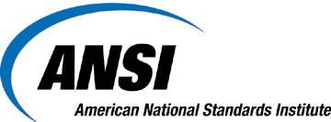  EVENT REGISTRATION |  | 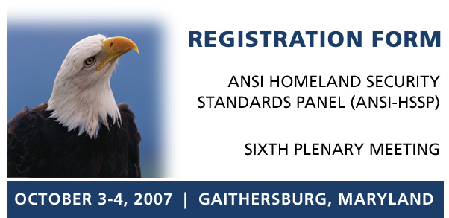
Please complete and return this form to the ANSI Registration Coordinator:  Email: jgaeta@ansi.org  Tel: 212.642.4903  Fax: 212.840.2298  Post:  American National Standards Institute  25 West 43rd Street - Fourth floor  New York, NY 10036  Attn: Jessica Gaeta  Venue  NIST – Red Auditorium  100 Bureau Drive  Gaithersburg, MD 20899  Accommodations  By stating that you are attending a "NIST" meeting, you will receive a discounted rate at the Gaithersburg Hilton (301) 977-8900. Additional area hotels are listed on the hyperlinked webpage above.  Conference Schedule  October 3rd: 9:00 am – 5:00 pm  October 4th: 8:30 am – 5:00 pm  Questions / Additional Information?  Matt Deane  Director, Homeland Security Standards  American National Standards Institute  T: 212.642.4992  E: mdeane@ansi.org
  Name
  Title
  Organization
  Address
  City
  State | Zip Code
  E-mail
  Telephone | . . extension
  Networking Event
  Please accept ANSI’s invitation to attend a networking reception
  on Wednesday evening, October 3rd, from 5:00 – 7:00 pm.
  Check only if unable to attend this event
  Registration Fee
  Members of ANSI or the ANSI-HSSP: $249
  Non-members: $299
  Please note that no on-site registrations will be accepted.
  Please charge the registration fee to my credit card.
  Card Type:
  Expiration Date: / Card Security Code:
  Card Number:
  Name on Card:
  I will pay the registration fee by check.
  (Please make checks payable to the American National Standards Institute)

