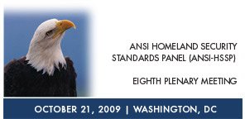 | Homeland Security Standards  And Their Business Application in the Private Sector  Final Meeting Report  October 21, 2009  Renaissance Washington D.C. Hotel  999 Ninth Street NW  Washington, DC 20001
Welcome

Fran Schrotter, Senior Vice President, Chief Operating Officer, American National Standards Institute (ANSI) opened the meeting and welcomed the participants. Ms. Schrotter provided a background on the context of which the ANSI Homeland Security Standards Panel (HSSP) was formed, and noted that the HSSP allows us to coordinate standards activities that are applicable to homeland security by leveraging the public-private partnership the panel facilitates.

Ms. Schrotter gave an overview of the plenary program, noting that she anticipated that the program would be an informative series of discussions identifying the initiatives that are working and how to capture those successes, build upon them, and make further advancements.

Ms. Schrotter concluded her remarks by acknowledging the sponsors: Phillips Nizer, National Fire Protection Agency, Homeland Security Studies & Analysis Institute, Vidient, and Booz Allen Hamilton, for their generous support. Ms. Schrotter then introduced Dr. Bert Coursey.

Keynote Address

Dr. Bert Coursey, Standards Executive, Science & Technology (S&T) Directorate’s Office of Standards, U.S. Department of Homeland Security (DHS) delivered a presentation on behalf of Bradley Buswell, Under Secretary for Science & Technology (Acting), U.S. Department of Homeland Security (DHS).

Dr. Coursey began his remarks by commending the work of the HSSP and noting its success in providing a forum for the private and public sectors to partner in addressing homeland security-related standardization and conformity assessment needs. Furthermore, Dr. Coursey cited the top priorities of the U.S. Department of Homeland Security’s (DHS) Secretary, Napolitano, including
- Strengthen relationships with state, local, tribal, and territorial agencies
- Strengthen focus on science and technology applications for protecting the nation
- Counterterrorism and domestic security management
- Secure borders
- Smart, tough enforcement of immigration laws
- Prepare for, respond to, and recover from disasters
- Mature and unify DHS

In addition, Dr. Coursey noted that DHS is conducting its first Congressionally mandated Quadrennial Homeland Security Review (QHSR) examining the key areas noted above. Secretary Napolitano will provide her conclusions from the comprehensive review to Congress in a final report by December 31, 2009.

Dr. Coursey provided an overview of DHS S&T’s divisions and portfolios. A key area of focus that Dr. Coursey mentioned is the vital role of standards in securing our transportation systems. Since the attacks of 9/11 the most visible outlet in security is transit security. Dr. Coursey noted that DHS is proactively trying to understand the threats against transit security systems and deploy more efficient screening techniques. To further this effort DHS has been partnering with both federal agencies and standards developers.

Dr. Coursey emphasized the critical role standards play in ensuring resiliency in the Private Sector Voluntary Certification Program (PS-Prep). He noted that this program is implementing the recommendations of the 9/11 Commission Act of 2007. Dr. Coursey added that a Federal Register Notice has been released on October 15, 2009 seeking public comment on the three standards DHS intends to select as part of the PS-Prep program.
Dr. Coursey concluded his remarks by noting that he is pleased to have a partnership with the ANSI-HSSP to work with the private sector in order to ensure effective homeland security technology through standards. Dr. Coursey thanked all of the participants on behalf of Acting Under Secretary Buswell.

Introductory Remarks

Gordon Gillerman, ANSI-HSSP Co-Chair, National Institute of Standards and Technology (NIST), welcomed the meeting participants. He noted that this effort clearly demonstrates the public and private sector partnership, and thanked ANSI for their efforts in facilitating the panel.

Mr. Gillerman discussed the role of NIST in the standards and conformity assessment community. He noted that NIST works closely with DHS and other federal, state, local, and private sector partners to bring about the development of standards and conformity assessment systems that help the nation do a better job. Mr. Gillerman emphasized two key messages that he has learned in his standards work at NIST:
1. Government agencies should look to private sector consensus standards first before developing their own standards as outlined in Public Law 104-113, the National Technology Transfer and Advancement Act (NTTAA), as referenced by the Office of Management and Budget (OMB) through its Circular A-119.
2. NIST coordinates conformity assessment to increase effectiveness and decrease redundancy in standards. Also, it brings together a group of standards executives from federal agencies to develop broad policies about use of standards through its Interagency Committee on Standards Policy (ICSP).

Mr. Gillerman concluded his remarks by noting how the diverse activities of the HSSP have helped to develop solutions to identified needs via issue-driven workshops and activities (e.g. standards, conformity assessment systems, management systems approaches, test methodologies, and minimum performance requirements).

Mr. Gillerman then introduced Christian Dubay, ANSI-HSSP Co-Chair, National Fire Protection Association (NFPA).

Mr. Dubay began his remarks by noting that NFPA appreciates experts in the standards field such as Mr. Gillerman volunteering to participate in their standards development process. He noted that NFPA is a standards developing organization and a large portion of their standards activities apply directly to DHS activities, including a significant number of their standards that are devoted to first responders.

Mr. Dubay concluded his remarks by identifying the HSSP as a platform which allows all relevant stakeholders (e.g. end-users, customers, and enforcers) to come to the table to identify gaps in standards activities as well as areas where standards are needed, and make recommendations as to how these issues can be addressed.

Mr. Dubay then welcomed Dr. Bert Coursey back to the podium.

Introduction to the Plenary Program and Update on Standards Activities and Standards Programs within the U.S. Department of Homeland Security

Dr. Bert Coursey, Standards Executive, Science & Technology Directorate’s (S&T) Office of Standards, U.S. Department of Homeland Security (DHS), provided an overview presentation of the DHS standards portfolio and its technical program areas. Dr. Coursey outlined the DHS Standards Policy and its implementation. In addition, he gave a description of highlights for standards programs in 2009 which include biometrics, wildland fire mitigation, chemical detection systems, explosives detection systems, and private sector preparedness standards.

Dr. Coursey focused his presentation on the Private Sector Voluntary Certification Program (PS-Prep) as per the panel session on this topic later in the program. He gave a history of the ANSI HSSP’s involvement in the development of PS-Prep program highlighting the ANSI meetings and workshops that led to the submission of a recommendation to the 9-11 Commission.

Dr. Coursey concluded his remarks by pointing out the importance of the public-private sector partnership and the efforts of the HSSP community that aided in advancing this initiative.

ANSI-HSSP Update on Emergency Preparedness for Persons with Disabilities and Special Needs

Chris Dubay introduced this panel. Mr. Dubay noted that this session will brief participants on the ANSI-HSSP efforts related to addressing standardization gaps on emergency preparedness for persons with disabilities and special needs. Priorities identified at the February 2009 ANSI-HSSP Workshop on Emergency Preparedness for Persons with Disabilities and Special Needs as they relate to the key areas of the built environment and operations will be presented. Also, next steps and the path forward will be laid out and utilized as an opportunity to recruit key stakeholders for follow-on activities related to this topic.

The Panelists for this session were:

- Allan Fraser, Building Code Specialist, National Fire Protection Association (NFPA). Mr. Fraser delivered a presentation that focused on the need for standards based solutions for more effective emergency preparedness for the community of persons with disabilities and special needs.

- Glenn Hedman, Chair of RESNA (The Rehabilitation Engineering and Assistive Technology Society of North America) Standards Committee on Emergency Stair Travel Devices for Individuals with Disabilities. Mr. Hedman delivered a presentation on the RESNA standards committee on emergency stair travel devices used by individuals with disabilities.

Items addressed by panelists during their remarks and in response to questions from audience members included:
  - Background was given on the NFPA Disability Access Review and Advisory Committee (DARAC) group. It was noted that this group discusses the need for product standards for components used by people with disabilities, as well as the need for third party certification programs.
  - ANSI-HSSP Workshop next steps were discussed. The ANSI-HSSP will form a task group to prioritize specific needs outlined at the February 2009 ANSI-HSSP Workshop, as well as perform outreach to key stakeholders who did not participate during the first workshop.
  - Information was provided on the current RESNA standards work for persons with disabilities, including standards for wheelchairs, seating systems, personal transportation, support surfaces, AT for sensory impairment, and adaptive sports equipment.
  - Information was provided on the work of the RESNA standards committee on Emergency Stair Travel Devices (ESTDs) used by individuals with disabilities. It was noted the RESNA committee is seeking participation, and that more information can be found at www.resna.org.

ANSI-HSSP Update on Transit Security Standardization

Chris Dubay introduced this session which briefed participants on the ANSI-HSSP efforts surrounding transit security standardization. He noted that high-level findings resulting from the January 2009 ANSI-HSSP Workshop on Transit Security Standardization will be presented. Mr. Dubay then introduced Thomas Farmer, Deputy General Manager, Mass Transit, Transportation Security Administration (TSA), U.S. Department of Homeland Security (DHS).

Mr. Farmer began his remarks by noting that a significant challenge in transit security is identifying solutions that integrate the development of technology standards with the necessary operating procedures that would allow the end user to apply that technology most effectively. Mr. Farmer added that another key challenge in the transit security arena is the need for a coherent, cohesive message from the federal agencies involved including TSA and DHS. Mr. Farmer emphasized the need for developing standards and best practices in the transit area.

Mr. Farmer highlighted key areas of focus from the ANSI-HSSP January 2009 workshop on Transit Security Standardization. He noted that credentialing and access control was discussed, and that this is an area of great importance that TSA has been working on extensively. Mr. Farmer added that the other areas examined at the ANSI-HSSP workshop included video analytics and explosives detection. Mr. Farmer acknowledged that explosives detection is a challenge in the mass transit arena, as there are several areas of technology regarding detection that need further review and standards based solutions.

Mr. Farmer noted that TSA is looking for opportunities to unify efforts related to transit security standardization. He added that TSA is seeking to integrate recommended best practices into security assessments, while managing that information in order to understand the context of the information being shared. Mr. Farmer added that as part of the ANSI-HSSP workshop process a list of standards was compiled that includes standards currently existing related to transit security and included in the final workshop report.

ANSI-HSSP Update on Cyber Risk

Chris Dubay introduced this session noting that its purpose is to brief participants on the joint efforts of ANSI and the Internet Security Alliance (ISA) related to the progress of Phase II of Cyber Risk “The Financial Impact of Cyber Risk – 50 Questions Every CFO Should Ask?” aimed at providing a methodology for the “C-Suite” to make better informed decisions related to cyber risk. The final Workshop framework document from Phase I is available for review at http://webstore.ansi.org/cybersecurity.

Mr. Dubay introduced Larry Clinton, President, Internet Security Alliance (ISA).

Mr. Clinton delivered a presentation providing an overview of the Internet Security Alliance (ISA), including its mission statement and core principles. Mr. Clinton noted that ISA views cybersecurity as much of an economical issue as a technical issue. As such, he pointed out that the economy is reliant on the internet and as a result it is necessary to understand business economics to address cyber issues. Furthermore, cybersecurity should be viewed as an enterprise-wide initiative to ensure adequate communication across corporate structures. Mr. Clinton stated that the issues of economics and cyber risk are what lead to the ISA-ANSI Phase I document “The Financial Impact of Cyber Risk – 50 Questions Every CFO Should Ask”.

Mr. Clinton noted that Phase II of the ANSI-ISA Cyber Risk workshop is currently underway and is focused on developing an implementation strategy / process for the Phase I questions and filling out that framework so that C-suite executives can make better informed decisions related to cyber risk from an economic standpoint. The final publication is anticpated for January 2010 and will provide guidance to help executives responsible for legal issues, business operations and technology, privacy and compliance, risk assessment and insurance, human resources management and corporate communications mitigate the impact of cyber attacks. Lastly, he noted that in addition aiding businesses in every sector plan for the multi-dimensional components of risk management, this initiative responds to the Obama Administration’s priorities in looking at cyber risk issues from an economic vs. technical context.

Mr. Clinton concluded his remarks by calling attention to the May 2009 Cyberspace Policy Review commissioned by President Obama emphasizing the need for the government to identify strategies that will incentivize the market to develop more secure products and services available to the public.

Private Sector Voluntary Certification (PS-Prep)

The Title IX program will utilize voluntary preparedness standards to assess private sector entity compliance. As defined under the law, the term “voluntary preparedness standards” means a common set of criteria for preparedness, disaster management, emergency management, and business continuity programs. The Title IX text states that DHS “shall adopt one or more appropriate voluntary preparedness standards that promote preparedness, which may be tailored to address the unique nature of various sectors within the private sector.”

Moderator
- Don Grant, Federal Emergency Management Agency (FEMA), U.S. Department of Homeland Security (DHS), delivered a presentation that provided an overview of the PS-Prep program. He noted that DHS published a notice in the Federal Register http://www.access.gpo.gov/su_docs/aces/fr-cont.html on October 15, 2009 seeking public comment on the following three new standards intended for selection under (PS-Prep):
- ASIS SPC 1-2009, Organizational Resilience: Security Preparedness, and Continuity Management Systems – Requirements with Guidance for Use
- NFPA 1600, Standard on Disaster / Emergency Management and Business Continuity Programs, 2007 Edition
- BS 25999, Business Continuity Management (Part 1 dated 2006; Code of Practice, and Part 2, dated 2007; Specification)

- Additionally, individuals wishing to submit comments on the proposed standards may obtain a comment form and instructions for submission online at www.regulations.gov, in Docket ID: FEMA-2008-0017 no later than November 15th.

The Panelists for this session were:
- Peter Shebell, Science & Technology (S&T) Office of Standards, U.S. Department of Homeland Security (DHS), delivered remarks highlighting the process of identifying the three aforementioned standards intended for selection.
- Scott Richter, ANSI-ASQ National Accreditation Board (ANAB), delivered a presentation that provided an overview of ANAB’s plans to support the PS-Prep program as well as an example of a supply chain utilizing the PS-Prep program.
- Debra Ballen, Institute for Business and Home Safety, delivered a presentation that provided an overview of small business considerations in private sector preparedness.

Items addressed by panelists during their remarks and in response to questions from audience members included:
  - The goal of the PS-Prep program is to improve private sector preparedness and acquire full private sector support and participation.
  - On December 24, 2008 a Federal Register notice was issued asking for comments on the target criteria as well as recommending standards to use for the PS-Prep program. As a result of that notice there were 21 recommendations for standards to be used for the PS-Prep Program. The target criteria were then applied to these recommendations.
  - It was noted that as part of the Federal Register comments process, new standards can be submitted and standards already submitted can be reintroduced and will be considered equally.
  - The importance of valid accreditation through the International Accreditation Forum (IAF) is essential for business.
  - The Institute for Business and Home Safety has developed a preparedness program that is aligned with the PS-Prep program. More information on this program can be found at www.disastersafety.org.

Homeland Security Standards and their Private Sector Application

This panel session addressed private sector organizations that have conducted business in compliance with various homeland security standards, and their best practices and experiences in doing so.

Moderator
- Gordon Gillerman, ANSI-HSSP Co-Chair, National Institute of Standards and Technology (NIST), delivered a presentation that illustrated a conformity assessment approach to homeland security.

Panelists

- Caroline Purdy, Domestic Nuclear Detection Office (DNDO), U.S. Department of Homeland Security (DHS), delivered a presentation on the GRaDER Program for Evaluating Radiation Detection Systems for Homeland Security. More information on this program is available at www.dhs.gov/GRaDER.

- Debra Stoe, Department of Justice (DOJ)/National Institute of Justice (NIJ), delivered a presentation highlighting the National Institute of Justice Standards and Testing Program.

- Adam Williamson (H.P. White Intertek), delivered a presentation providing an overview of the National Voluntary Laboratory Accreditation Program (NVLAP).

Items addressed by panelists during their remarks and in response to questions from audience members included:
  - It was noted that the National Technology Transfer and Advancement Act (NTTAA) both promotes private sector consensus standards for government use and establishes NIST’s role in coordination of conformity assessment.
  - The GRaDER program has developed various compliance levels that can be adjusted as technology evolves. These compliance levels are used as criteria for grants and federal procurements. This program also enables first responders and Law Enforcement agencies to benefit from better equipment and standardized performance results.
  - The National Institute of Justice standards are used by manufacturers to develop products as grant funding is tied to standards, and by purchasers in order to specify and buy products that meet NIJ standards.
  - The National Institute of Justice maintains a website that lists the products that are compliant with NIJ testing and procedures. This list can be found at www.justnet.org.
  - The National Voluntary Laboratory Accreditation Program (NVLAP) is now required for laboratories participating in the NIJ body armor program, as well as laboratories participating in military and DOD testing. The NVLAP process documents testing throughout each step which results in tests being more accurate.

Homeland Security Standards Resources

This session provided an introduction to the hierarchical resources cataloging data related to homeland security standards and equipment. Additionally, this session educated the homeland security standards community on the various functions, capabilities, and objectives of each of the following resources:

- Universal Task List
- Target Capabilities List
- Authorized Equipment List
- Responder Knowledge Base
- ANSI-Homeland Security Standards Database

Moderator
- Phil Mattson, U.S. Department of Homeland Security (DHS), introduced the panel and noted that this panel would be discussing homeland security resources and summarizing the resources and tools for standards.
Panelists

- Joshua Dozor, Federal Emergency Management Agency (FEMA), U.S. Department of Homeland Security (DHS), delivered a presentation on the following resources:
- Universal Task List
- Target Capabilities Listing
- Sebastian Heath, Federal Emergency Management Agency (FEMA), U.S. Department of Homeland Security (DHS), delivered a presentation on the following resource:
- Authorized Equipment Listing

- Sharon Ranftle, Science Applications International (SAIC), Responder Knowledge Base – Products, Certifications, and Standards, delivered a presentation on the following resource:
- Responder Knowledge Base (RKB)

- Bob Hager, Senior Director, Publishing and Production, American National Standards Institute (ANSI), delivered a presentation on the following resource:
- Homeland Security Standards Database (HSSD)

Items addressed by panelists during their remarks and in response to questions from audience members included:
- The Target Capabilities List (TCL) currently consists of 37 capabilities grouped within ‘common’, ‘prevention’, ‘protection’, ‘response’, and ‘recovery’ mission areas. Each outlines the capability’s description and outcome, major preparedness and operational activities, and other materials. This list was released in September 2007 with the National Preparedness Guidelines.
- The TCL guidance reflects preparedness goals for large-scale, non-routine events. The TCL also identifies target outcomes for a community to strive to meet.
- The Authorized Equipment List (AEL) was published by the FEMA Grant Programs Directorate and allows grantees to quickly and easily determine cost allowability under multiple grant programs.
- The AEL lists 21 allowable equipment categories that include interoperable communications, physical security enhancement, search and rescue, and cyber security.
- The Responder Knowledge Base (RKB) was developed to provide emergency responders with an online source of information on a variety of equipment related information. The RKB serves as an emergency responder decision support tool and is utilized by equipment purchasers, FEMA grant applications, and CEDAP Applicants among others.
- The RKB exchanges standards information with the ANSI Homeland Security Standards Database (HSSD).
- The ANSI Homeland Security Standards Database (HSSD) was launched in 2004 with DHS funding. Key features of the HSSD include an advanced search option which includes filtering searches by SDO, classification based searches, alerting, and links from the Responder Knowledge Base.
- The HSSD contains 5,000 records from 130 standards developing organizations (SDOs). The HSSD also has a high concentration of international standards represented.

ANSI-HSSP Updates/Closing Remarks

Karen Hughes, Director of Homeland Security Standards, American National Standards Institute (ANSI), delivered a presentation on the ANSI Homeland Security Standards Panel (HSSP) and its recent activities.

Ms. Hughes began her presentation by thanking the meeting sponsors; Phillips Nizer, National Fire Protection Agency, Homeland Security Studies & Analysis Institute, Vidient, and Booz Allen Hamilton, for their generous contributions. Ms. Hughes then reinforced the mission of the ANSI-HSSP: to identify and facilitate the development and enhancement of homeland security standards and conformity assessment systems. In addition, she provided an overview of all HSSP workshops since the panel’s inception as well as their corresponding deliverables.

Additionally, Ms. Hughes highlighted priorities for the HSSP in 2010 including a follow-up activity to the February 2009 HSSP Workshop on Emergency Preparedness for Persons with Disabilities and Special Needs, as well as launching a new workshop on explosives detection in partnership with the U.S. Department of Homeland Security Explosives Standards Working Group (ESWG). Other potential items for HSSP exploration include a follow up to the January 2009 HSSP Workshop on Transit Security Standardization, as well as launching a workshop addressing standardization and conformity assessment needs for children in disasters.

Ms. Hughes concluded the meeting by thanking all of the meeting participants for their help in making the meeting a success.

ANSI would like to thank the following organizations for their support of this event:

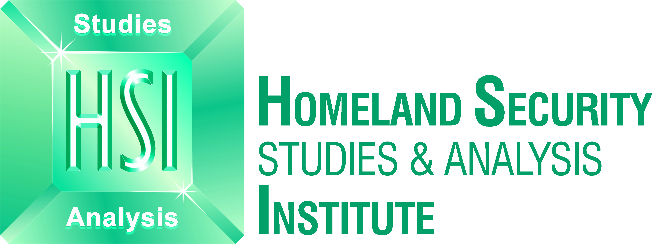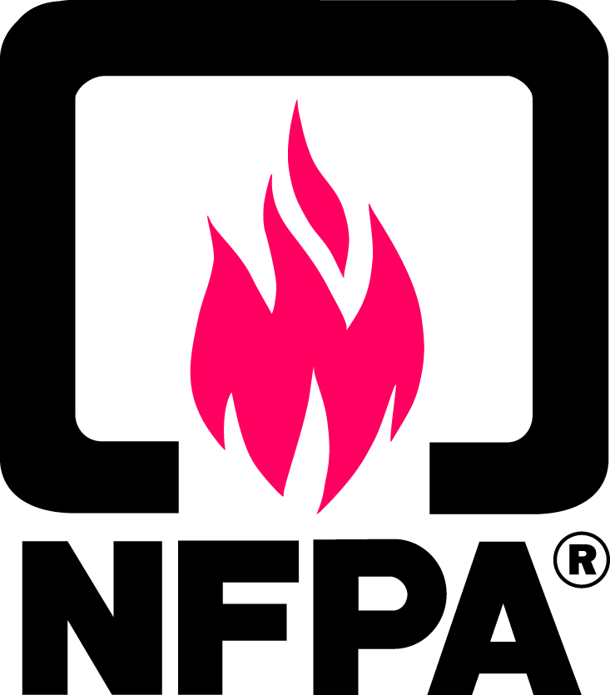





ANSI HSSP 2009 Plenary Attendance

First Name | Last Name | Organization
Agha | Ahmed | U.S. Department of Homeland Security (DHS)
Michael | Aisenberg | Mitre
Stephen | Amitay | ASIS International
Meliha | Ayvaz | Booz Allen Hamilton
Debra | Ballen | Institute for Business and Home Safety
Dan | Bart | Valley View Corporation
Jane | Bass | U.S. Department of Homeland Security (DHS)
Bill | Billotte | National Institute of Standards and Technology (NIST)
Shellie | Blakeney | T-Mobile USA
Peg | Blechman | Access Board
Jerry | Brashear | ASME
Roberta | Breden | U.S. Department of Homeland Security (DHS)
Dan | Campbell | U.S. Department of Homeland Security (DHS)
Jessica | Carl | American National Standards Institute (ANSI)
Lauren | Choi | Booz Allen Hamilton
Larry | Clinton | Internet Security Alliance
Tod | Companion | U.S. Department of Homeland Security (DHS)
Robert | Connors | Raytheon
Jerome | Conrad | U.S. Department of Homeland Security (DHS)
Rich | Cooper | Catalyst Partners LLC
Eve | Copeland | U.S. - Israel Science and Technology Foundation
Bert | Coursey | U.S. Department of Homeland Security (DHS) - Science & Technology Directorate
James | Creel | ASME
Robert | Dickens | Homeland Security Studies and Analysis Institute
Don | Donahue | The Potomac Institute for Policy Studies
Joshua | Dozer | U.S. Department of Homeland Security (DHS) - Federal Emergency Management Agency (FEMA)
Chris | Dubay | National Fire Protection Association (NFPA)
Eric | Dunn | Intertek
Tom | Farmer | U.S. Department of Homeland Security (DHS)
Allan | Fraser | National Fire Protection Association (NFPA)
Gordon | Gillerman | National Institute of Standards and Technology (NIST)
Mohamed | Gohar | Booz Allen Hamilton
Dave | Gorshkov | Chair of APTA TSWG1
Don | Grant | U.S. Department of Homeland Security (DHS) - Incident Management Systems Integration Division
Fred | Hayes | Packaging Machinery Manufacturers Institute
Sebastian | Heath | U.S. Department of Homeland Security (DHS) - Federal Emergency Management Agency (FEMA)
Glenn | Hedman | Chair of RESNA Standards Committee
Kathleen | Higgins | U.S. Department of Homeland Security (DHS) - Science and Technology Directorate
Karen | Hughes | American National Standards Institute (ANSI)
Thomas | Jackson | Phillips Nizer LLP
Bradley | Johnson | U.S. Department of Homeland Security (DHS)
Sara | Jones | Homeland Security Studies and Analysis Institute
Edwina | Juillet | Fire/Life Safety for People with Disabilities
Stephen | Krill | Booz Allen Hamilton
John | Kulick | Siemens Corporation
Ann | Liebschutz | U.S. - Israel Science and Technology Foundation
Thomas | Lockwood | U.S. Department of Homeland Security (DHS)
Alex | Martell | Vidient Systems
Phil | Mattson | U.S. Department of Homeland Security (DHS)
Alex | McLellan | Homeland Security Studies and Analysis Institute
Nancy | McNabb | National Fire Protection Association (NFPA)
Geraldine | Mijares | U.S. Department of Homeland Security (DHS)
Ashley | Moore | U.S. Department of Homeland Security (DHS)
Marjorie | Morgan | Internet Security Alliance
Yonas | Nebiyeloul-Kifle | Homeland Security Studies and Analysis Institute
Tamara | Nolan | Booz Allen Hamilton
Philip | Padgett | Emergency Management Accreditation Program
Michael | Penders | Environmental Security International
Anthony | Policastro | Smiths Detection
Marcus | Pollock | U.S. Department of Homeland Security (DHS) - Federal Emergency Management Agency (FEMA)
Deborah | Prince | Underwriters Laboratories, Inc.
Caroline | Purdy | DNDO
Bill | Raisch | New York University InterCEP
Sharon | Ranftle | SAIC
Robert | Reilly | Booz Allen Hamilton
Scott | Richter | ANAB
Lori | Rivera | U.S. Department of Homeland Security (DHS)
Allen | Rose | U.S. Department of Homeland Security (DHS)
Antoinette | Rucker | U.S. Department of Homeland Security (DHS) - Science and Technology Directorate
Fran | Schrotter | American National Standards Institute (ANSI)
Mary Beth | Schultz | United States Senate
Peter | Shebell | U.S. Department of Homeland Security (DHS) - Science & Technology Directorate
Charles | Sleeper | U.S. Department of Homeland Security (DHS)
Jacqueline | Snelling | U.S. Department of Homeland Security (DHS) - Federal Emergency Management Agency (FEMA)
Mark | Steffler | Vidient Systems
Robert | Stenner | Pacific Northwest National Laboratory
Boyd | Stephenson | American Trucking Associations
Stephanie | Stocum | SAIC
Debra | Stoe | DOJ/NIJ
Ravi | Subramaniam | MET Laboratories, Inc.
Tom | Ulmer | Remlu, Inc.
Richard | Vandame | U.S. Department of Homeland Security (DHS)
Robert | Vondrasek | National Fire Protection Association (NFPA)
Dave | Williams | SAIC
Larry | Williams | Homeland Security Studies and Analysis Institute
Adam | Williamson | Intertek
Kay | Winn | CSA America, Inc.
Robert | Zimmerman | Homeland Security Studies and Analysis Institute

