**ANSI: A Brief Overview**

**ANSI’s Role**

ANSI is the coordinator of the U.S. standardization system. We are a non-profit organization, not a government agency. We act as a neutral forum for all those interested in standardization, conformity assessment, and related policy matters. While we are a membership organization, and members do receive benefits that I’ll outline below, overall ANSI is a mission-driven organization that seeks to represent the best interests of all U.S. stakeholders in standardization, whether they are members or not.

Another important role we play is the U.S. member body to ISO and IEC, two major international standardization organizations.

**A Common Misconception**

People often assume that ANSI writes technical standards. This is absolutely not our role. We do accredit standards developing organizations (SDOs) based on their demonstrated processes for openness, balance, consensus, and due process in standards development. We further may approve the standards that these SDOs develop as “American National Standards,” which is a mark of quality in standards development work. If you’ve ever seen reference to an “ANSI standard,” it means that the document is an American National Standard, not that ANSI wrote it. It’s important to note that the technical effort is not ours, and the intellectual property is not ours.

**How Are Standards Purchased?**

ANSI, SDOs, standards bodies, and other resellers typically place these technical documents for sale online. ANSI has its own webstore.ansi.org, and other organizations typically have their own sites. Further, SDOs may negotiate with ANSI, other bodies, and resellers to make their standards available through other commercial platforms. In other words, while ANSI doesn’t develop standards, we have worked with various SDOs so that we can sell their standards on our webstore.

**How Else Are Standards Accessed?**

As you are likely aware, sometimes a standard or code is referenced in a federal, state, or local law. We refer to this as “incorporation by reference” or IBR. I shared our website with you earlier, but I’ll put it here again just for the sake of completeness: [www.ansi.org/ibr](http://www.ansi.org/ibr). When an agency incorporates a standard by reference into law, they must make sure that standard is made “reasonably available.” This means that the standard is accessible to any potential user. It does not require that the standard be made available without a fee, since standards do not lose their copyright protection just by virtue of being referenced. But many SDOs do make their standards available online, typically in read-only format. ANSI has its own IBR portal – ibr.ansi.org. Most SDOs have their own reading rooms and solutions for making IBR-ed standards available.

**What’s Membership Got to Do with It?**

In ANSI’s case, very little. ANSI members do receive a small discount on the purchase of standards through our webstore, but membership is not a prerequisite for access to standards, nor are standards ever given away for free to members. Others in the standards community may have different business models. For example, consortia standards often have very high membership fees for participation in the development of the standard, but then the final document is given away for free to anyone. Other SDOs keep their membership fees low or non-existent because they want to encourage the broadest possible participation in the development of the document. Then, they charge for the resulting standard.

**Membership Benefits**

ANSI has six types of members: company, government, organizational, educational, international, and individual. The fee structures vary based on membership type. I’ll describe company, government, and organizational below. Individual is very simple: a $995 fee.

For companies, here is the dues structure:

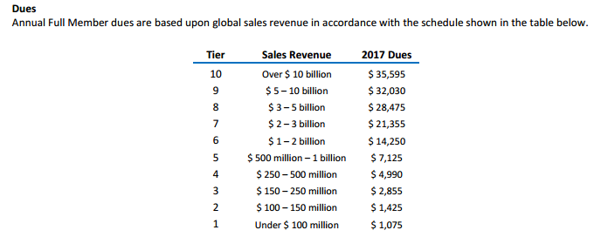

For government:

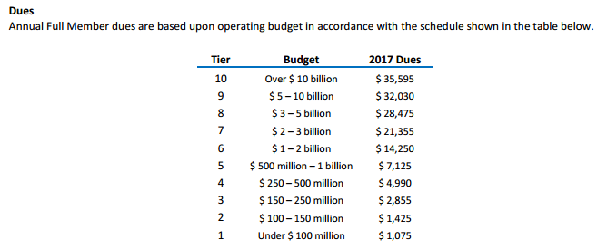

For organizations:

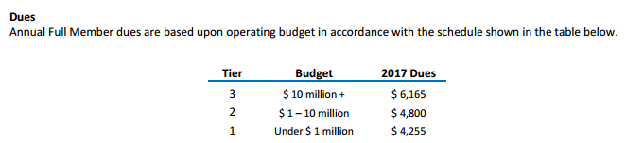

What do they get out of ANSI membership? Primarily, it’s access to standards policy information, and opportunities for participation and leadership. Because of ANSI’s unique role as a coordinating body, we find that members come to us because they want the broadest set of information and influence. Here’s a link to our membership brochure, which has the specific benefits and engagement vehicles outlined on pages 7 and 8: <https://share.ansi.org/Shared%20Documents/News%20and%20Publications/Brochures/membership_package.pdf>