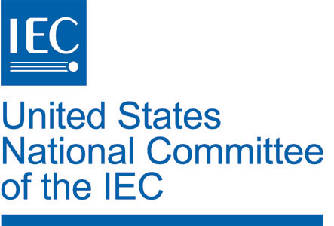
USNC Commitment Form – 2022 IEC General Meeting

General Sponsorship

_____ YES, I would like to be a general sponsor for the IEC 2022 General Meeting. The level of sponsorship for my Organization/Company/Agency is anticipated to be:
____Diamond $100K Total
____Platinum $50K Total
____Gold $25K Total
____Silver $15K Total
____Bronze $10K Total
____Member $5K Total
____Other amount $__________
Option #1:

___ Please invoice me in 2021 for a single amount as indicated.

*Option #2:

___ I wish to provide support on a different schedule as follows:

$_______ / year for _____ years
*All payments are due in full by 31 December 2021

Sponsorship of Special Event
In addition to a general sponsorship, my Organization has interest in sponsoring the following specific events at the level indicated. A sponsorship may not be exclusive unless specific arrangements are made. Please note, amounts listed below are subject to change – for reference purposes ONLY.

____Coffee Break Sponsor (Entire Meeting) | $350K
____Daily Coffee Break During Meeting | $50K
____Daily Coffee Break – Off Week | $25K
____Opening Dinner/ Reception (Entire) | $175K
____Opening Dinner / Reception (Share) | $25K
____Farewell Dinner (Entire Dinner) | $325K
____Farewell Dinner (Share) | $50K
____Presidents’/Secretaries’ Dinner | $100K
____Council Lunch | $25K
____TC/SC Chairs Forum Reception | $5K
____Presidents’ Forum Reception | $5K
____Secretaries’ Forum Reception | $5K
____CB Luncheon | $5K
____CAB Luncheon | $5K
____ExCo Luncheon | $5K
____SMB Luncheon | $5K
____Business Center and IT  (Printers, PC’s, Fax machines, Copiers) | $150K
____Delegate Bags | $130K
____Audio Visual | $120K

SPONSOR CONTACT INFORMATION

Contact Name: _________________________________ Phone: _______________________________

Organization/Company: _________________________________________________
E-mail:____________________________________ Signature:___________________________________
Note: This intent to sponsor is not legally binding, but is used as a way to gauge support. If you indicate your willingness to sponsor this meeting your organization's annual USNC/ANSI membership invoice will have an additional amount added as you indicate.

