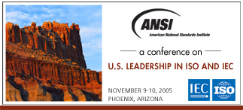  Name  Title  ISO or IEC Leadership Role  Company/Organization  Address  City State Zip  E-mail  Telephone  Telefax  Will you be accompanied by a guest/spouse at the social event on Wednesday evening (no additional charge)?  □ Yes □ No  Method of Payment  See fee schedule shown at right. Please enclose your check  or money order, payable to the American National Standards Institute, or provide credit card information below.  Amount enclosed $ .00  □ Check □ Money Order  □Visa □ AMEX □ MasterCard  Credit card number  Expiration Date /  Authorized signature |   Registration  For priority handling, please complete and send this form to the Registration Coordinator:  Email: registration@ansi.org  Fax: 212.398.0023  Or mail to:  Conference on U.S. Leadership in ISO and IEC  American National Standards Institute  25 West 43rd Street, 4th floor  New York, NY 10036  Register by September 30, 2005  □ ANSI member: $349  □ Non-member: $399  Register after September 30, 2005  □ ANSI member: $399  □ Non-member: $449  On-site registration subject to availability.  Venue  Pointe Hilton Squaw Peak  7677 North 16th Street  Phoenix, Arizona 85020  602-997-2626 or 1-800-Hiltons  Additional Information  Please click here and follow the links for Conference on U.S. Leadership in ISO and IEC for additional important information regarding this conference, including:  - Conference program  - Cancellation and transfer policy  Questions?  Please contact Steven Cornish (scornish@ansi.org; 212.642.4969)  or visit www.ansi.org/events.

