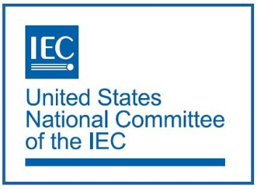

**USNC YEP/Protégé Travel Program Application**

# **Process, Timing, and Eligibility**

Travel Request Applications need to be submitted to Ade Gladstein ([agladstein@ansi.org](mailto:agladstein@ansi.org)) eight weeks, or more, prior to the USNC Management Meetings highlighted in this application. Applications will be assessed by a panel of USNC Council and YEP Committee members, and applicants will be notified no later than six weeks prior to the event to allow for final travel arrangements to be made.

# **Application Form**

## Name:

___________________________________________________

## Status (Bold one of the following):

Current Employee, Consultant, Intern, Student, Other

## Title:

___________________________________________________

## Organization:

___________________________________________________

## Address:

___________________________________________________

## Telephone:

___________________________________________________

## Email:

___________________________________________________

## Name of meeting that the applicant would like to attend:

___________________________________________________

## Location of the event:

___________________________________________________

## Date of the event:

___________________________________________________

## Has the applicant received approval from their primary employer that if the travel application is approved they will be able to attend the above listed event?

___________________________________________________

## To avoid any misunderstandings regarding travel or reimbursable costs by recipients approved to attend USNC Management Meetings, the following guidelines have been established. Any USNC travel request to attend USNC Management Meetings caps reimbursement up to $1,500 for airfare and hotel.

## Recipients are allowed reasonable expenses for airfare and hotel. The total cost of airfare and hotel (including taxes and fees) require approval from USNC staff prior to purchasing.

## Approved airfare will be reimbursed by USNC. Original ticket receipt and proof of payment (i.e., credit card statement) must be submitted for reimbursement. Recipients must fly coach class and use non-refundable tickets. The hotel folio and proof of payment must also be submitted for lodging reimbursement. Does the applicant understand that they or their company is responsible for any costs over $1,500?

___________________________________________________

## Prior to reimbursement distribution, the applicant must agree to complete a short post-meeting survey to evaluate the success of this travel fund program. Receipts shall be attached to the survey for reimbursement.

___________________________________________________

## Applicant Personal Statement: Please include a one-page personal statement explaining 1) your current activities within the standards and conformity assessment, 2) your familiarity with the USNC, and 3) why you believe attendance at this event will help you achieve your professional development goals.

___________________________________________________